DENNIS HOOVER
AUCTIONEER / BROKER
5652 Co. Rd. 64
Spencerville In. 46788

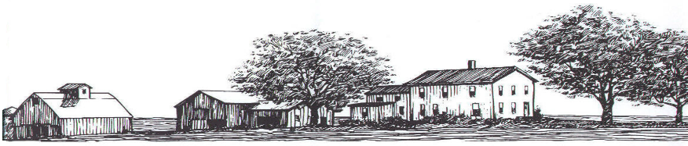

CELL PHONE 260-704-1111 BUSINESS PHONE 260 -238-4999

Saturday, June 1, 2024 @ 10 A.M.
Location: 2725 E 500 S Hamilton In. 46742

Directions: From Hamilton go North on 427, (then turns in to SR 1), 2.8 mile to E500S. Then West on E500S to auction site. Or from Angola go East on SR 20 4 mile to SR 1. Then South on 1- 4 mile to E500S. Then West 1.5 mile to auction site. Watch for signs. Auction is back a long lane on the South side of the road.
- Glock 30 mod. from RMR, modified trigger.
- Ruger Blackhawk 44 mag.
- Glock 21 Gen 1. 45 ACP.
- S&W 9 mm 2.0.
- Diamond Black DB9.
- IMI Jericho 941 9 mm and .41AE.
- Bushmaster AR15-STD.
- Mauser M-48, 8 mm.
- Mossberg Model 500 pump 20 ga.
- Mossberg Model 500 pump 12 ga. Tactical.
- Benelli Montefeltro Delta Waterfowl gun of the year #214 of 250 20 ga.
- Benelli Nova 12 ga. In Camo.
- Norinco SKS 7.62X39 w/ scope.
- Winchester model 1894 32 w/serial number 1371238.
- Marlin model 1894 .44 mag. w/ scope.
- Marlin model 1894 .44 mag. FAL .308 Imbel.
- Henry Arms .22LR Lever action.
- Marlin Bolt action .22 WMR.
- Ruger American 22-250 Rem.
- Ruger M77 Mark 11 .300 Win Mag w/ 3.8-12 x 44 scope.
- Ruger 10-22 w/ Mod stock folding.
- AR-15 w/ Magpul sight & Troy hand grip.
- Savage 110- 308 w/Accutrigger, metal bed, heavy barrel. Nightforce ATACR 4-16x42 scope sold after gun.
- Aero Precision receiver Ghost w/ Geissele trigger, Krieger SS, heavy barrel, JP Enterprises handgrip, Magpul Adj. stock. Trijicon ACOG 3.5X35 scope sold after gun.
- Imbel FAL IN. 7.62 x 51mm.
- S&W M&P9 M2.0 Cal 9mm.
Lots of loading supplies and camping gear.

