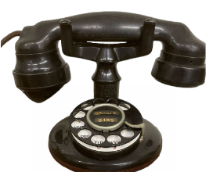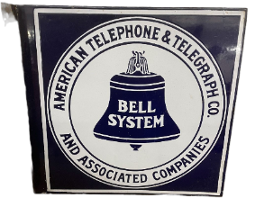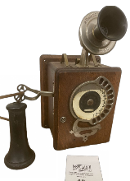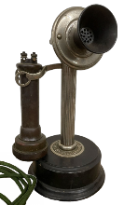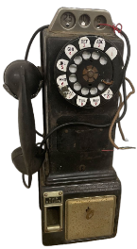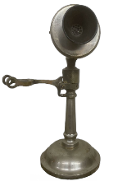
The Degnen Antique Telephone Collection
Online Telephone Collection Auction
Begins Sunday, July 3rd, 2022 & Ends Sunday, July 24th, 2022

Freeland Auction Services has been entrusted to bring to market the Antique telephone collection of Matt Degnen. Matt was a member of The Antique Telephone Collectors Association and attended conventions for several years. Matt’s passion was to restore his phones and he had hundreds of projects. Matt passed away in 2014 and his phones have been in storage since his passing. This is the 1st of several absolute online auctions for the Degnen Telephone Collection.
This first auction of 150 items begins on Sunday, July 3rd and will end Sunday, July 24th beginning at 6pm. Please visit Proxibid.com or our FreelandAuctionServices.com website for more information. There is a 10% buyers premium. We do ship all items in house, so there will be no hidden high dollar fees for shipping.
Matt had amassed a wonderful collection that we will be bringing to you on Proxibid.com with several featured absolute online auctions. He has hundreds of payphones that will come to market over the next year.
Now is your chance to own these pieces and add them to your collection. Every item described to a 'T" with dozens of photos so there will be no doubt that you will have value in the years to come. You now have the opportunity to add one or more of his telephones to your collection.
Have a field day and revel in some of the most treasured items in the telephony field brought to you by Freeland Auction Services, a “Premier Auction House” connecting collectors with collections! Good Luck in your bidding, check back often, and feel confident that you will have a great piece of history. So, please bid confidently, and enjoy this liquidation of a wonderful ATCA member’s collection. Shipping is available, as well as local pickup in Freeland, MI. If you are attending either of the Shipshewana, IN ATCA Convention this summer, delivery of larger items can be discussed. Have fun and please contact Barry with Freeland Auction Services if you have any questions!
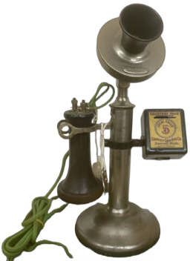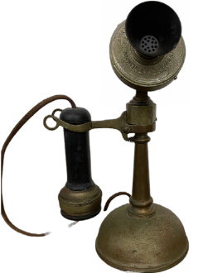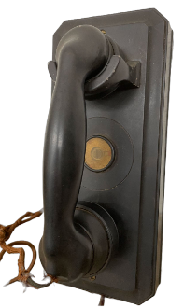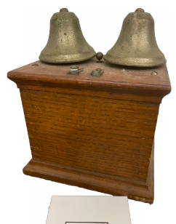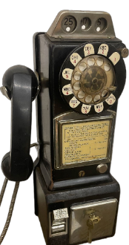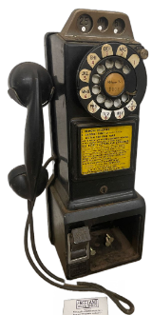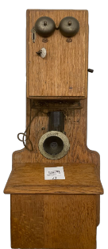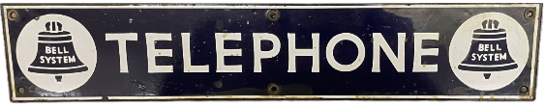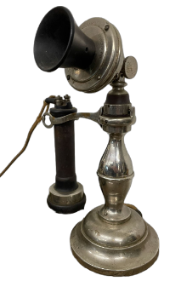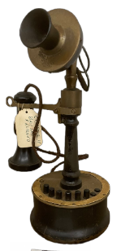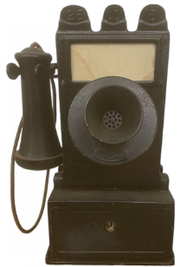

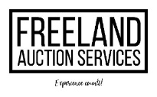CONTACT: Barry Huckeby (989) 878-3308
FreelandAuctionServices.com

