LOCATION: 351 E CONESTOGA ST., NEW HOLLAND, PA 17557. From Intersection of Rt. 322 & Rt. 23 in Blue Ball; Take Rt. 23 West for 1.9 miles, Turn R on N. Kinzer Ave, Follow 3/10 mile to L on East Conestoga St. to Property on R.

REAL ESTATE: MOVE IN READY 3 BEDROOM RANCHER situated on .29 +/- acres. Located in New Holland Borough, Elanco School District. This property feature mature landscaping, large backyard with concrete patio on rear of home, new roof and soffit in 2019, and attached 2 car garage with access to attic storage. This 1464 sq. ft. home features refinished hardwood floors throughout. The home has a very open floorplan with a large family/living room opening to dining area with wood fireplace and access to patio. Kitchen features new LVP flooring, dishwasher and range. The hallway follows to guest bathroom with tub/shower and linen closet; and bedrooms. Follow hall to master bedroom with master bath which includes a walk in shower. Closet space & storage is abundant in this beautiful home. First floor laundry area with easy access to garage and basement entrance. Basement features large workroom, partially finish family room and storage/utility area. This Rancher features a Central Air/ Heat pump system (2009), electric hot water heater (2013), public water & sewer.

NOTE: Property has great location on a dead end peaceful street; with easy access to major highways and locations. This property is a great retirement home or a starter home; come prepared to bid, as current owners are motivated to sell.

OPEN HOUSES: Saturday, September 12, 19 & 26 (1-3pm) or by apt. call (717) 587-5105
TERMS: 10% down day of Auction, settlement within 45 days of sale
TERMS BY: Michael Englerth & Brittany Hall ---- Kling & Deibler Attorneys (717) 354-7700

SEE REVERSE SIDE FOR MORE DETAILS OR VISIT OUR WEBSITE
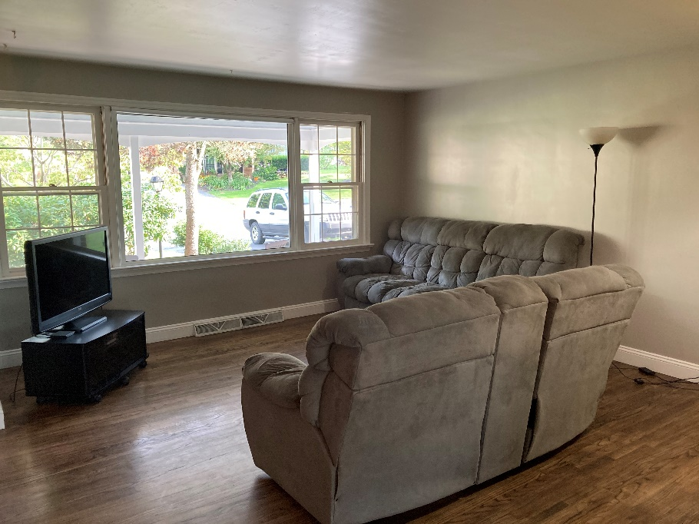
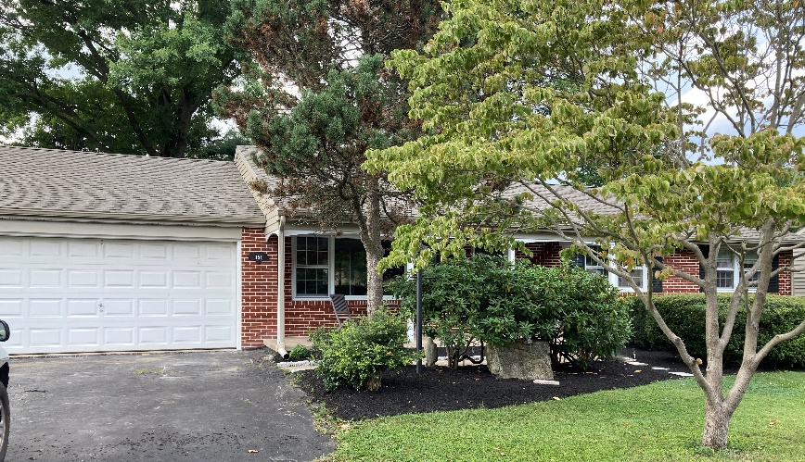

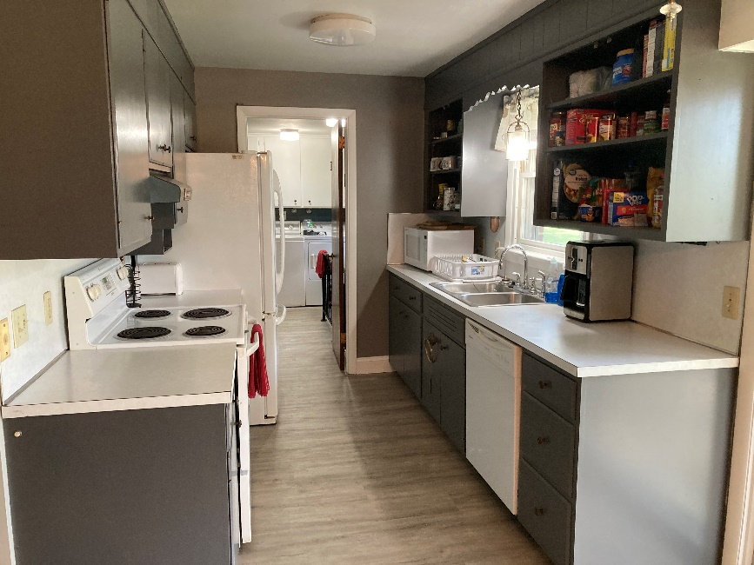

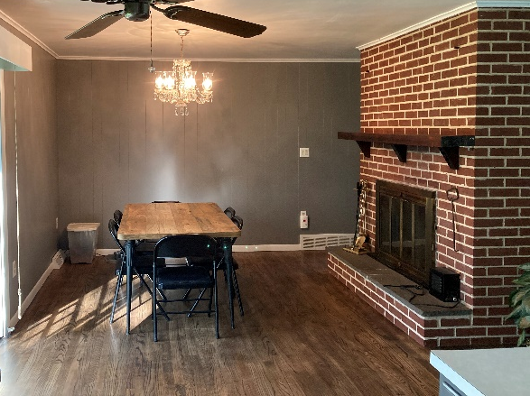
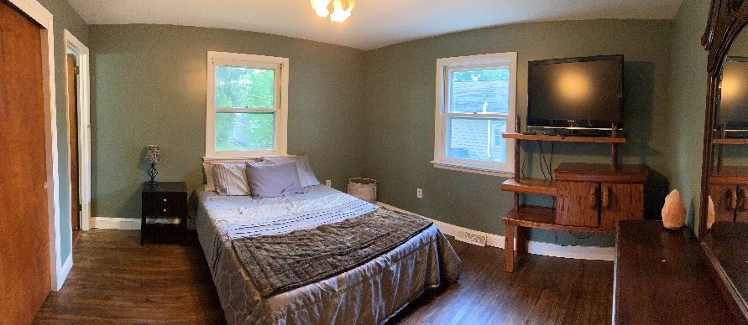
ROOM DIMENSIONS
Living Rm: 19’x18’ Dining Area: 16’x13’ Kitchen: 8’x10’ Laundry: 8’x 12.5” Master Bdrm: 12.5”x13’ Master Bath 4x10
2nd Bdrm: 12.5’x13’ 3rd Bdrm: 16’x11.5’
Guest/Main Bath 8’x8’

Lot size/Acres: .29 +/- Acres Roof: Shingles (2019) Bedrooms: 3
School District: Elanco Basement: Partly finished Fireplace: Yes
Township: New Holland Borough Condition: Good (Move in) Water: Public
County: Lancaster Baths: 2 Heating: Central Air/ Heat pump
Taxes: Approx. $3795 Flooring: Hardwood, LVP Appliances: Range, Dishwasher

