SATURDAY, MAY 29, 2021
TACK & CARTS @ 9:00 AM, PONIES @ 11:00 AM
(PONIES DRIVING @ 10:00 AM)
AUCTION TO BE HELD AT NEW HOLLAND SALES STABLES
101 W FULTON STREET, NEW HOLLAND, PA. 17557
SEEKING CONSIGNMENTS OF PONIES, HALFLINGERS, MINI’S AND DONKEYS, NEW & GOOD USED TACK, WAGONS, BUGGIES, SLEIGHS, CARTS ECT.
OVER 100 HEAD EXPECTED!! ACCEPTING CONSIGNMENTS UNTIL Wednesday MAY 26, 2021

PONIES OF MENTION: 8 Yr. old Halflinger Gelding, Trail rides, sound
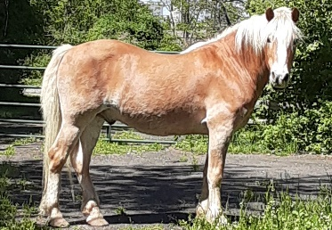
5-6 Yr. old Hackney Gelding, broke to carriage, sound
2 Yr. old Hackney Cross stud, Green broke in harness
Load of ponies coming from the south
NEW & USED TACK: Load of brand new tack, harnesses, saddles, halters, leads, buckets, wormer, Nice used set of mini driving harness (up to 34 Inch)
CARTS & WAGONS: Like New Meadowbrook natural finish pony cart, Very nice 9 passenger cut under Surrey w/ rubber trimmed wood wheels & LED lights, new brake system.
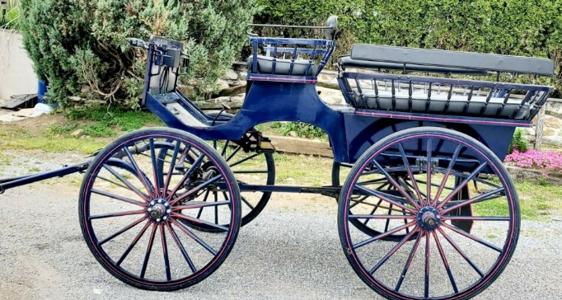
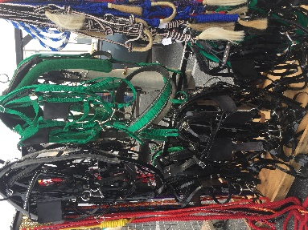
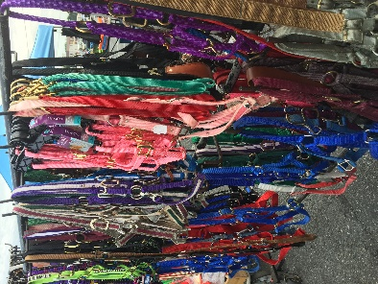
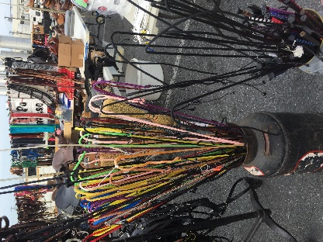

PLEASE HAVE INFORMATION TO BRIAN OBERHOLTZER (717) 587-5105 BY WEDNESDAY MAY 26 @ 7:00PM

ALL TACK AND PONIES SHOULD BE AT SALE BARN BY 8AM DAY OF AUCTION!
ALL LIVESTOCK SUBJECT TO $5.00 PER HEAD HAY/FEED FEE
ALL CONSIGNMENTS TO RUN THROUGH BL OBERHOLTZER AUCTION SERVICE,
WHICH IS PERMITTED AND BONDED THROUGH USDA
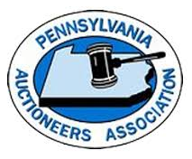
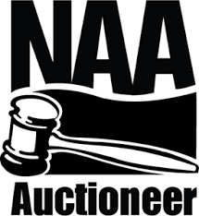
B.L. OBERHOLTZER AUCTION SERVICE
Brian L. Oberholtzer AU-005951 Reinholds, PA 17569
Jordan Martin AA-019691 “SELLING YOU ON AUCTIONS”
717.587.5105 | info@OBAuctioneer.com | OBAuctioneer.com

