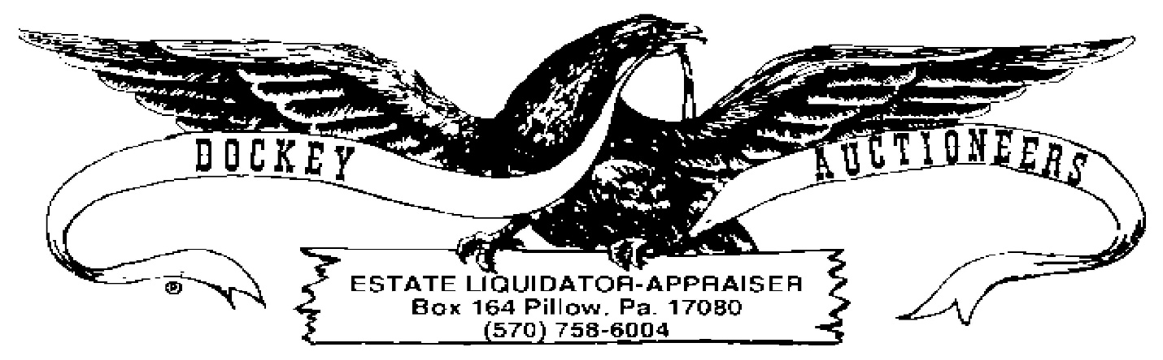

COIN LISTING ~ 12 APRIL 2024 ~ 6:00 P.M.
CROSSROADS MARKET & AUCTION
- Lot: $10.00 Eisenhower Dollars
- Lot: $10.00 Eisenhower Dollars
- Lot: $10.00 Eisenhower Dollars
- Lot: $10.00 Eisenhower Dollars
- Lot: $10.00 Eisenhower Dollars
- Lot: $10.00 Eisenhower Dollars
- Lot: $10.00 Eisenhower Dollars
- Lot: $10.00 Eisenhower Dollars
- Lot: $12.00 Sacagawea Dollar Coins
- Lot: $9.00 Sacagawea Dollar Coins
- UNC Roll US Mint $25.00 Sacagawea Dollar Coins
- Lot: $9.00 Presidential Coins & Susan B. Anthony Dollar Coins
- 1886 Morgan Silver Dollar
- 1879-S Morgan Silver Dollar
- 1812 Capped Bust Half Dollar, AS IS
- Lot: $3.50 Bicentennial Half Dollars
- Lot: $5.00 Kennedy Half Dollars, Assorted Dates
- Lot: $5.00 Washington Quarters, Assorted Dates
- Lot: $2.00 Washington Quarters, Assorted Dates
- Lot: $6.00 Washington Quarters, Assorted Dates
- (2) UNC Rolls US Mint 1999 PA State Quarters, Buyer’s Choice
- Lot: $10.00 Bicentennial Quarters (over)
- Lot: $2.00 Roosevelt Dimes, Assorted Dates
- Lot: $7.50 Roosevelt Dimes, Assorted Dates
- Lot: $1.50 Jefferson Nickels, Assorted Dates
- Lot: $.70-(9) Jefferson Nickels & (1) Washington Quarter
- UNC Roll US Mint Jefferson Nickels
- Lot: (59) Wheat Cents
- Lot: (51) Wheat Cents (1920-45)
- Running Antelope/The Silver Chief 5-oz. .999 Silver Commemorative Coin
- Lot: (2) Bicentennial Dollars in Belt Buckle & Money Clip
- Sterling Bar: Jesus on the Cross/Ten Commandments
- Lot: 3-cent Nickel & COPY OF 1804 Dollar
- Mickey Mouse 1999 Holiday Treasure 1 Troy oz Silver Token
- 1922 Peace Dollar
- 1988 US Mint Proof Set
- 1984 UNC US Mint Set
- 1992 UNC US Mint Set
- 1993 UNC US Mint Set
- 1994 UNC US Mint Set
- 1999 UNC US Mint 50 State Quarter Coin Set
- Lot: (5) 1972 Eisenhower Dollars
- 1964 Kennedy Half Dollar
- 1985 Kennedy Half Dollar covered in 24 KT Gold.

