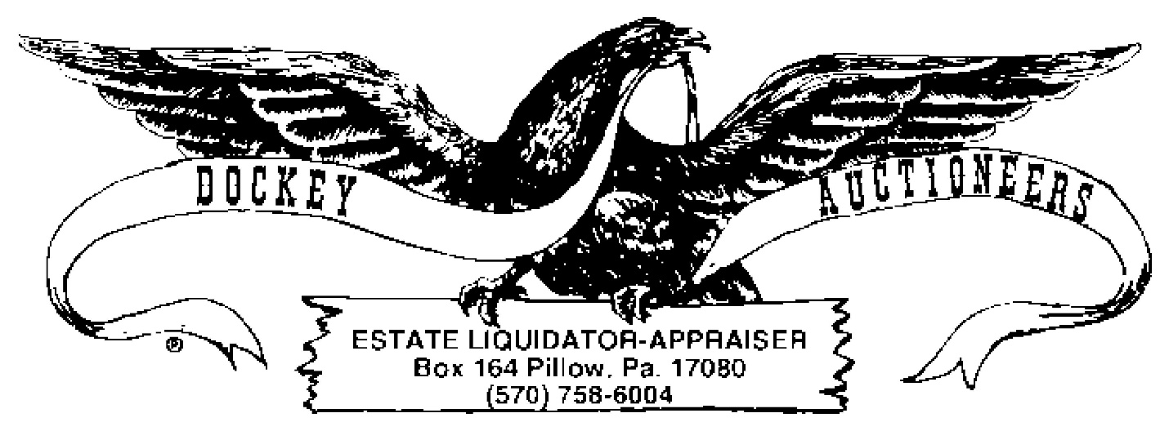
COIN AUCTION CROSSROADS SALE & MARKET
01 MARCH 2024 - 6:00 P.M.
- Lot: (10) Kennedy Halves (1971, 1971-D, 1972, 1972-D, 1974, 1974-D, Bicentennials)
- Lot: (11) Kennedy Halves (1978, 1979, 1980, 1981, 1983, 1984, 1985-D, 1986-D, 1988, 1989)
- Lot: (6) Silver Quarters (1925, 1941-D, 1943, 1947-S, 1953-D)
- Lot: 1905 Barber Dime & 1907 V-Nickel
- Lot: (7) Mercury Dimes (1919, 1936-D, 1937, 1941, 1942)
- Lot: (7) Roosevelt Silver Dimes (1947, 1951, 1952, 1956)
- Lot: (7) Roosevelt Dimes (1960, 1961, 1963, 1964)
- Lot: (11) Roosevelt Dimes (1965, 1966)
- Lot: (11) Roosevelt Dimes (1967, 1969-D, 1971, 1972-D, 1973-D, 1974-D)
- Lot: (11) Roosevelt Dimes (1980-D, 1981, 1983, 1984, 1985, 1989, 1990, 1992, 1996)
- Lot: (10) Buffalo Nickels (1915, 1916, 1924, 1925, 1927, 1928, 1929)
- Lot: (10) Buffalo Nickels (1928, 1929, 1930, 1934, 1935)
- Lot: (10) Buffalo Nickels (1935, 1936, 1937)
- Lot: (7) Buffalo Nickels (1937, 1938)
- Lot: (10) Buffalo Nickels (1935, 1936)
- Lot: (12) Buffalo Nickels (1936, 1937)
- Lot: (25) Jefferson Nickels (1950’s)
- Lot: (5) Indian Head Cents, (3) Buffalo Nickels & (2) Silver Quarters
- $3.00 Washington Quarters, 1970’s
- Lot Foreign Coinage
- Lot: (5) Susan B. Anthony Dollar Coins
- Lot: (5) Indian Head Cents (1887, 1888, 1890, 1892, 1893)
- Lot: (6) Indian Head Cents (1895, 1896, 1897, 1898, 1900)
- Lot: (6) Indian Head Cents (1901, 1902, 1904, 1905, 1907, 1908)
- Lot: (20) Wheat Cents (1909, 1910, 1911, 1911-D, 1912, 1913, 1913-D, 1913-S, 1914, 1914-D, 1915, 1915-D, 1916, 1916-D, 1916-S, 1917, 1917-D, 1917-S, 1918, 1918-D)
- Lot: (20) Wheat Cents (1918-S, 1919, 1919-D, 1919-S, 1920, 1920-D, 1920-S,1921, 1921-D, 1921-S, 1923, 1923-S, 1924, 1924-S, 1925, 1925-D)
- Lot: (20) Wheat Cents (1925, 1925-S, 1926, 1926-D, 1926-S, 1928, 1928-D, 1928-S, 1929, 1929-D, 1929-S, 1930, 1930-D, 1930-S, 1931, 1931-D, 1932)
- Lot: (26) Wheat Cents (1932-D, 1933, 1933-D, 1934, 1934-D, 1935, 1935-D, 1935-S, 1927, 1927-D, 1927-S, 1936, 1936-D, 1936-S, 1937, 1937-D, 1937-S, 1938, 1938-D, 1938-S, 1939, 1939-D, 1939-S, 1940, 1940-D, 1940-S)
- Lot: (5) $2.00 Green Seal, 1976 Series Bills
- Lot: (5) $2.00 Green Seal, 1976 Series Bills
- (2) 200th Anniversary Commemorative American Eagle Ingots (5 grams) with 18” Sterling Neck chains
- (3) Buffalo Nickel Pendants w/Chains
- Lot: Trump Plaza Tokens
- (3) Bags Lower Mahanoy Bicentennial Wooden Nickels

