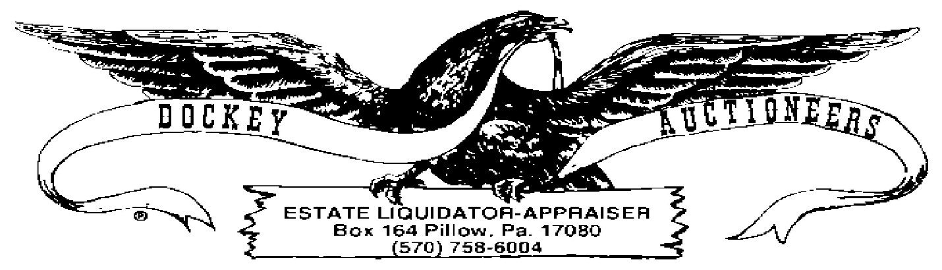
09 FEBRUARY 2024 ~ 6:00 P.M.
- 1923 Large Red Seal $1.00 Bill
- 1934D Blue Seal Silver Certificate $5.00 Bill
- 1928G Red Seal $2.00 Bill
- Lot: (7) 1953 Red Seal $2.00 Bills
- Lot: (3) 1953A Red Seal $2.00 Bills
- Lot: (2) 1953C Red Seal $2.00 Bills
- Lot: (3) 1963 $2.00 Bills
- Lot: (5) 1976 $2.00 Bills
- Lot: (1) 1935D Blue Seal Silver Certificate $1.00 Bill and (1) 1935F Blue Seal Silver Certificate $1.00 Bill
- Lot: (2) 1957 Blue Seal Silver Certificate $1.00 Bills
- Lot: (1) 1957A Blue Seal Silver Certificate $1.00 Bill and (1) 1957B Blue Seal Silver Certificate Bill
- 1896-O Morgan Silver Dollar
- 1927 Peace Silver Dollar
- 1927 Peace Silver Dollar in Belt Buckle
- 1958 Franklin Half & 1932 Standing Liberty Half Dollars
- Lot: 1921 Standing Liberty Quarter, 1941 & ’42 Mercury Dimes, 1943 War Nickel & (1) Buffalo Nickel
- (4) 1967 ’68 Kennedy Clad Half Dollars
- (5) Susan B Anthony Dollars
- (4) Sacagawea Dollars
- (3) $10.00 Eisenhower Dollar Lots, BC
- Lot: (6) Eisenhower Dollars
- Lot: $10.00 UNC 2002 Ohio State Quarters
- Lot: (153) Wheat Cents
- Lot: Assorted Foreign Coins & Tokens

