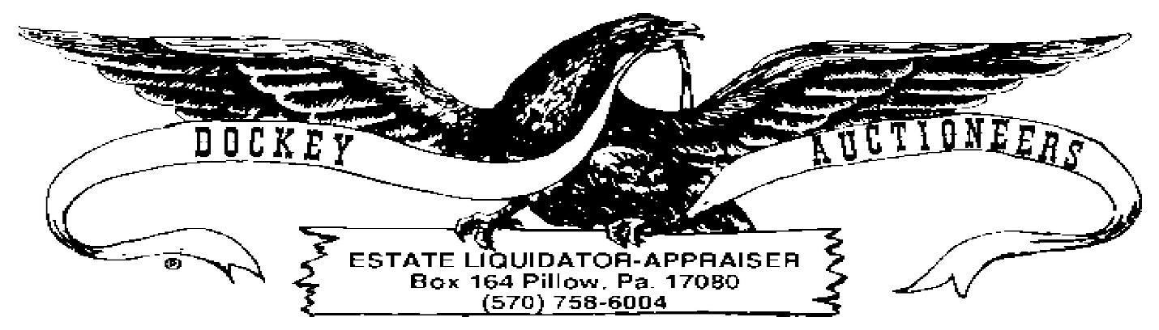
COIN LISTING-01-19-24
6:00 P.M.
- 2009 Territorial Quarter Collection, P&D
- World Reserve Monetary Exchange USA Presidential Dollar Collection Denver
- World Reserve Monetary Exchange USA Presidential Dollar Collection,
Philadelphia
- (2) Rolls Thomas Jefferson Presidential Coins, BC
- 1934A Green Seal $10.00 Bill
- 1934 Green Seal $10.00 Bill
- 1963 Red Seal $5.00 Bill
- (2) 1928A Blue Seal $1.00 Silver Certificates, BC
- 1928B Blue Seal $1.00 Silver Certificate
- (2) 1934 $1.00 Silver Certificates, BC
- (2) 1957 $1.00 Silver Certificates, BC
- (3) UNC 2003 $2.00 Bills, BC
- Bank of England One Pound Note
- (2) 1954 Canadian Dollars, BC
- British Coin Paperweight

