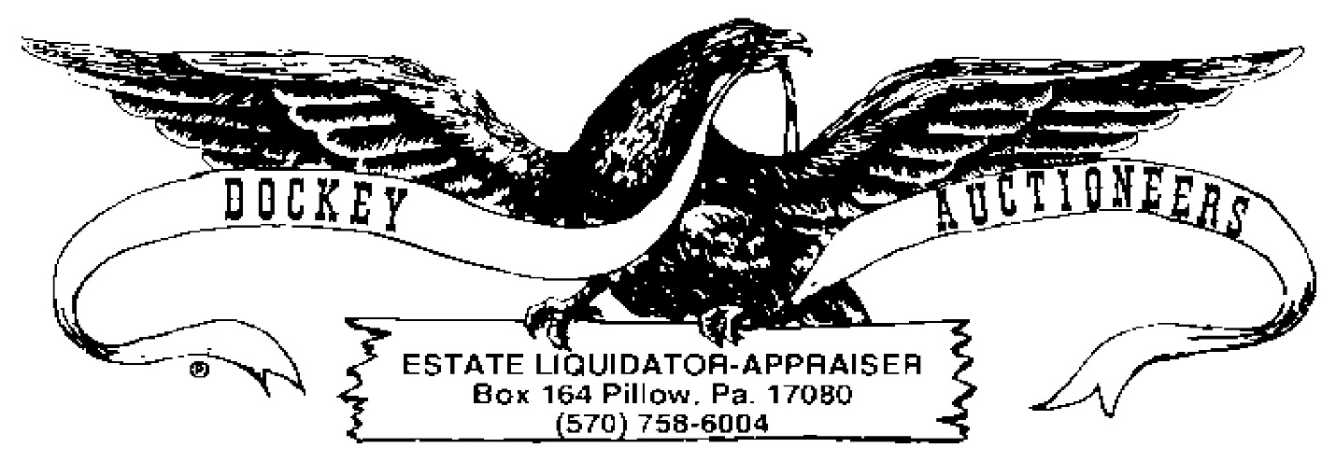
COIN LISTING-09 JUNE 2023-CROSSROADS-6:OO P.M.
- 1861 INDIAN HEAD CENT
- 1867 INDIAN HEAD CENT
- 1870 INDIAN HEAD CENT
- 1872 INDIAN HEAD CENT
- LOT: (9) INDIAN HEAD CENTS, 1879-1886
- LOT: (10) INDIAN HEAD CENTS, 1887-1893
- LOT: (10) INDIAN HEAD CENTS, 1893-1899
- LOT: (10) INDIAN HEAD CENTS, 1899-1909
- LOT: (10) WHEAT CENTS, 1910-1923
- LOT: (10) WHEAT CENTS, 1923-1937
- LOT: (14) WHEAT CENTS, 1937-1943
- LOT: (10) 1943 STEEL CENTS
- LOT: (15) WHEAT CENTS, 1951-1969
- LOT: (14) V-NICKELS, 1883-1895
- LOT: (10) V-NICKELS, 1896-1901
- LOT: (10) V-NICKELS, 192-1910
- LOT: (5) V-NICKELS, 1911-1912D
- LOT: (12) BUFFALO NICKELS, 1930-1937
- LOT: (9) JEFFERSON NICKELS, 1939-1942
- LOT: (10) WAR NICKELS
- LOT: (10) WAR NICKELS
- LOT: (5) WAR NICKELS
- LOT: (15) JEFFERSON NICKELS, 1946-1970
- LOT: (10) MERCURY DIMES, 1916-1919D
- LOT: (10) MERCURY DIMES, 1919S-1924S
- LOT: (10) MERCURY DIMES, 1925-1928
- LOT: (10) MERCURY DIMES, 1928D-1934D
- LOT: (10) MERCURY DIMES, 1935-1938
- LOT: (10) MERCURY DIMES, 1938D-1941
- LOT: (10) MERCURY DIMES, 1941D-1944
- LOT: (6) MERCURY DIMES, 1944D-1945D
- LOT: (10) ROOSEVELT DIMES, 1968-1972
- LOT: (10) ROOSEVELT DIMES, 1965-1967
- LOT: (11) ROOSEVELT DIMES, 1972-1979
- LOT: (8) WASHINGTON SILVER QUARTERS, 1932-1936S
- LOT: (8) WASHINGTON SILVER QUARTERS, 1937-1941
- LOT: (10) WASHINGTON SILVER QUARTERS, 1914S-1945
- LOT: (2) SILVER KENNEDY HALVES, 1964 & 1964D
- LOT: (5) 40% SILVER KENNEDY HALVES
- LOT: (5) 40% SILVER KENNEDY HALVES
- LOT: (6) SUSAN B ANTHONY DOLLARS
- LOT: (90) WHEAT CENTS
- LOT: (300) LINCOLN CENTS
- LOT: (114) LINCOLN CENTS
- LOT; (200) LINCOLN CENTS
- HISTORIC AMERICAN DEPICTED ON COINS-6 LINCOLN CENTS
- THE JEFFERSON ERA-13 JEFFERSON NICKELS
- THE KENNEDY STORY-3 KENNEDY HALVES
- TREASURY BUREAU OF MINT LARGE COMMEMORATIVE TOKEND REGAN, LINCOLN & LINDBERGH
- (2) BUFFALO NICKEL PENDANT NECKLACES
- LOT: 1234 ASSORTED LINCOLN CENTS

