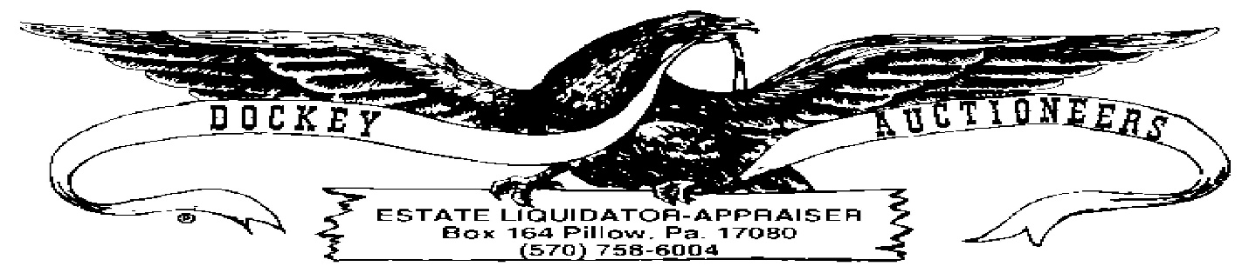

COIN LISTING-29 APRIL 2023-LOYALTON
MORGAN SILVER DOLLARS
- 1878
- 1880
- (3) 1881, BC
- (3) 1882, BC
- 1883-S
- 1882
- 1884
- 1886-O
- (3) 1887-O, BC
- 1888-O
- 1889-O
- 1889
- 1891
- 1891-O
- 1896-O
- 1897
- 1898
- 1899-O
- 1900-O
- (2) 1901-O, BC
- 1902
- (4) 1921, BC
- (4) 1921, BC
- 1921-D
- (3) 1921-S
PEACE DOLLARS
- (3) 1922, BC
- (3) 1922, BC
- (3) 1922, BC
- (4) 1922-S, BC
- (3) 1922-D, BC
- (3) 1923, BC
- (3) 1923, BC
- (4) 1923, BC
- (2) 1923-D, BC
- (3) 1923-S, BC
- (4) 1923-S, BC
- (3) 1924, BC
- (3) 1924, BC
- (3) 1925, BC
- 1926
GOLD COINS
- 1904 $20.00
- 2005 $10.00 GOLD EAGLE
- 1913 $2-1/2 ~ 43A. 1887 $10.00 MOUNTED ON MEDALLION ~ 43B. 1986 $50.00 1OZ.
SILVER EAGLE DOLLARS
- 1986
- (4) 2003, BC
- (4) 2003, BC
- (4) 2003, BC
- (4) 2003, BC
- (4) 2003, BC
- (4) 2004, BC
- (4) 2004, BC
- (4) 2004, BC
- (4) 2004, BC
- (4) 2004, BC
- (4) 2004, BC
- (4) 2004. BC
- (4) 2004. BC
- (4) 2004, BC
- (4) 2004, BC
HALF DOLLARS
- LOT- (4) BARBER
- LOT-(9) WALKING LIBERTY
- LOT-(5) FRANKLIN
- LOT-(10) 1964 KENNEDY
- LOT-(10) 1964 KENNEDY
- LOT-(7) 1964 KENNEDY
- LOT-$10.00 SILVER CLAD KENNEDY
- LOT-$10.00 SILVER CLAD KENNEDY
- LOT-$10.00 SILVER CLAD KENNEDY
- LOT-$5.50 SILVER CLAD KENNEDY
QUARTERS
- LOT-(2) BARBER & (3) STANDING LIBERTY
- LOT-(40) SILVER WASHINGTON
- LOT-(40) SILVER WASHINGTON
- LOT-(40) SILVER WASHINGTON
- LOT-(40) SILVER WASHINGTON
DIMES
- LOT-$10.00 MERCURY
- LOT-$10.00 MERCURY
- LOT-$10.00 MERCURY
- LOT-$10.00 ROOSEVELT
- LOT-$10.00 ROOSEVELT
NICKELS
- LOT-(13) V-NICKELS
- LOT-$2.00 BUFFALO
- LOT-$2.05 BUFFALO
CENTS
- 1827 Modified Liberty Head Large Cent
- 1817 Modified Liberty Head Large Cent
- 1855 Modified Liberty Head Large Cent-with hole. 85A. 1928 Large Cent
- LOT-(10) Indian Head Cents
- LOT-(10) Indian Head Cents
- LOT-(15) Indian Head Cents
- LOT-(22)Steel Cents
- LOT-(310) Wheat Cents
- LOT-(300) Wheat Cents
MISC.
- 1992 Giant Proof Silver Eagle, 16 Troy Oz.
- 1992 Giant Proof Silver Eagle, 16 Troy Oz.
- LOT-$2.50 Asst. Silver Mercury & Roosevelt Dimes
- LOT-(2)Morgan Silver Dollars, as is
- LOT-Silver Washington Quarters, War Nickel & Bent Mercury Dime
- LOT-Misc. US Coinage
- LOT-$10.00 Eisenhower Dollars
- LOT-$10.00 Eisenhower Dollars
- LOT-$10.00 Eisenhower Dollars
- LOT-$10.00 Eisenhower Dollars
- LOT-(5) Susan B. Anthony Dollars & (11) Sacagawea Dollars
- 52-pc. Commemorative State Quarter Album, 1999-2008
- LOT-Sealed US Quarters
- LOT-Bush & Clinton Coins
- LOT-$5.50 Canadian Coinage
- LOT-Assorted Foreign Coinage
PAPER CURRENCY
- Lg. $20.00 Gold Certificate, 1906 Series
- Lg. $10.00 Gold Certificate, 1907 Series
- Lg. $1.00 Silver Certificate, 1923 Series
- $10.00 Silver Certificate, Blue Seal, 1953 Series
- LOT-(3) $5.00 Red Seal Notes, 1963 Series
- LOT-(2) $5.00 Red Seal Notes, 1928 Series
- LOT-(2) $5.00 Silver Certificate Blue Seal Notes, 1934 Series
- LOT-(2) $5.00 Silver Certificate Blue Seal Notes, 1953 Series
- $2.00 Red Seal Note, 1928 Series
- LOT-(8) $2.00 Red Seal Notes, 1953 Series
- LOT-(3) $2.00 Red Seal Notes, 1963 Series
- LOT-(3) $2.00 Green Seal Notes, 1976 & 1995 Series
- LOT-(3) $2.00 Green Seal Notes, 1976 Series Cancelled with Stamp/Elizabethville & (1) 1976 Cancelled with Stamp/Millersburg
- LOT-(10) $1.00 Silver Certificates
- LOT-(10) $1.00 Silver Certificates
- LOT-(10) $1.00 Silver Certificates
- LOT-(10) $1.00 Silver Certificates
- LOT-(10) $1.00 Silver Certificates
- LOT-(4) $1.00 Silver Certificates w/Star
- LOT-Assorted Foreign Japanese & Canadian Paper Currency

