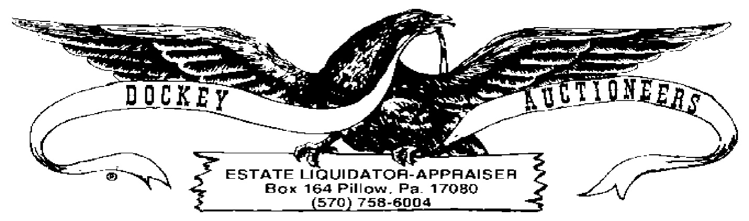
CROSSROADS MARKET & PUBLIC AUCTION WEEKLY PUBLIC AUCTION
COIN LISING FOR 27 MAY 2022-6:00 P.M.

- $7.00 LOT EISENHOWER DOLLARS
- $7.00 LOT EISENHOWER BICENTENNIAL DOLLARS
- (2) $14.00 LOTS SUSAN B. ANTHONY DOLLAR COINS, BUYER’S CHOICE
- $7.00 LOT PRESIDENTIAL DOLLAR COINS
- (2) $7.00 LOTS PRESIDENTIAL DOLLAR COINS & SUSAN B. ANTHONY COINS
- PARTIAL BOOK-(16) PRESIDENTIAL DOLLAR COINS
- (5) $7.00 BICENTENNIAL HALVES LOTS, BUYER’S CHOICE
- (4) $7.00 BICENTENNAIL QUARTER LOTS, BUYER’S CHOICE
- (2) LOTS-10 INDIAN HEAD CENTS, BUYER’S CHOICE
- LOT: (26) BUFFALO NICKELS
- LOT: (9) WARTIME NICKELS
- LOT: (34) V-NICKELS, ASSORTED DATES
- LOT: $7.00 JEFFERSON NICKELS
- (2) $3.00 LOTS WHEAT CENTS, BUYER’S CHOICE
- PARTIAL BOOK-WASHINGTON QUARTERS STATE COLLECTION VOL. I-1999-2003 ($12.50)
- PARTIAL BOOK-WASHINGTON QUARTERS STATE COLLECTION VOL II-2004-2008 ($8.75)
- (10) ROLLS UNC WASHINGTON STATE QUARTERS, BUYER’S CHOICE (CA, CO, FLA, HI, IOWA, MI, OK, OR, TX & WEST VA)

