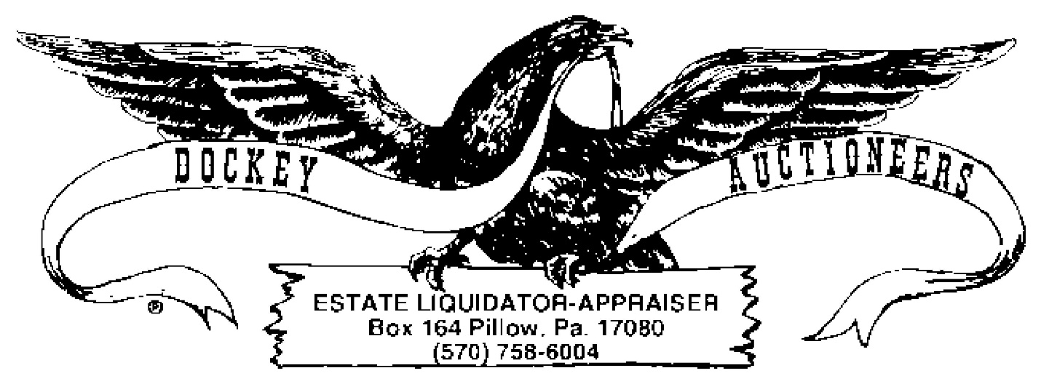
COIN LISTING
SATURDAY, 22 MAY 2021 11:00 A.M.
- 1923 Silver Dollar
- 1938 Standing Liberty Half
- 1950 Franklin Half
- 1953 Franklin Half
- 1960 Franklin Half
- 1962 Franklin Half
- 1963 Franklin Half
- Lot: $2.00 1964 Kennedy Halves
- Lot: $2.00 1964 Kennedy Halves
- Lot: $1.50 1964 Kennedy Halves
- Lot: $5.00 Asst. 40% Kennedy Halves, 1965-1969
- Lot: $5.00 Asst. 40% Kennedy Halves, 1965-1969
- Lot: $6.00 Asst. 40% Kennedy Halves, 1965-1969
- Lot: $3.50-(11) Washington Quarters & (3) Standing Liberty Quarters
- Lot: (8) Buffalo Nickels
- Lot: (17) Steel Cents
- Lot: $2.00 Kennedy Bicentennial Halves
- Lot: $2.00 Eisenhower Dollars
- Lot: $7.00 Kennedy Halves
- Lot: $7.00 Kennedy Halves
- Lot: $7.00 Kennedy Halves
- Lot: $1.46 Canadian Coinage, German & New Zealand Coins

