Real Estate Auction
Borough of Macungie
Historic 2½ Story 19th C Stone House W/Later Addition, 4 Bedrooms, 1½ Bathrooms, Full Basement, Concrete Patio/Deck w/Rear Yard

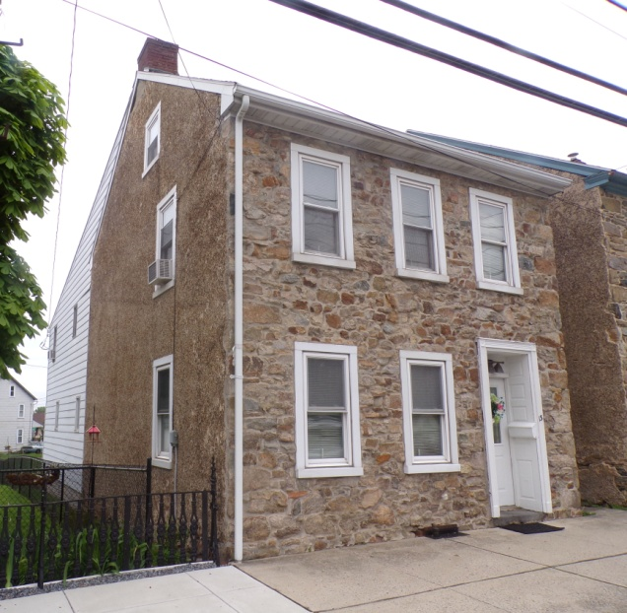

Real Estate Auction
Tuesday, June 25, 2019 @6:00 PM
OFFERED BY Leon J. Lichtenwalner &
Constance Lichtenwalner

OPEN HOUSES:
Thursday, June 13 from 4-6 PM &
Thursday, June 20 from 4-6 PM

13 W. Main Street * Macungie, PA 18062-1118
Municipality – Borough of Macungie Zoning – Residential
County – Lehigh Land Use Code - Single Family Detached School District – East Penn Homestead Act 72 – 12/01/2004; 1/01/2007
Improvements – Single Family 4 Bedroom Stone House, Year Built – circa 1854
w/Later Addition, Full Basement Total Taxes $ 3,585.91
Lot Size – 0.09469 +/- Acres (4125 Square Feet) County $ 527.07
Parcel No. – 547388357546 1 Municipal/Township $ 567.62
School $ 2,491.22
HOUSE
Construction – 2½ story 19th C stone farmhouse Electric – 200 amp circuit breaker panel
w/later addition, total of 4 bedrooms; w/sub panel
asphalt shingle roof, aluminum fascia/ Heat – Oil / Hot Water
soffits, gutters & downspouts; Original Central Air - No
house w/fieldstone foundation walls, Roof – Asphalt Shingle
concrete/pebble/stone siding, aluminum Water - Public
clad replaced double hung windows; Septic - Public
Later Addition w/cinder block foundation
walls, concrete floor, aluminum clapboard
siding, wooden double hung windows

ORIGINAL HOUSE LATER ADDITON
First Floor First Floor
Room Size Room Size
Living Room (L-shaped) 16’9” x 23’10” x 13’6” Kitchen/Eating Area 17’2” x 19’3” x 6’ (L shaped)
Laundry Room 5’7” x 6’
Second Floor Size Powder Room 4’5” x 5’7”
Room Second Floor
Front Bedroom 4’11” x 5’2” (w/closet) Room
Middle Bedroom 4’8” x 6’ (w/walk-in closet) Hallway 3’ x 14’10”
Middle Bedroom 9’4” x 10’6”
Third Floor – Unfinished attic storage w/old Back Main Bedroom 10’1” x 16’11” x 8’2”
subflooring Full Bathroom 9’2” x 4’11”
Hallway to Spiral Staircase 3’ x 5’9”
BASEMENT - fieldstone foundation walls
17’ x 23’9”
REMARKS- House
Interior: Original House Interior: Later Addition
lst Floor lst Floor
. Large spacious living room, L-shaped w/wood paneling . Kitchen/Eating Area, L-shaped w/drywall, rear bay window,
. Wall to wall carpeting crank out casement windows, partial vinyl flooring w/wall to wall
. Tile ceiling carpet in eating area, Spectra 4 burner electric range w/glass
. Door leading to basement stairway top, Rangemaster hood, Siemens HydraSensor automatic
. Wagon wheel hanging lamp dishwasher, stainless steel double basin sink, birch cabinets,
. Coat closet Formica top counters, steel spiral stairway to 2nd floor, door to
. Rustic beam archway sidewalk
. Original deep window sills . Laundry Room w/louvered doors
. Stairway to second floor w/wall to wall carpeting . Powder Room w/single basin sink-Corian type w/oak cabinet
base, wall to wall carpet
2nd Floor . Coat Closet
. Front Bedroom: wood paneling, gray finish, wall to wall
carpeting, open walk-in closet, deep window sills, drop 2nd Floor
ceiling w/large tiles . Hallway w/drywall, wall to wall carpeting, coat closet
. Middle Bedroom off stairway: partial original fieldstone . Middle Bedroom: drywall, wall to wall carpeting, no closet
& wood paneling, wall to wall carpeting, ceiling fan, drop . Full Bathroom: vintage green fixtures, single basin sink
ceiling, built-in shelving, walk-in closet, access to attic; w/Formica top counter & cabinet base, vinyl flooring,
currently used as an office tub/shower, drywall, ceiling ventilation fane
. Back Main Bedroom: L-shaped, drywall, wall to wall carpeting,
3rd Floor double hung windows, large closet w/sliding doors, small closet
. Unfinished Attic Storage w/old subflooring, opening . Hallway to spiral staircase
to attic area in new addition
Basement
Basement . Cinder block foundation walls, concrete floor, rear entrance
. Original fieldstone foundation walls, dirt floor, wooden w/Bilco floors
steps to living room . 200 Amp circuit breaker panel w/sub panel in original basement
. New Yorker oil fired furnace, Model FR-122-WP,
SN-64253403 Exterior: Later Addition
. 275 gallon fuel oil tank . Aluminum clapboard siding
. Circuit breaker sub panel . Wooden double hung windows, not clad
. Rear bay window
Exterior: Original House . Rear concrete patio/deck
. Original fieldstone front . Bilco doors to basement
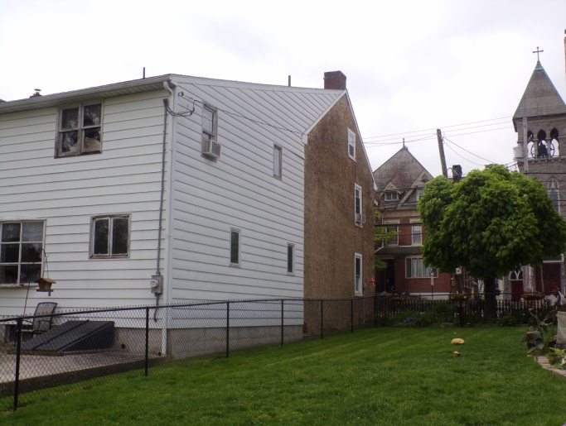
. Concrete w/pebble/stone sides . Small backyard lawn area leading to Miller Street
. Original doorway w/raised panels & classic molding
. Replaced double hung windows, aluminum clad
(approx. 25 years)
. Aluminum fascia/soffits, gutters & downspouts
. Asphalt shingle roof
. Front & side concrete sidewalks
. Steel front door
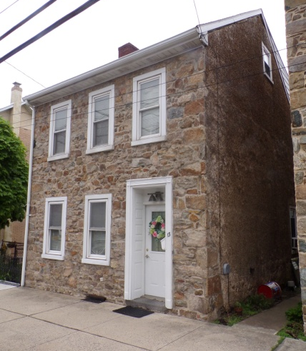
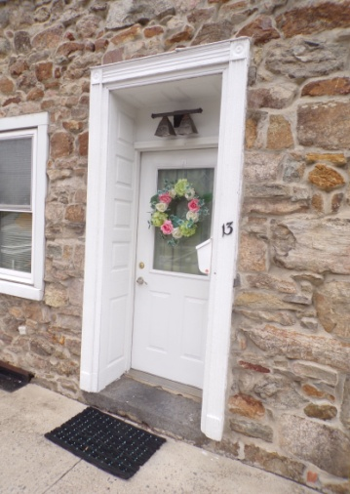

**Semi Permanent Storage Shed NOT included in auction**
Terms: 10% day of sale
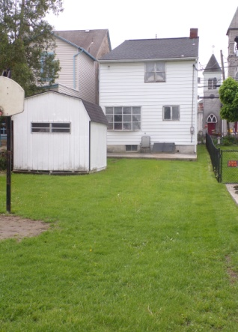
Settlement 60 days.
Robert H. Clinton & Company, Inc. The information herein was
Auctioneers & Appraisers obtained from reliable
P.O. Box 29 * Ottsville, PA 18942 sources and is for
610-847-5432 * AY000093-L * advertising purposes only.
website: www.rhclintonauction.com Accuracy cannot be
In cooperation w/Somers Auctioneering, AU-003981-L guaranteed.

