PUBLIC AUCTION – ON PREMISES
REAL ESTATE & PERSONAL PROPERTY
Lower Mount Bethel Township
Martins Creek, PA 18063
Two Single Family Homes & Outbuildings
on 1.0 +/- Acres

Tuesday, August 24, 2021 @4:00 PM
Real Estate Offered at 6:00 PM
For The Estate of Eva Mary DiLorenzo, Dec’d.
Ordered By the Estate’s Co-Executrixes

6686 & 6696 School Street, Martins Creek, PA 18063

OPEN HOUSES:
Tuesday, August 3 from 4-7 PM
Wednesday, August 11 from 4-7 PM
Sunday, August 15 from 1-3 PM
Personal Property Begins @4:00 PM
to include Vintage Advertising
Items, Variety of Small Collectibles,
Primitives & Furniture, Etc.

Municipality – Lower Mt Bethel Township Zoning – Residential
County – Northampton Land Use Code - Single Family, Residential
School District – Easton Year Built – Dwelling #1 – ca. 1956
Improvements – Two Single Family Homes Year Built – Dwelling #2 - Unknown
& Outbuildings Total Taxes $ 6,104.29
Lot Size – 1 +/- Acres County $ 881.34
Parcel No. – H10NW1 8 4 0317 Municipal/Township $ 346.29
Deed Book - 369/ Page Nos. – 288, 289, 290 School $ 4,440.66
Street Light (Twp.) $ 66.00
Sanitation Fee (Twp.) $ 370.00

HOUSE – Dwelling #1: 6686 School Street HOUSE – Dwelling #2: 6696 School Street
Note: This house is currently rented & occupied
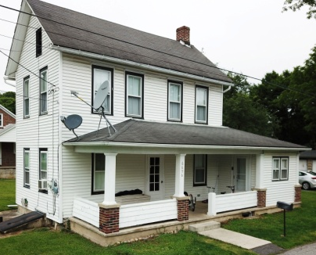
Construction – 1 ½ story frame house w/red brick Construction – 2 ½ story
siding, 4 bedrooms on first floor, 2 additional bedrooms
late Victorian frame
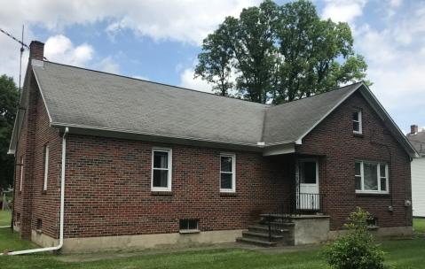
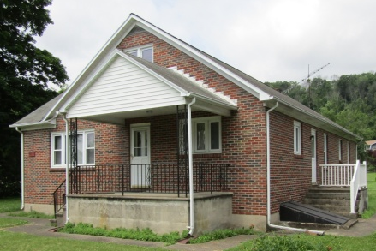
on partially unfinished second floor, 1 full bathroom,
house, 3 bedrooms,
asphalt shingle roof,
1 ½ bathrooms, asphalt
aluminum gutters &
shingle roof, older style
downspouts, replacement double hung windows,
windows & doors, cinder aluminum gutters &
block foundation walls,
downspouts, updated
basement w/concrete
vinyl clapboard siding,
floor, front, side & rear
fieldstone foundation
entrances walls, front porch w/overhang & columns
Electric- updated Electric - updated
circuit breaker panel
circuit breaker panel
Heat – Oil / Hot Water
Heat – Oil / Hot Water
Central Air - No
Central Air - No
Roof – Asphalt Shingle
Roof – Asphalt Shingle
Water – Onsite well
Water – Onsite well
well services both dwellings
well services both dwellings
Septic – Onsite
Septic - Onsite
Dwelling #1: 6686 School Street Dwelling #2: 6696 School Street
First Floor First Floor
Room Size Room Size
Living Room 18’4” x 18’6” Kitchen 13’1” x 23’1”
Kitchen 12’9” x 15’5” Dining Room (Office) 10’9” x 15’1”
1st Bedroom on Right 12’4” x 10’7” Laundry Area 8’4” x 8’11”
2nd Bedroom on Right 12’4” x 13’ Full Bathroom 4’9” x 8’3”
1st Bedroom on Left 12’4” x 11’2” “Mud Room” 7’7” x 4’1”
2nd Bedroom on Left 12’19” x 12’4” Living Room (ceiling 8’8”) 10’10” x 15’3”
Full Bathroom 12’3” x 6’11” x 4’5”
Hallway 25’4” x 3’
Closet w/Toilet Fixture
Second Floor – Partially Unfinished Second Floor
Room Room Size
Landing 5’2” x 7’ Bedroom to Left of Stairs 15’2” x 10’9”
Bedroom to Left of Stairs 10’11” x 13’3” x 22” Bedroom to Right of Stars 10’9” x 15’4”
Middle Room 17’10” x 10’11” Back Bedroom 9’10” x 8’4”
Far Bedroom to Right Powder Room 4’10” x 4’
of Stairs 10’11” x 13’2”
Unfinished Eaves Storage Unfinished Attic
L-shaped Basement 35’4” x 50’ x 72” Full Basement w/Partition Walls
REMARKS: REMARKS:
Dwelling #1: 6686 School St. Dwelling #2: 6696 School St.
Interior: Interior:
. Drywall, hardwood floors, cast iron baseboard heat . Combination of wallboard & plaster walls, cast iron radiators
throughout; original wooden kitchen cabinets, doors, later remodeling in various room throughout
moldings & valances 1st Floor
1st Floor . Kitchen w/newer wooden finish cabinets, Formica countertop, . . Living room w/double door sliding closet, backyard double stainless steel sink, parquet style floor
access . Dining room (currently being used as office/playroom),
. Kitchen w/original classic 1950’s yellow & black tile laminated style flooring, ceiling fixture, access to basement
linoleum floor & L-shaped countertop, stainless steel . Laundry area w/washer/dryer hookup, closet, window
double sink, veneered wooden cabinets, newer . Full bathroom off laundry room w/replaced tub/shower, ceiling
stainless steel Kenmore Elite electric stove w/5 burner fixture w/vent
glass top, self cleaning oven . “Mud” room off laundry w/concrete floor, plywood ceiling,
. 1st Bedroom on right w/sliding double door closet doorway to side yard
w/hookup for washer/dryer, single window & ceiling . Small entry area w/vintage Victorian door & original molding
light . Center staircase
. 2nd Bedroom on right w/sliding closet doors, 2 windows 2nd Floor
ceiling fixture . Bedroom to left of stairs w/laminated style flooring, closet
. 1st Bedroom on left w/sliding double door closet, single (4) windows, ceiling fixture w/fan
window, ceiling light . Bedroom to right of stair w/laminated style flooring, closet,
. 2nd Bedroom on left w/sliding double door closet, (4) windows, ceiling fixture, access to attic
2 windows . Back bedroom w/2 windows, ceiling fixture
. Full Bathroom w/original pink & black tile, linoleum . Powder room w/newer tile floor, replaced fixtures & window
floor, cast iron tub, porcelain single sink on chrome Basement
legs, linen closet . Fieldstone foundation walls, dirt/stone floor, outside exit
. Hallway w/basement access, storage closet, closet w/Bilco doors
w/toilet fixture at end of hallway . Updated circuit breaker panel
2nd Floor . Weil McLain Model P468-HT oil fired furnace, 151000 BTU,
. Partially unfinished serviced 12-8-2020; (2) fuel oil tanks
. Landing w/linoleum floor, opens to attic storage
. L-Shaped Bedroom to left of stars w/linoleum floor, Exterior
closet, ceiling fixture, single window . Frame construction w/replaced vinyl clapboard siding
. Middle room to immediate right of stairs w/subflooring, . Asphalt shingle roof
open eaves, unfinished . Aluminum gutters & downspouts
. 2nd Bedroom to far right of stairs, w/windows, . Older style double hung windows
Basement . Front concrete porch w/overhang & columns
. Spacious full L-shaped area w/cinder block foundation
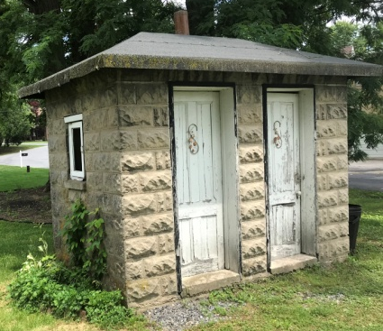
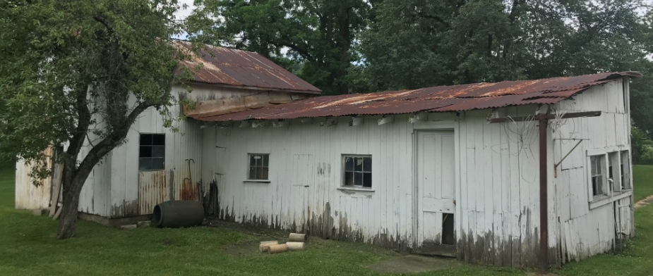
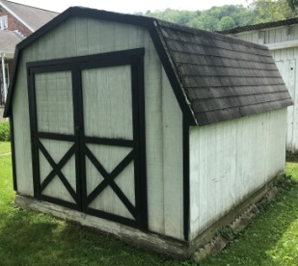
walls, concrete floor, outside exit w/Bilco door to side Outbuildings
yard, 2 main I-beam steel girder supports & steel
columns
. Small wine/cool cellar w/dirt floor-7’4” x 12’10”
. Hook-ups for work shower, sink & toilet
. Updated circuit breaker panel
. Weil McLain Model Gold P-Wt90-4 oil fire furnace
serviced 12-20-2017 .
. 275 gallon fuel oil tank
Exterior
. Frame construction w/brick siding
. Asphalt shingle roof
. Aluminum fascia/soffits, gutters & downspouts
. Replacement double hung windows & doors
throughout
. Front door entry to living room w/concrete landing & overhang, wrought iron railings
. Side door entry to kitchen w/concrete porch
& overhang, wrought iron rails
. Back door entry to kitchen w/concrete landing 2 Car Detached Garage – 24’ W x 30’ L
. Concrete walk from driveway to dwelling . Cinder block foundation walls, concrete floor, metal roof,
. Gravel driveway partial metal exterior siding, 2 aluminum overhead doors w/Genie electric openers
Terms: 10% Day of Sale * Settlement 45 days. L-Shaped Frame Barn/Chicken House–20’ D x 46’6” W x 12’6”
. Wood & partial galvanized tin siding, galvanized tin roof,
Robert H. Clinton & Company, Inc. concrete floor, steps to partial 2nd floor, original unrestored
Auctioneers & Appraisers condition
P.O. Box 29 * Ottsville, PA 18942 Stone Building w/Interior Brick Oven & Root
610-847-5432 * AY000093-L Cellar – 6’6” x 11’3”
www.auctionzip.com, Auctioneer #1888 . Outdoor oven/cook house w/root cellar, asphalt shingle roof, 2
or www.rhclintonauction.com doors, 2 windows
In cooperation w/Somers Auctioneering, Inc. AU-003981-L Semi Permanent Detached Storage Shed – 10’ x 12’ www.auctionzip.com, Auctioneer 5475; 484-375-8410 . T-111 siding w/asphalt shingle hip roof, 2 double doors
overhang, wrought iron railing
The information herein was obtained from reliable
sources and is for advertising purposes only.
Accuracy cannot be guaranteed
