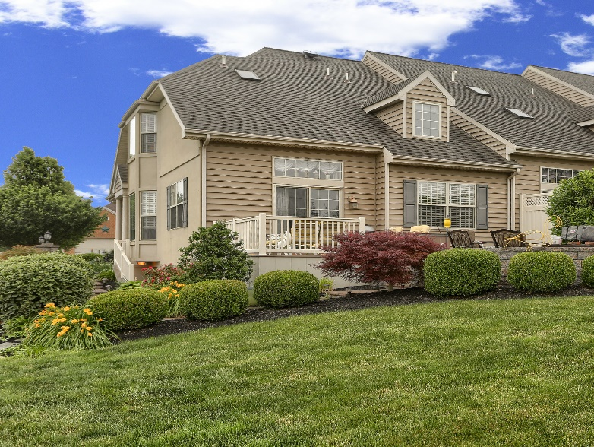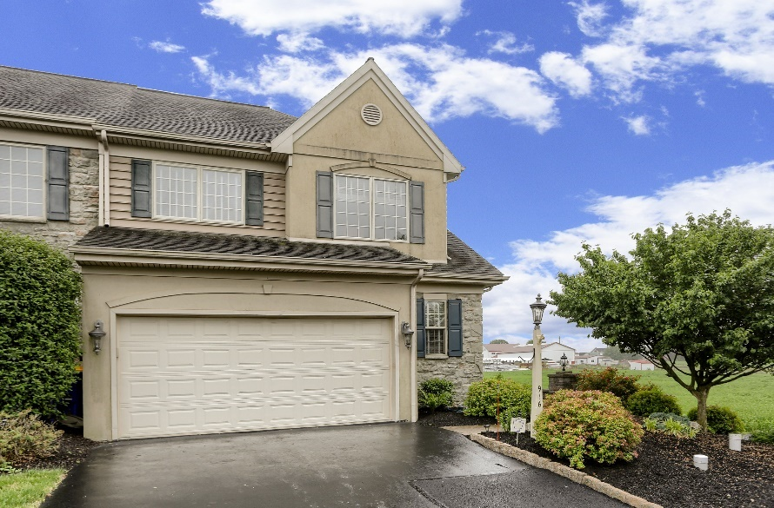

PUBLIC REAL ESTATE AUCTION
3 Bedrooms, 3 Full Bathrooms, First Floor Laundry 1/2 Bathroom,
1900 sq. ft., Additional 800 sq. ft. Finished Basement In Law Quarters
THURSDAY, JULY 22nd, 2021, 6:00 p.m.
This end of row town house, currently owned by the Lowell R. Roth Estate, has been highly sought after by many for its spacious, open floor plan, and exquisitely rich interior decorating, as well as its prime location looking west with an unobstructed view of rolling Lancaster Co. farm fields.
Special and untypical features of the townhouse compared to others within the same development include a modified floorplan that expands the already large, vaulted ceiling living room. The originally planned first floor master bedroom was converted into the living room expansion and can easily be reconverted to a large master bedroom with existing master bathroom. Other features include 1st floor laundry room, large deck and patio, finished basement with separate entrance and emergency egress, 3rd bedroom and second full kitchen in basement, 2nd floor loft overlooking living room, custom kitchen cabinetry with stone countertops with full appliances, and oversized attached garage. Gas hot water heat, central forced air HVAC, Gas and electric kitchen stoves, Mature landscaping and much more.
Take a look at this MUST SEE property and you will Want to OWN it!!!!
Zoned Residential R-1, Taxes approximately $3,300.
916 WALNUT ST., NEW HOLLAND, PA 17557
WINDING OAKS DEVELOPMENT, EARL TWP, LANCASTER CO.
Go to www.pmorganauctions.com for Large Photo Gallery and Details
SHOWN BY APPOINTMENT ONLY….CALL Patrick Morgan @ 717-278-9202
Real Estate Terms: 10% down payment on day of sale, Good PA check or Certified Funds for out of state buyers. Settlement within 45 days, immediate settlement and possession available. Real Estate is being sold as/is and subject to purchaser's sole discretion of value and condition. All announcements made at time of auction take precedence over any and all previously printed material or verbal statements.
Home is located in the Winding Oaks Homeowner Assoc. Special occupancy terms and bylaws apply to all buyers.
HOA Manager Donna Ward 717-354-8546
La
Mmm
Terms By
Estate of Lowell R. Roth;
Executor Jeffery Shirk,
Atty: Kling & Deibler,
New Holland, Pa.
717-354-7700

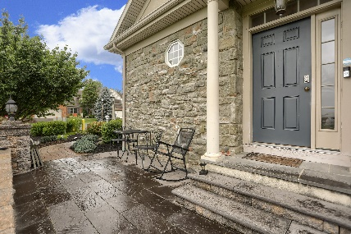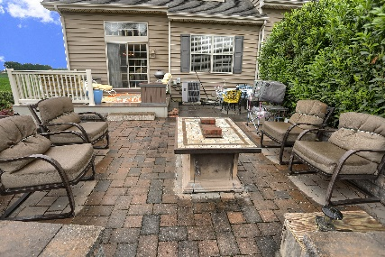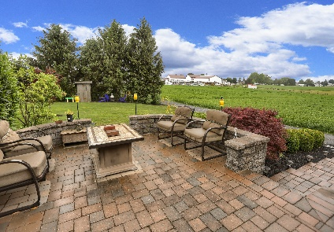

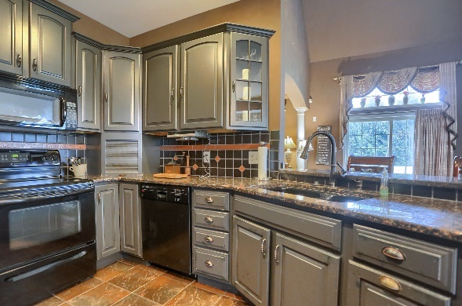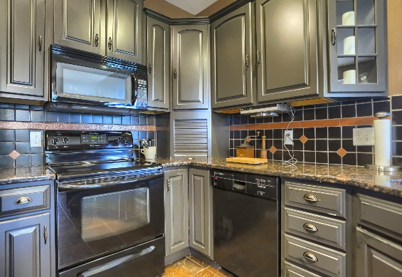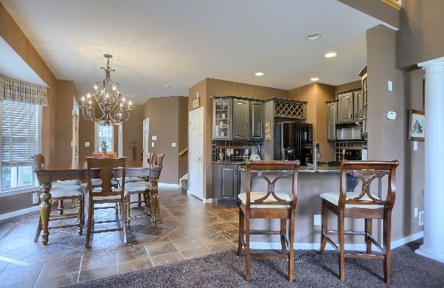

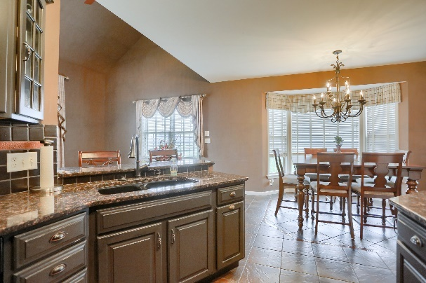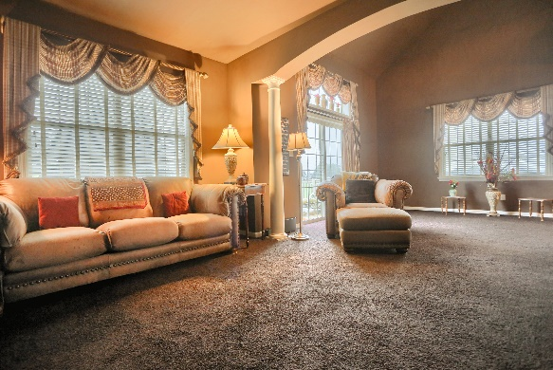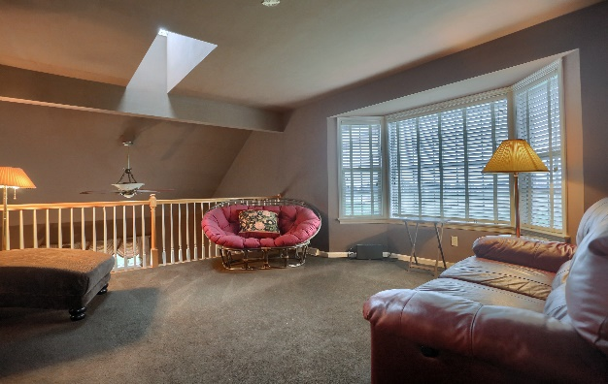

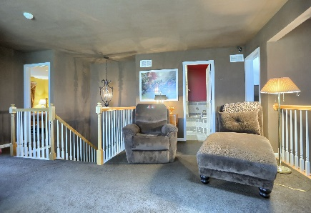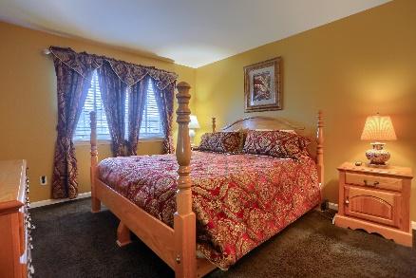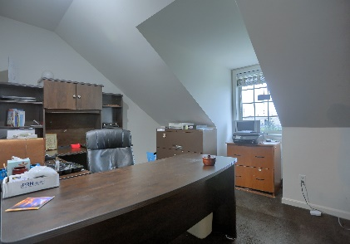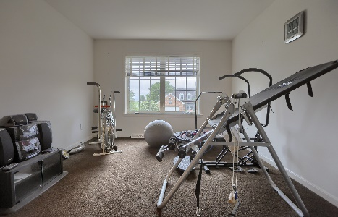

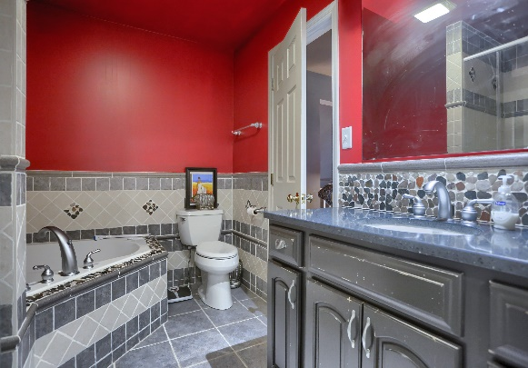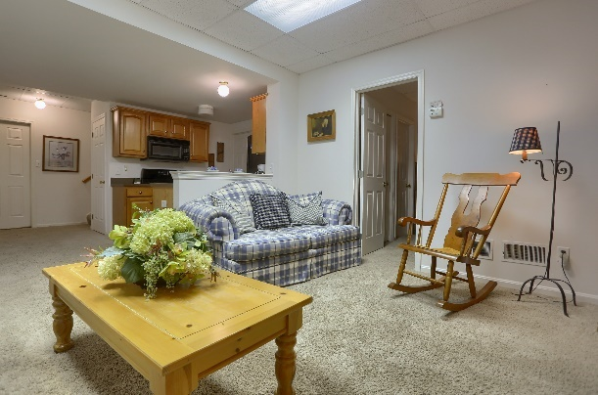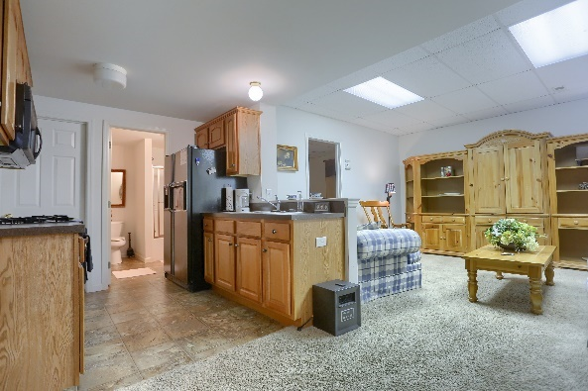

PUBLIC REAL ESTATE AUCTION
ESTATE of LOWELL R. ROTH
THURSDAY, JULY 22nd, 2021, 6:00 p.m.
916 WALNUT ST., NEW HOLLAND, PA 17557

LARGE PHOTO GALLERY and MORE DETAILS at www.pmorganauctions.com

