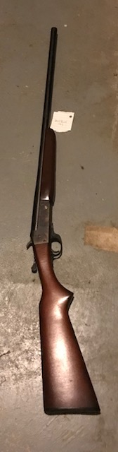
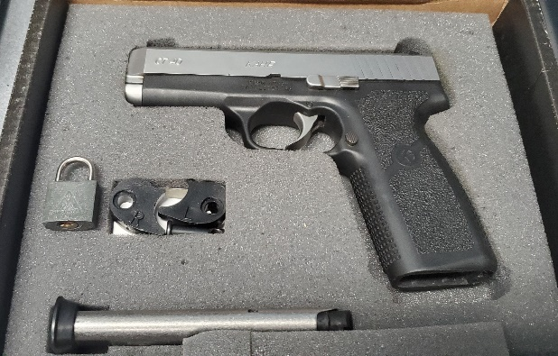
LIQUIDATION
PUBLIC AUCTION
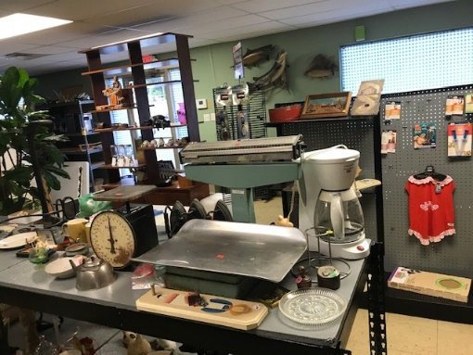
Formerly Pigg’s Pet!
A rare collection of personal and store liquidation
Too much to list, see pics!!!
Saturday, October 3, 2020 * 11 a.m.
Sale Site: 1710 West Osage ~ Pacific, MO
GUNS COINS FURNITURE JEWERLY SPORTING GOODS TOOLS MISCELLANEOUS
APARTMENT DRYER WHEEL CHAIR’S PET SUPPLIES DOLLS PORTABLE SHED SODA MACHINE
ICE BOX CONCRETE LAWN ORANMITS RARE ALBINO DEER HEAD RAM HEADS DEER HORNS FISH MOUNTS DISPLAY CASES CASH REGISTER JEEP WENCH FISHING EQUIPMENT STORE RACKS/SHELVES STORE FIXTURES
WE ARE JUST BEGINNING TO SET UP SO THIS IS A VERY PARTIAL LISTING. FOR FULL LISTING & PICTURES SEE AUCTIONZIP.COM ID#3477116
TERMS: Announcements day of the sale supersede all previously advertised announcements. No item shall be removed until settled for. All items are sold “As Is, Where Is” with no warranties. Auction staff are not responsible for accidents.
SILVER DOLLAR AUCTION LARRY MUELLER, AUCTIONEER
FOR MORE INFORMATION, CALL LARRY AT 314-210-7033
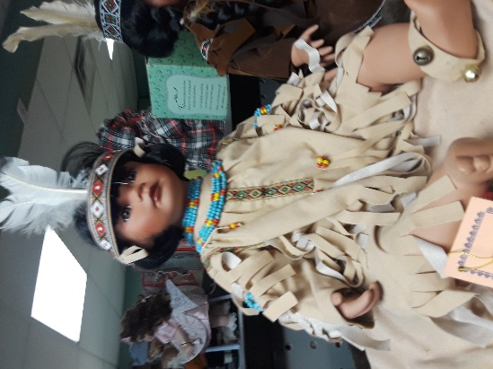
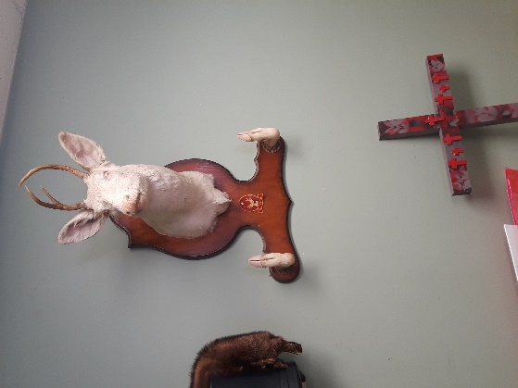
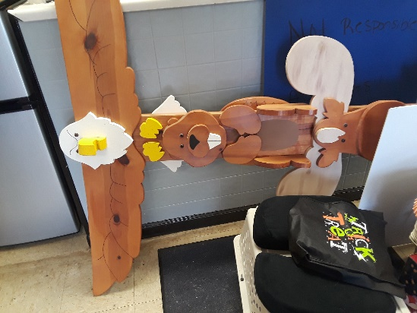
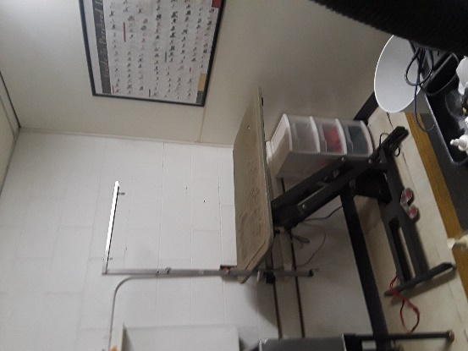
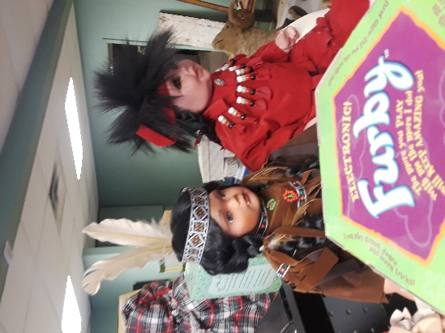

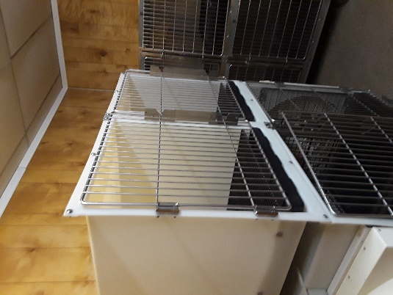
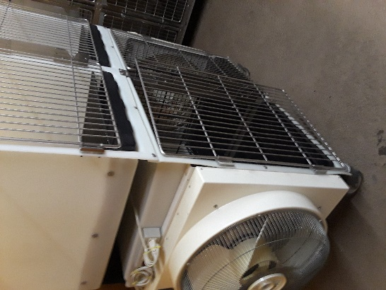
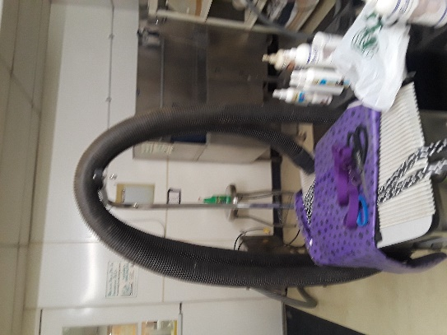
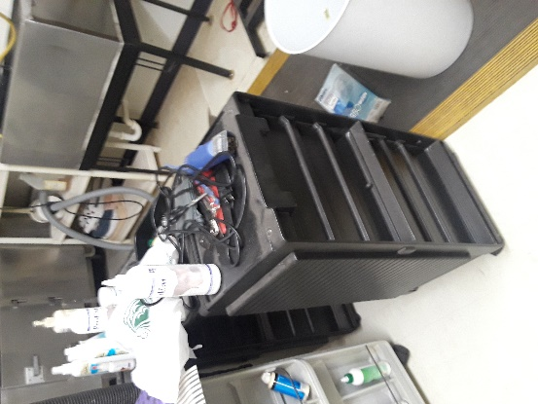
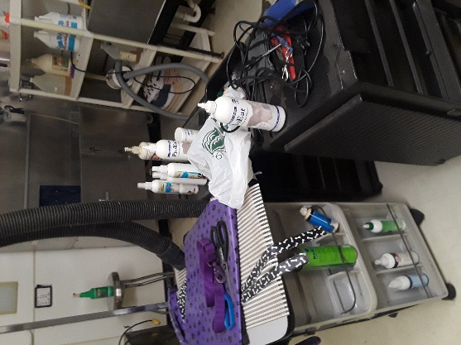

0

