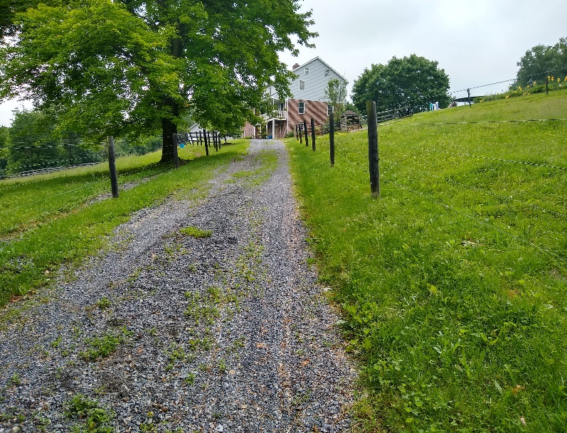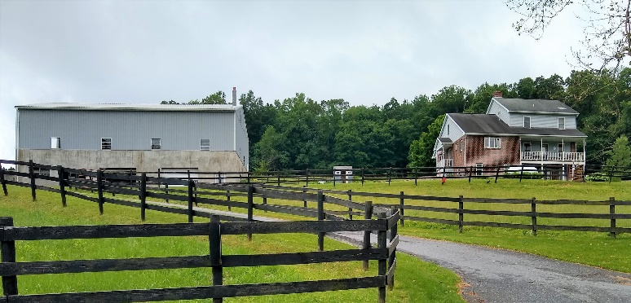

**Public Auction: 2 Properties**

Parcel #1:11.6+/- Acre w/ 2 Story Home

Parcel #2: 1.8 Acres, Fenced w/ Pole Barn & Stream

Monday July 29, 2019 @ 6:30 P.M.

2440 Beaver Dam Road, Honey Brook, PA 19344

Chester County (Honey Brook Twp.)

**Description: (Parcel #1):**  11.6 acres w/ country-style two-story home w/ 2,400 sq. ft. living space. Eat-in kitchen w/ appliances, 23 ft. of oak kitchen cabinets, built-in pantry, living room (surrounded w/ windows), family room w/ oak chair rail, 5 bedrooms w/ master bedroom on the 1st floor, 2 full bathrooms, laundry in basement w/ chute from top 1st & 2nd floors, full walk-up attic, full basement w/ wood stove, aux. propane heat in kitchen. Low maintenance exterior w/ vinyl siding & brick, 3 porches. Amazing location in the country w/ outstanding views! Outbuildings:2 story masonry barn: (lower level- 30x70 w/ 3 horse stalls & shop area), (upper level- 40x70 w/ 7 horse stalls/horse barn/shop area). 6 x 8 chicken house w/ chain link fence area, 8 x 10 dog kennel w/ outdoor runs, pasture, stream, lawn, established garden area, on-site well & septic, 5 fenced pastures. Ideally located family spot w/ acreage. In Act 319/515. **Taxes: $5,542 +/- per yr.**

**(Parcel #2):** 1.8 acre (opposite main tract w/ buildings), 25 x 40 pole barn, fenced, stream, concrete pad, tobacco barn foundation, possible building lot, no existing perc test. Located minutes from Honey Brook, Parkesburg, Morgantown w/ easy access to Routs 10, 340 and PA Turnpike. In Act 319/515. **Taxes:** **$92.00 +/- per yr.**

**Open Houses:** Tuesday: July 9 & 16, 4-7 pm & Sat. July 13 & 20, 1-4 pm. For more information or to schedule a private showing, contact Elvin Stoltzfus at 610-333-5447.

**Terms:** $50,000 due day of auction. Buyer to pay 2% transfer taxes. Settlement on or before **October 25, 2019.**

**Attention Realtors:**  1% Broker Participation offered to Realtors who pre-register their buyers and who become successful bidder day of auction. Pre-registration forms & additional pictures are available on-line.

**For more information, pictures and forms go to:**

[www.beiler-campbellauctions.com](http://www.beiler-campbellauctions.com) or [www.auctionzip.com](http://www.auctionzip.com) or www.GoToAuction.com

**From Honey Brook, take 10 S to Beaver Dam Road, turn rt. Go appx. 1.1 miles. Property on corner of Lammey & Beaver Dam. Road.**

**Auctioneers:**

**Elvin Stoltzfus (610)-333-5447 AA #019514**

**Christ Taylor (717) 371-1915 AU# 005421**

**Sellers: Samuel K. & Naomi S. Zook**

**Attorney: Kling & Deibler** **(717) 354-7700**

**Attorney:**