# ESTATE FARM AUCTION

## SUNDAY, MARCH 24, 2024 * 12NOON * HUNTSVILLE, AR

### * ESTATE OF BOBBY SELF *

***DIRECTIONS:* FROM HINDSVILLE, AT JUNCTION OF 45 & 412, GO SOUTH ON FARMERS ROAD (CO. ROAD 7505). GO TO T, TURN RIGHT ON CO. ROAD 7615. GO TO 1143. LOG CABIN, FARM ON RIGHT THRU GATE. WATCH FOR AUCTION SIGNS. *1143 MADISON 7615***



# @ LARRY R WILLIAMS AUCTIONS

-FARM EQUIPMENT * CARS * TRAILER-

* Case 580-C backhoe w/bucket 6081hrs-LOOKS GOOD! (HAS RESERVE) * Bumper-pull 16’ stock trailer w/cut gate * Ford gas tractor w/front end loader 3750hrs. * 3pt 6’ box blade w/rippers * 3pt angle blade * 3pt rear spike * 18’ cattle guard * 2-sided creep feeder * 6’ Brush Hog for parts * 12’ long shop built hay feeder * 1971 Chevy car * (2) old 1950’s Studebakers to restore or parts * trailer frame * (2) hay rings * 10’ feed bunk * (2) 16’ wire panels * 10’ tube gate (LIKE NEW!) * driveline for Brush hog * top links * fence stretcher *

-ANTIQUES & COLLECTABLES-

* antique punch tin pie safe * Minnesota treadle sewing machine w/box top (NICE!) * #5 crock & (2) whiskey’s & bowl * HORSE DRAWN ITEMS: (2) Sickle mowers * plows * sickle mower w/cast iron seat * planter * harrow * cultivator * (2) wagon wheel hub lamps * old wood boom sprayer w/spoke wheels * push plow * old wood ladders * wood screen door * reel mower * misc. blacksmith items * galv. tub * (2) nail kegs * broad ax * old weed hook * barrel auger * owl figures * hand painted saw * tube-type radio * pheasant stuffed decoy * 5gal antique oil can * cast iron tea kettle & skillets * granite coffee pot * old tins * NICE cast iron clawfoot tub * kraut cutter * apple press * 1-gallon glass churn * blue jars * old oil lamps * elephant decanter * wood coffee sign * copper wall plaque old scales * red globe lantern * wood decorative box * hand corn planter * shoe laspe * grind rock * wooden ironing board * washboard shelf * old implement wheels * oval glass picture of man * wall hanging gun * Indian design blanket *

-TOOLS-

* (2) pancake air compressors * Campbell Hausfeld portable air compressor * (2) battery chargers (one on wheels) * Craftsman blower * drill bits * c-clamps * 14’ fiberglass ext. ladder * antique cement mixer *

-HOUSEHOLD & MISCELLANEOUS ITEMS-

* scrap metal * oils * misc. lumber * old tarps * large tow hook * planters * large stainless coffee pot * cooking utensils * small vanity desk * 4-drawer chest * Kenmore small chest freezer * farm scene wall plaque * bistro table & (2) chairs * G.E. fan on stand * old rugs * quilt rack * dropleaf table * bookshelf * maple easy chair * phono stereo in cabinet w/8 track * black leather button-tuft couch * maple dining table * cook-out pots & pans * wood wall phone * black metal mesh patio table & chairs * wood settee & (2) rockers on porch * metal lounge chair * (2) ladder back chairs * Troybilt mower (for parts) & others * park bench * (2) white mesh metal dining table & (4) chairs each * dump cart for mower * picnic table * propane cooker w/top shop built *

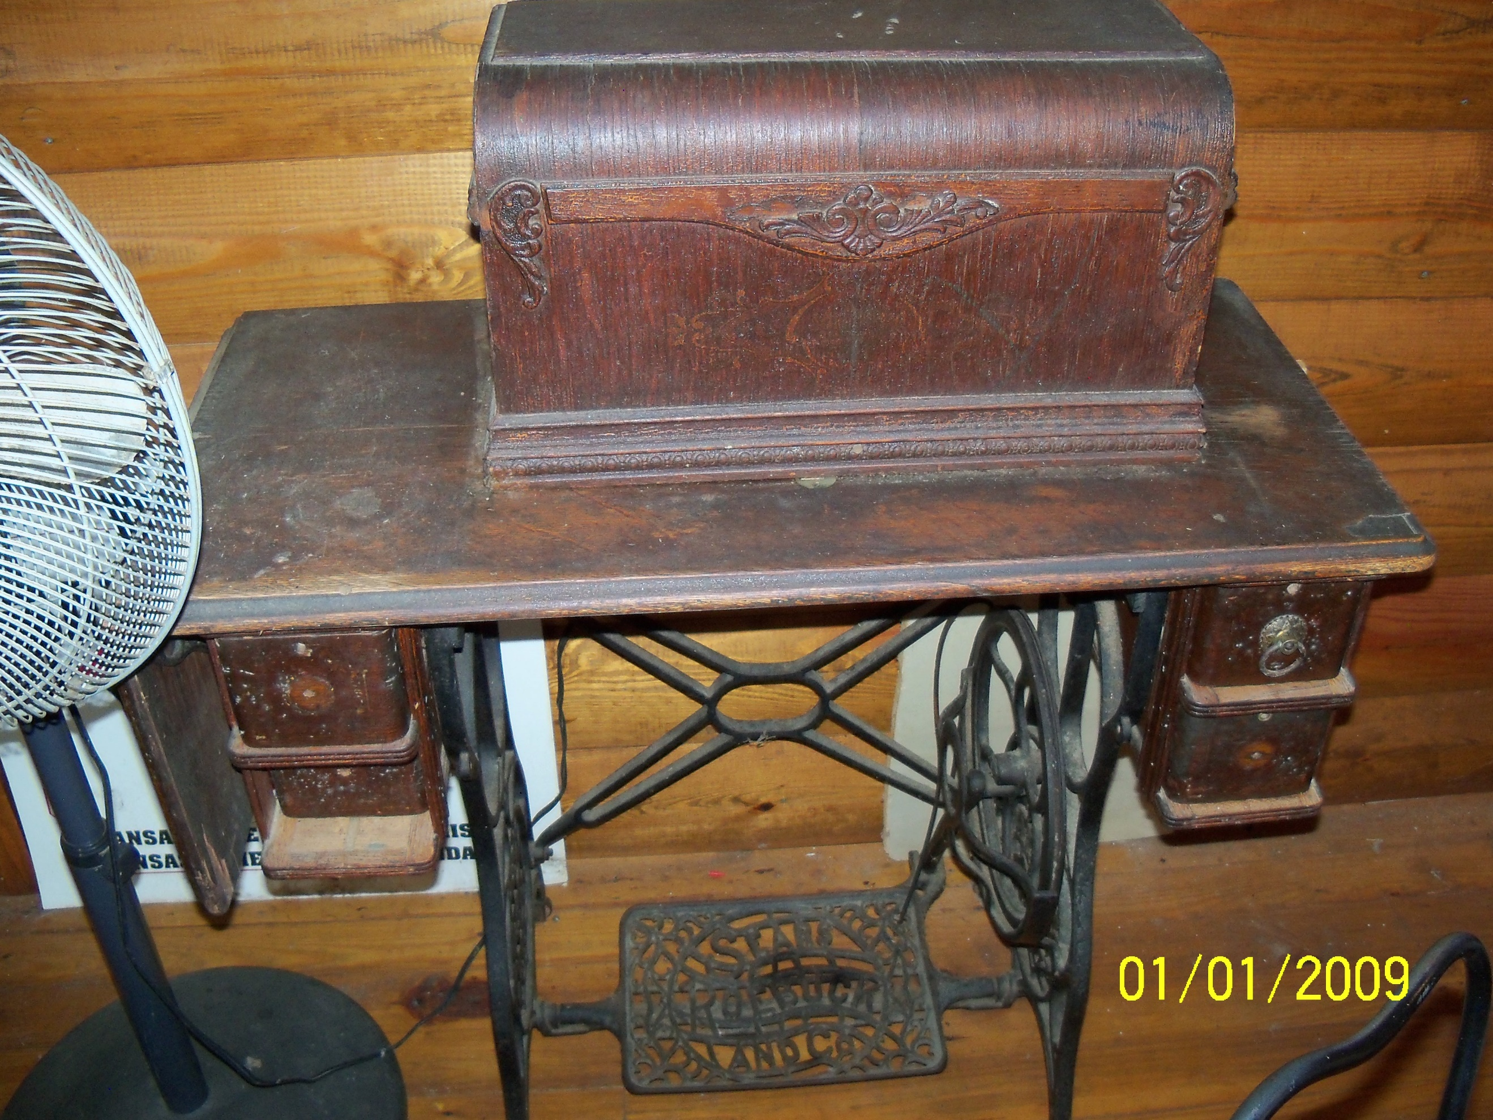

**AUCTIONEER’S NOTE:**  This is the 2nd auction for Mr. Self w/nice Case backhoe, Ford tractor, farm items, scrap metal, lots of nice antiques in the cabin & patio furniture outside. We will sell horse drawn equipment, small items & farm equipment at the barn, then drive up to the cabin for all items up there.

**TERMS & CONDITIONS: Cash or Check with Proper ID. Nothing Removed Until Settled For. Not Responsible for Accidents, Illness, Injury or Lost Articles. All Announcements Made Day of Sale Supersede All Previous Advertisements. All items Sold “AS IS”. Concession/Restrooms.**

**REAL ESTATE**

**FARM SALES**

**ESTATES, ANTIQUES**

**MACHINERY**

**LIQUIDATIONS**

**auctionzip.com #24078**

**gotoauction.com #4979**

**https://www.facebook.com/LarryRWilliamsAuctions**

***Large Tent and Display Wagons Available***

**Auctions by Larry R. Williams**

**Realtor * Auctioneer * Bonded * AR License #560**

**19847 Sonora Road, Springdale, AR 72764**

**479-756-0238, 479-466-2415**

The Auction Way Pays!

***Experienced Staff***

***Specializing in Personalized***

***“On- Site” Auctions***

***A Satisfied Customer, Our Best Advertisement!***

***Licensed w/Lazenby***

***Realty Group***

***Fayetteville, AR***

***CREDIT CARDS ACCEPTED***

***LIVING ESTATE AUCTION***

**MONDAY, NOV 6, 2023 * 3:30 P.M.**

**MR & MRS SCHINN * SPRINGDALE, AR**

**DIRECTIONS: TAKE HWY 412 E IN SPRINGDALE TO SONORA; TURN SOUTH ON SONORA ROAD; GO TO 19847 SONORA ROAD – THIRD PLACE ON THE RIGHT.**

__________________________________________________________________________________________________________