

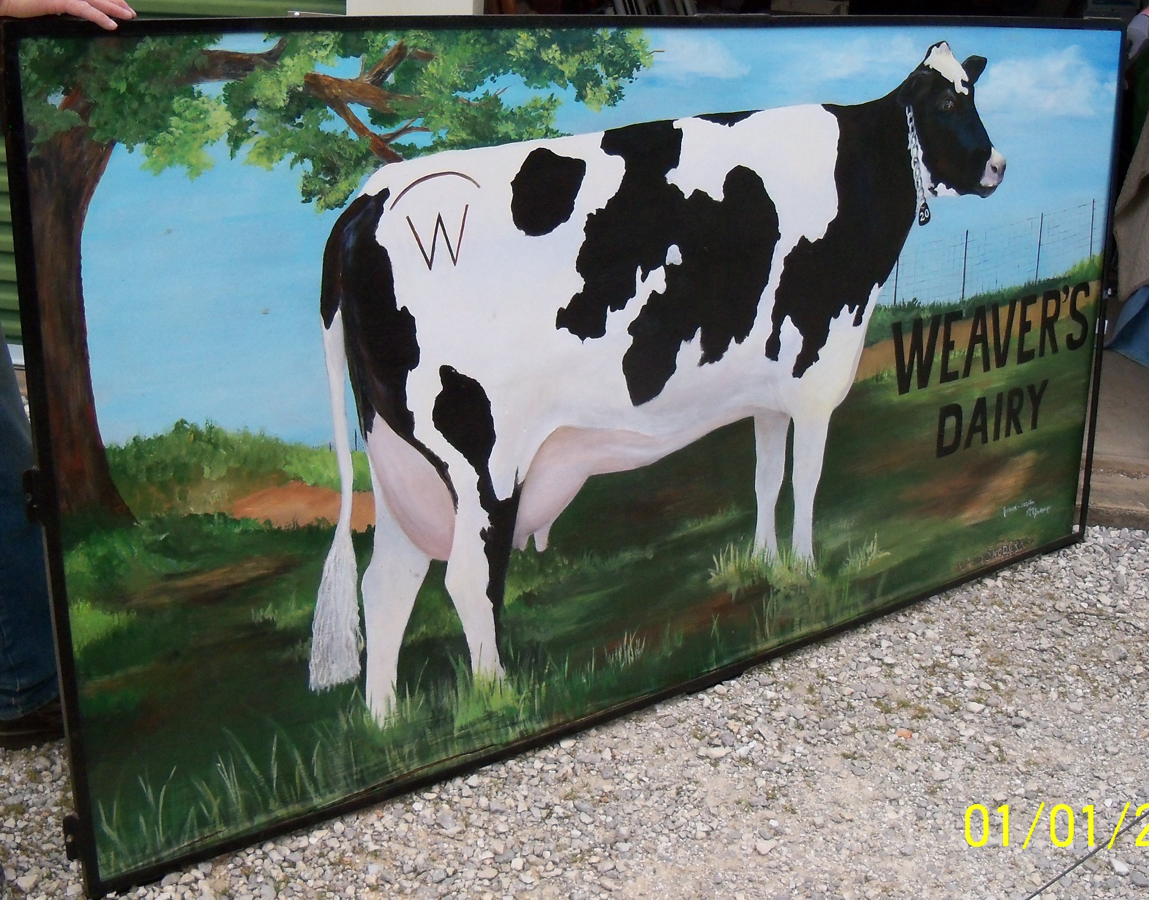 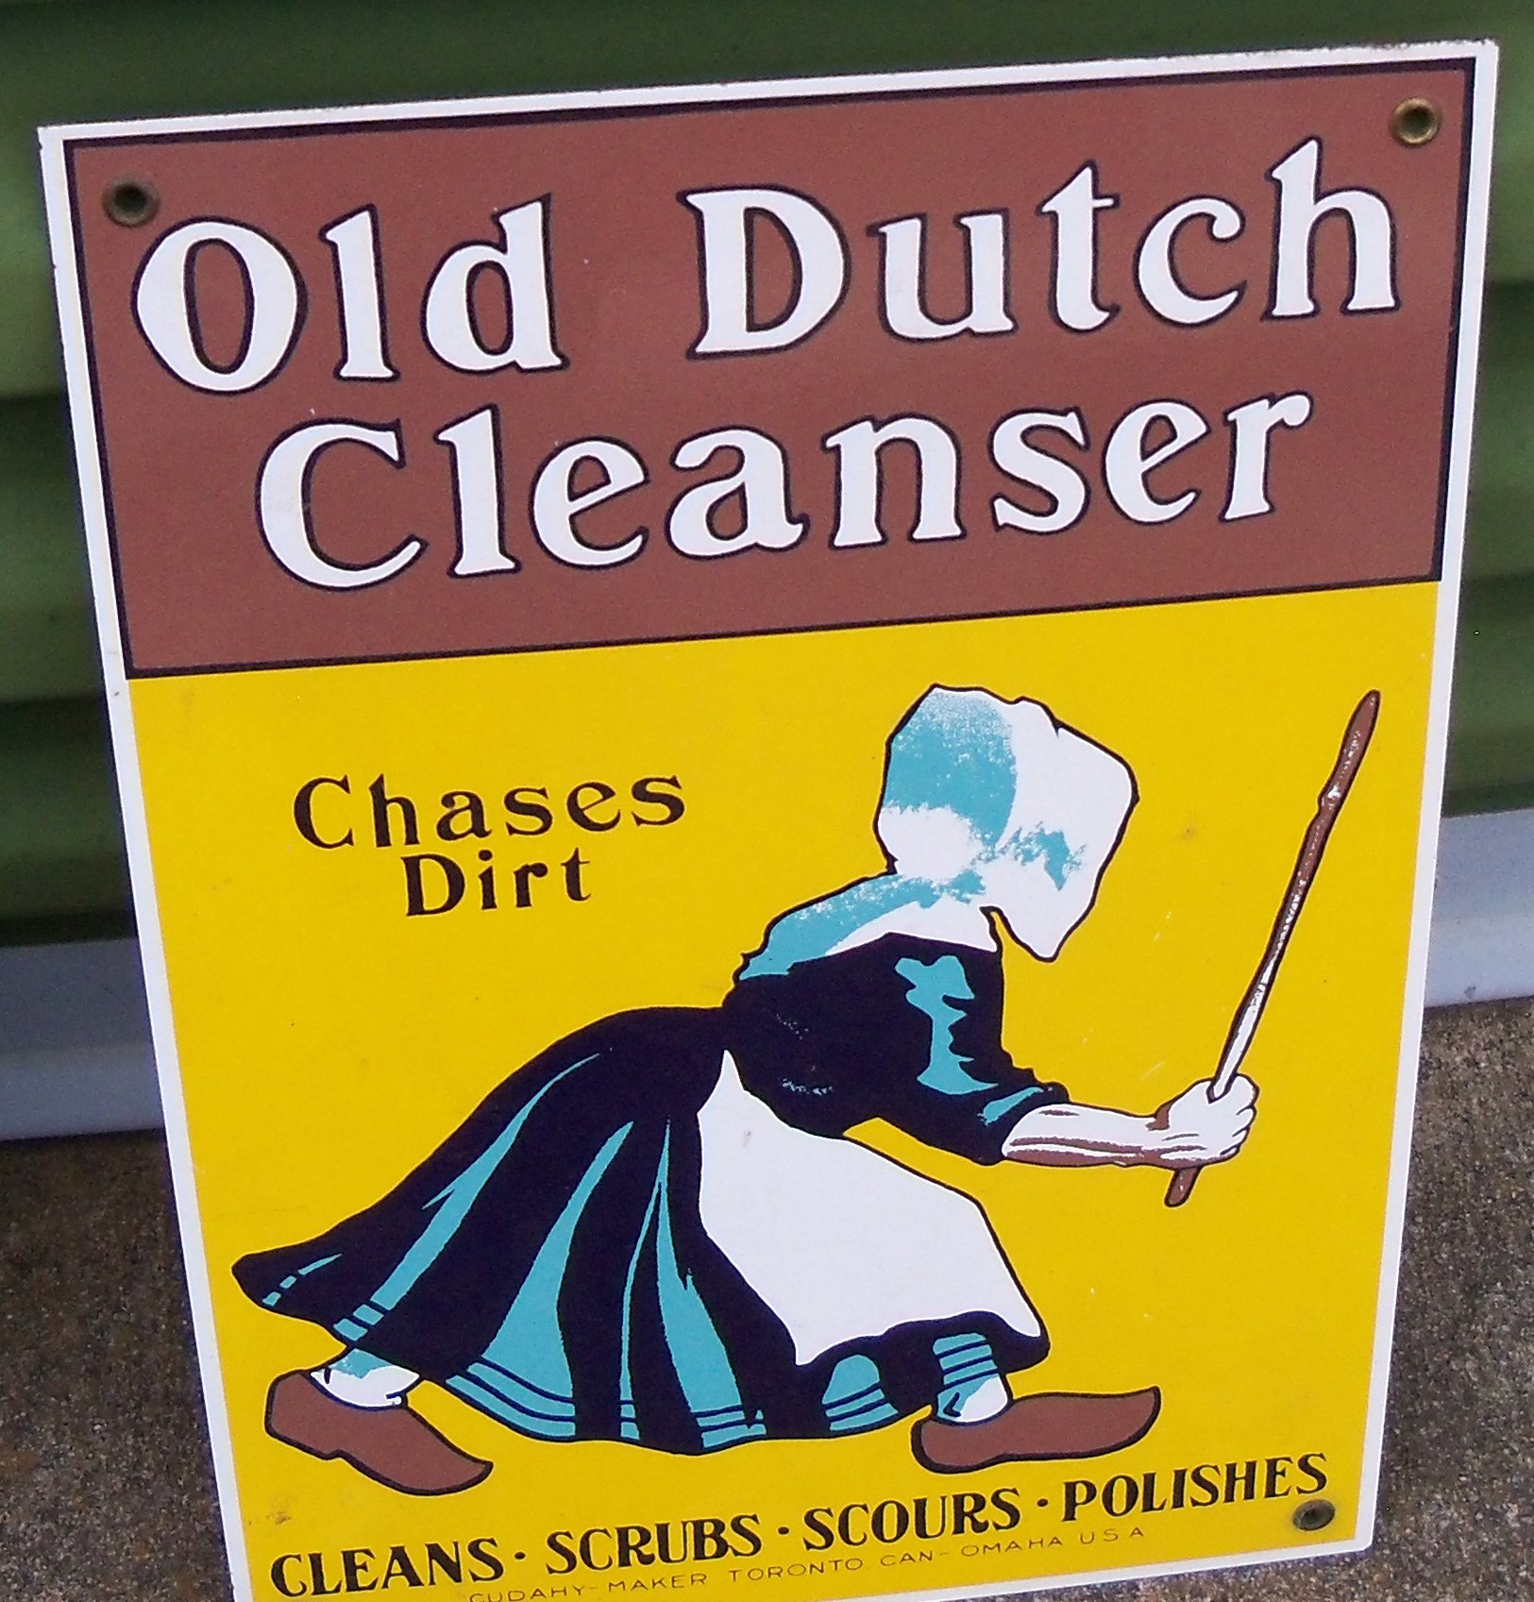 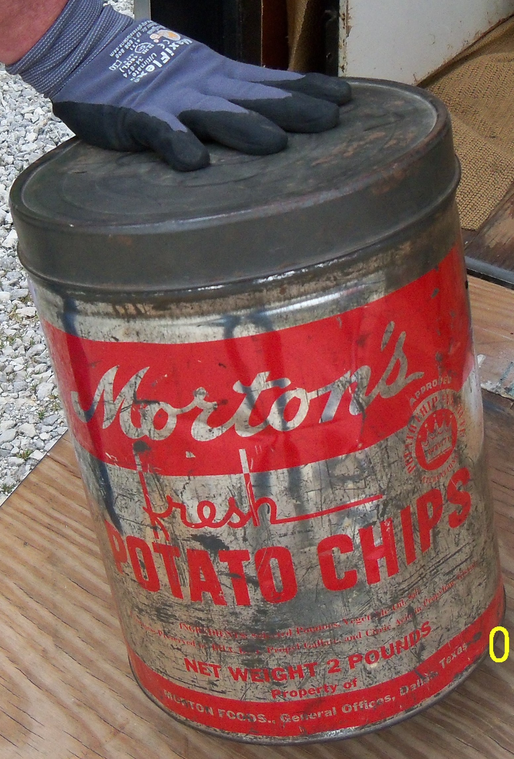

-FURNITURE – APPLIANCES-

* leather couch w/ cloth cushions * maple glider rocker * oval glass-top coffee & end tables * Bentwood rocker * (3) maple chairs * wicker settee * wood step-stool w/storage * buffet server * Bird’s Eye maple chair * French pro. lingerie chest * small maple desk * mahogany small desk w/leather top * Vizio TV *

-ANTIQUES & COLLECTABLES – OLD MONEY-

* old strawberry crates * small kerosene can * (3) barn lanterns * split-oak baskets * Atari game * Ducks Unlimited poster * galv. water bucket * metal lawn frog * Furby in box * camel saddle * **LOTS OF OLD METAL SIGNS:** Kodak * Holsum Bread * Ideal Bread * Trico * Makita * Southwestern Bell * Days Work * Trop Artic * Citgo & more * Staghorn coat rack * Model-T luggage rack holder * spring loaded hand washer * Sears, Roebuck & Co. wood wringer * tall Pepsi & Chevy thermometers * (2) general store paper racks * cast iron art deco tall ash tray * brass torches * cast iron tea kettle * old rugs * old kerosene tank w/ hand pump * several chalk clown heads England by L. Wright * old oil cans * sausage grinder * axle w/wire wheels * double oil lamp wall holders w/hardware * old National cash register * hand drills * old Singer sewing machine * (2) shoe laspe * advertising dust pan * old quilts * vintage house jacks * stamp albums * vintage Hamilton Beach malt maker * burlap adv. sacks * wood spools * baby wicker hamper * unique wicker picnic basket w/porcelain ref. dish & (2) Thermos’ * brace & bits * metal & wood spoke planes * very old small horse on metal wheels * large Penick Syrup can * Indian doll w/mink fur * porcelain ref. dish * 1950’s Coke tray * Model-A coils * sad irons * ice tongs * large Morton Potato Chip tin * cotton bats * German razor kit * lots of old porcelain dolls * white wicker baby bassinet w/metal wheels & lift-off top * old magazine rack wall hanger * several advertising tins * Buster Brown box * crosscut saw * large gold shadow box mirror 1958 * walnut bed * (2) iron beds w/rails * Hoosier-style kitchen cabinet top * Hoosier-style kitchen cabinet w/pull-out work table * 8’ wood Weavers Dairy sign w/Holstein cow *

*OLD MONEY: 1941-1958 wheat pennies – (4) rolls 2009 Lincoln – (4) rolls Jefferson nickels – (9) quarters – (7) Standing Liberty – (2) Barber quarters – (10) full-date Buffalo nickels – (13) Indian Head pennies – roll of steel pennies – (3) rolls Canadian cents – 2 ½ dimes 1858 & 1857 – (2) dimes 1854 & 1891 – 1964 & 1867 2-cent pieces – 1700’s 3 ½ cent pc – 1915 Cuba V-cents – 1933 New England 3-cent pc – (3) 1972 Eisenhower dollars – 1877 half dollar – 1871 silver Spain – 1878 silver – (3) Great Britain pennies 1935 & (2) 1945 – (4) rolls of wheat pennies (1920-1929) – 1976 2-dollar bill (has 1976 postage stamp on it)*

-GLASSWARE-

* hand-painted canister set * lots of moon & stars * teapot set * crystal vases & bowls * cobalt vases * salt & peppers * figurines * choppers * Franciscan Dinnerware * Seville Dinnerware * snack sets * local pottery * Fostoria * sandwich glass * pottery bowl w/lid * old syrup pitchers * Fenton basket * Alice in Wonderland plates *\* LARGE COLLECTION OF JEWEL T: Aladdin tea pot – cups & saucers - salt & pepper – water pitcher – cream pitchers – custards – gravy boats – mixing bowl set of 3 – lots of bowls – casserole – plates – platters (over 50 pcs)*

* large pottery pots * wash pitchers * Blakely Dinnerware SW design * cake plates * Mercury glass bowl * green jars * Venetian glass juicer & others * Shawnee platter * Tom & Jerry punch bowl w/cups *

-MISCELLANEOUS & SADDLES-

* flower pots * games * insect repellant * wind chimes * ribbon * picture frames * ladies shoes * camping * hunting clothes * poker chips in case * western belts * Scott’s seeder * tomato cages *

LARGE AMOUNT OF AMMO: 12GA * 16GA * 20GA * 30-30 * 225 * 270 WIN * 6MM * LOTS OF 22 *

*SADDLES: Black Pleasure saddle 15” * Wyeth 15” tooled saddle by Andy Gard, Shawnee, OK * High Back saddle \**

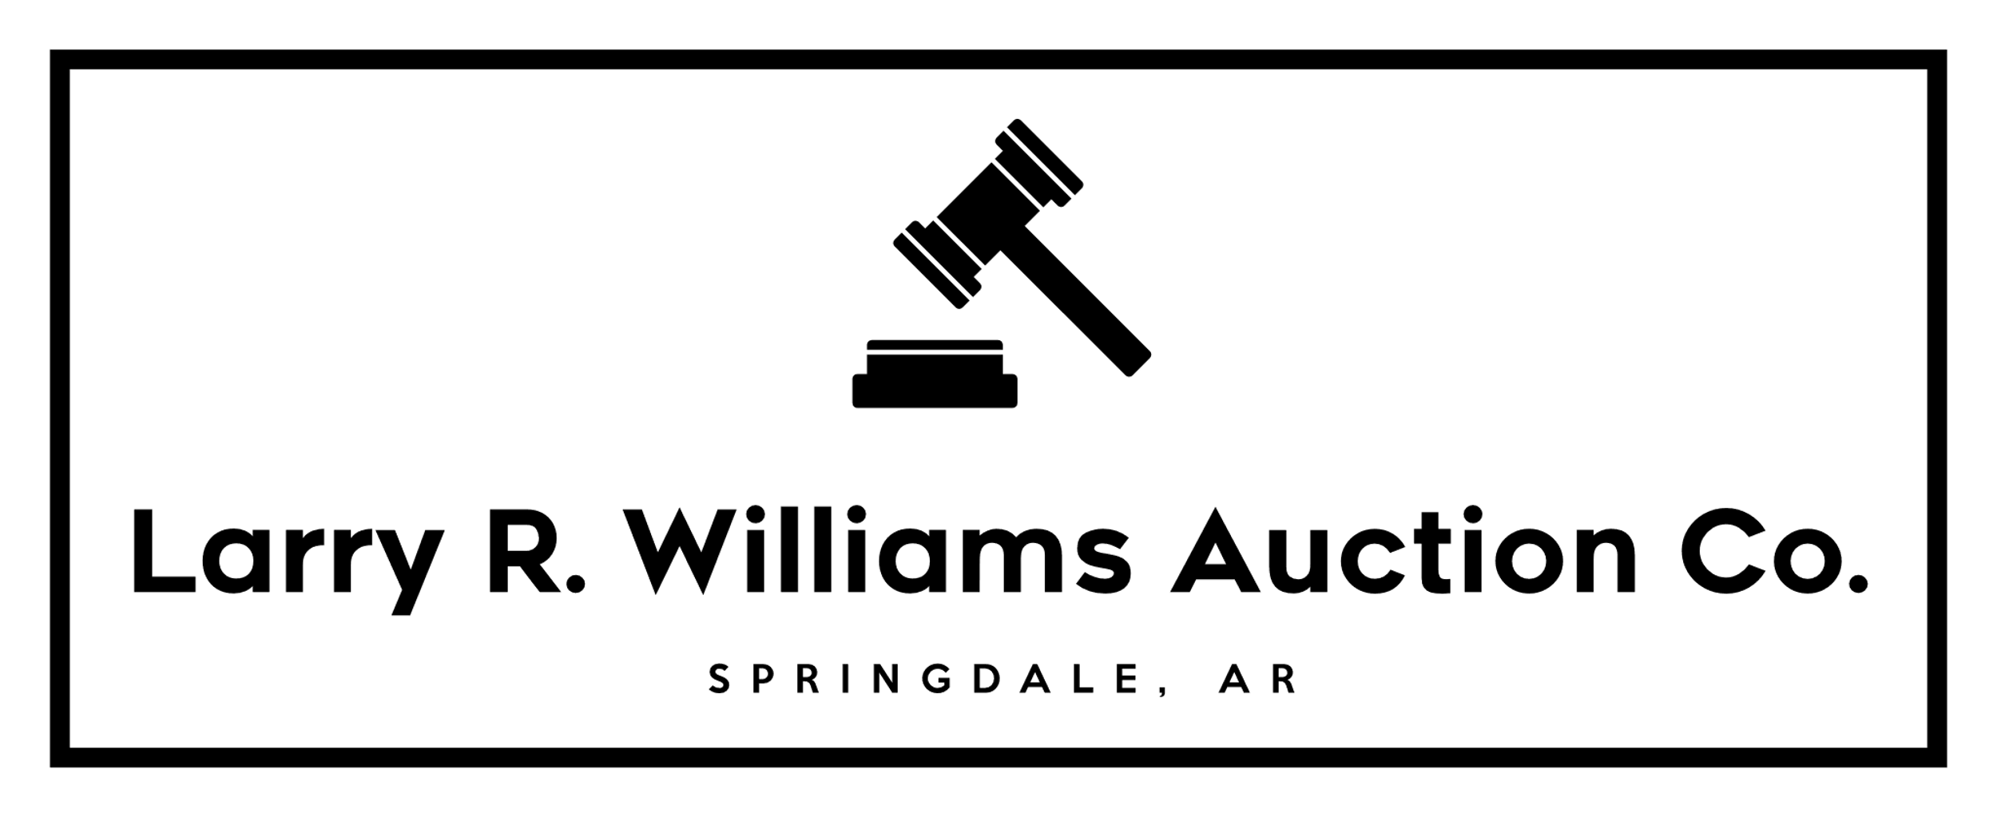

# @ LARRY R WILLIAMS AUCTIONS

**AUCTIONEER’S NOTE:**  Lots of small collectables, old signs, saddles, Jewel T, ammo, furniture, AND old money…. Just about everything you would ever need is in this auction!

Outside items to sell @ 3pm-Furniture sells @ 6pm

***-Larry & Staff***

# LIVING ESTATE AUCTION

## -MONDAY, MARCH 18, 2024 * 3PM SPRINGDALE, AR-

### * NELSON- CRIDER *

***DIRECTIONS:* TAKE HWY 412 E IN SPRINGDALE TO SONORA; TURN SOUTH ON SONORA RD; GO TO 19847 SONORA RD – 3RD PLACE ON THE RIGHT**

***Experienced Staff***

***Specializing in Personalized***

***“On- Site” Auctions***

***A Satisfied Customer, Our Best Advertisement!***

***Licensed w/Lazenby***

***Realty Group***

***Fayetteville, AR***

***CREDIT CARDS ACCEPTED***

***Large Tent and Display Wagons Available***

**Auctions by Larry R. Williams**

**Realtor * Auctioneer * Bonded * AR License #560**

**19847 Sonora Road, Springdale, AR 72764**

**479-756-0238, 479-466-2415**

The Auction Way Pays!

**REAL ESTATE**

**FARM SALES**

**ESTATES, ANTIQUES**

**MACHINERY**

**LIQUIDATIONS**

**auctionzip.com #24078**

**gotoauction.com #4979**

**https://www.facebook.com/LarryRWilliamsAuctions**

**TERMS & CONDITIONS: Cash or Check with Proper ID. Nothing Removed Until Settled For. Not Responsible for Accidents, Illness, Injury or Lost Articles. All Announcements Made Day of Sale Supersede All Previous Advertisements. All items Sold “AS IS”. Concession/Restrooms.**