Auction
  - Real Estate and Personal Property Sat. Dec. 9
REAL ESTATE sells at NOON.  3 Bed 1 ½ bath, brick home with basement,carport.and outbuildings on almost 2 acres of land  282 Graham Bridge Rd  Rockingham, NC  Personal Property auction begins @ 10 AM  Auctionzip/oneal.com | 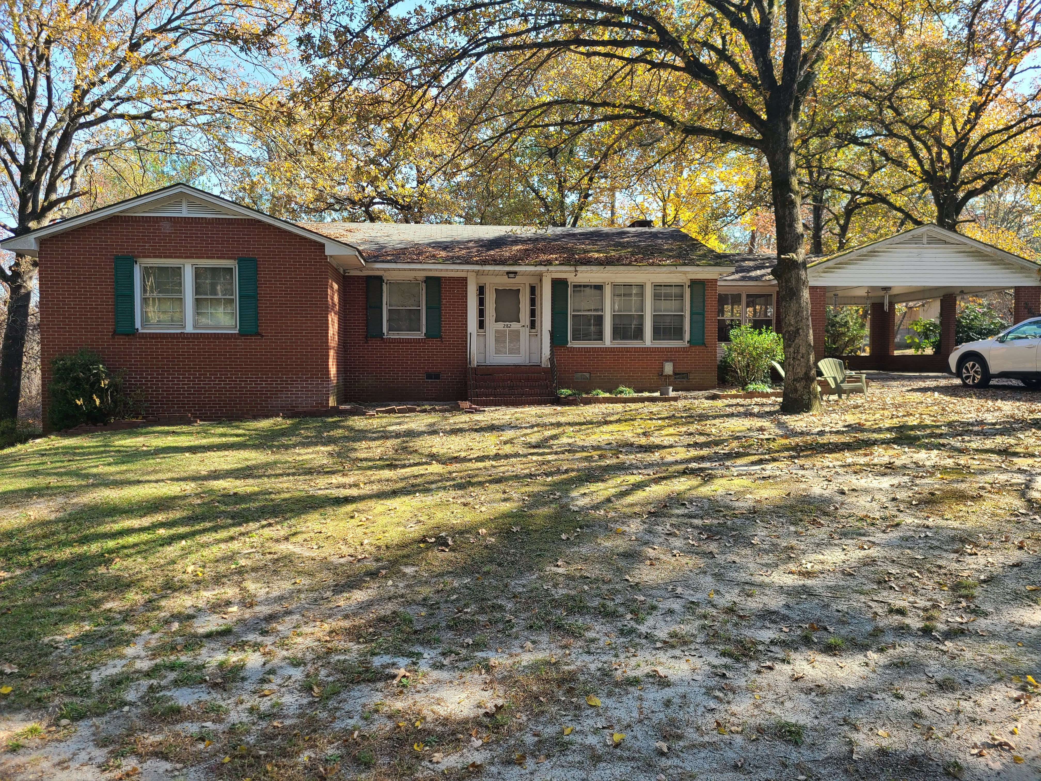  Full set of terms and conditions upon request or on auctionzip/oneal.com  See you at the auction!  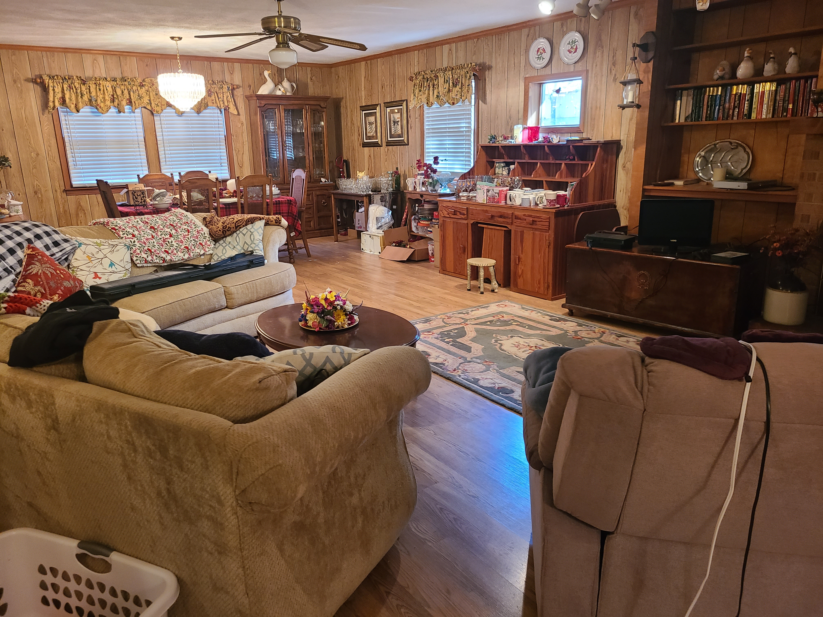
Do not Miss this auction Estate of John & Libby Thompson, deceased.
boneal16@gmail.com
704 474 5929
Open for registration and preview at 9 AM auction day  You must be registered to bid.  Cash or credit cards accepted.  10% Buyer’ premium on Personal property and 5% BP on REAL ESTATE | 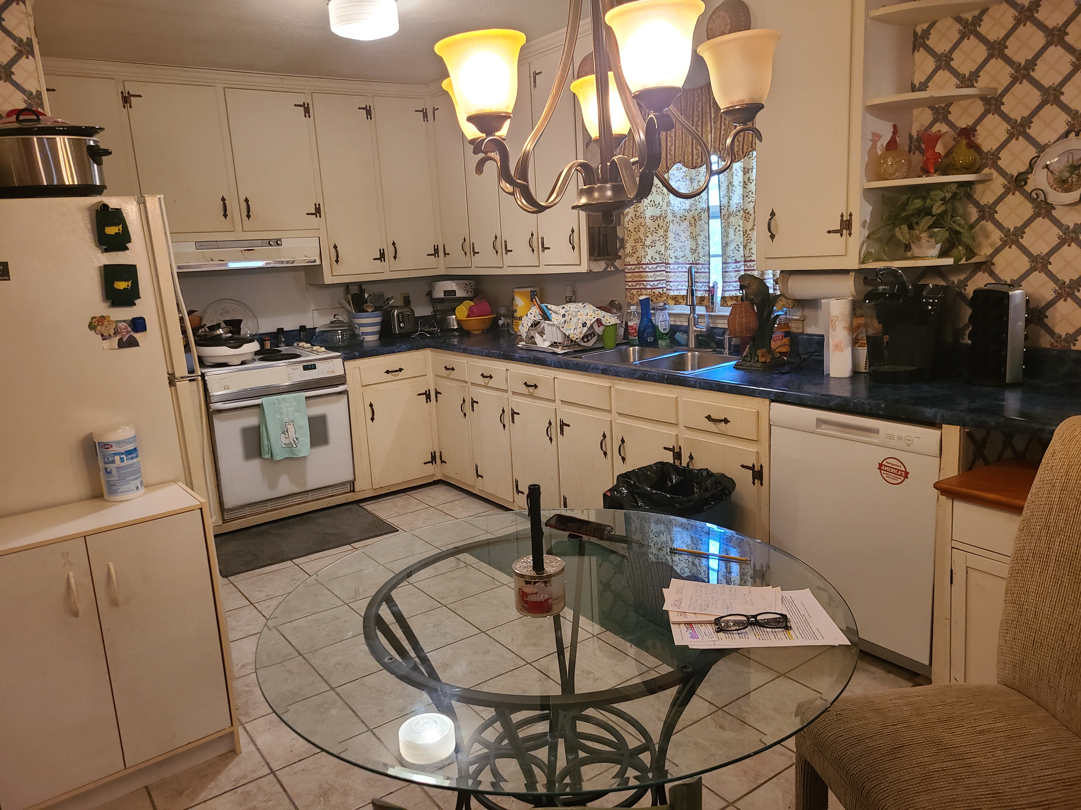

O’Neal’s Auction Services

PO Box 967 Norwood, NC 2812 8 NCAL 6690, 5825 RE # 24122

Hinson’s Auction LLC NCAF # 8405 NCAL 9798

