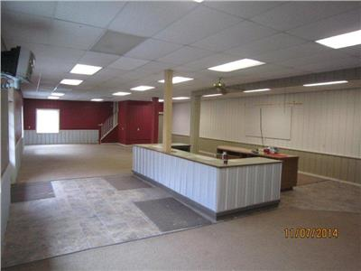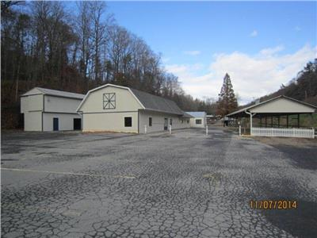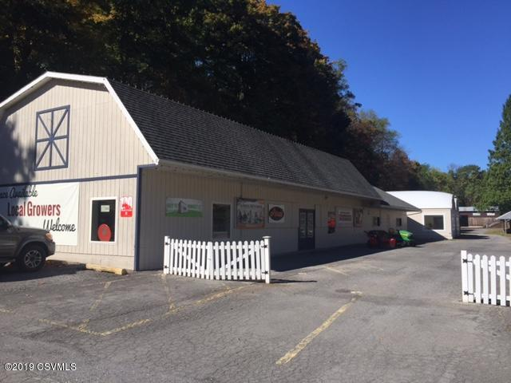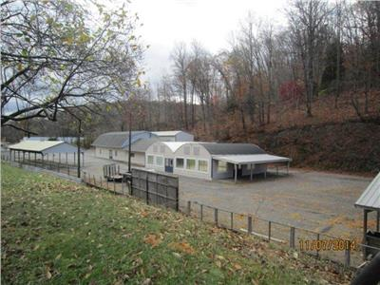 **Monday, August 17th @ 6 PM**

**Additional Information:**

All buildings painted within last 4yrs, high effficancy heat pump, roof 10-15yrs old, flooring and interior paint new, new insulation, 400 amp electric panel with two sub panels, two well systems with one system completely replaced in 2018, one holding tank and last pumped in 2018. .

**Features Include:**

* Prime Commercial Hwy 15 Location.
* Over 800 feet commercial road front
* Near Market Commons
* 50’ wide entrance & Large parking Area
* 5 Buildings, Unlimited Possiblities

**Client Contact**

**Devin & Jennifer Driggers**

**150 Adi’s Lane**

**Mifflinburg, PA 17844**

[**Devin@godigitalpa.com**](mailto:Devin@godigitalpa.com)

**(C) 570.428.2920**

**Retail Commercial Property**

* 5.9 +/- acres with over 800 feet of Commercial Hwy Exposure
* Excellent Location along Hwy15.

**5 Total Buildings**

* 1 - 3,500 sqft Retail Building with Half Bath & a 1,600 sq. ft. Greenhouse attached.
* 1 – 1,800 sq.ft storage building with 100 sqft heated office.
* 1 – 1,800 sqft pole building
* 1 – 1,800 sqft Maintenance Building with Spray Insulated Foam and 10x10 roll up door with electric opener.
* 1- 300 sqft office building

*Hess’s Auctioneering*

*Real Estate Information Sheet*



4507 N. Susquehanna Trail, Shamokin Dam, PA 17876

HESS’S AUCTIOEERING

***Lori Hess Lauver*, Auctioneer 570.966.2512 www. hessauctioneering.com**

**SALE**

For