Public Auction
2 RINGS
2 RINGS
SATURDAY, DECEMBER 17, 2022 @ 11:00 A.M.
2730 Harding Hwy. West, Marion, OH 43302
2007 Honda Fit w/ only 64,000 miles
Antiques · Gold · Sterling · Costume Jewelry · Labeled Boxes ∙ Old Tins ∙ Huber Items
Trading Cards ∙ Glassware ∙ Crocks ∙ Upper Sandusky Memorabilia ∙ Records ∙ Tools
Old Kids Books ∙ Hot Wheels ∙ DVDs ∙ Games ∙ Antique Furniture ∙ Picture Frames
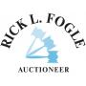
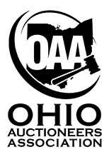
TOO MUCH TO IMAGINE!
**See website for more information**
www.rickfogleauctioneer.com
740-225-2541
OVER 1,000 PICTURES ON THE WEBSITE!
Owner: Peggy Sayre

