Public Auction
2 RINGS
2 RINGS
SATURDAY, OCTOBER 1, 2022
10:00 A.M.
Over 50,000 Comic Books and Sports Cards
Antiques · Gold · Sterling · Costume Jewelry · Beer Steins ∙ Labeled Bottles & Boxes
Old Tins · Glassware · Crocks · Upper Sandusky Memorabilia ∙ Records ∙ Tools
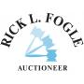
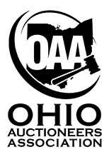
Old Kid’s Books ∙ Hot Wheels ∙ DVDs ∙ Games
TOO MUCH TO IMAGINE!
740-225-2541
**See website for more information**
www.rickfogleauctioneer.com

ONLINE BIDDING STARTING @ NOON ON PROXIBID

