“Dudley”
Public Auction
SATURDAY, JULY 16TH @ 10:30 AM
Location: 5806 Harding Hwy. E., Caledonia, OH
Truck w/ Snowplow ∙ Antiques ∙ Toys ∙ Furniture ∙ Tools
Household Items ∙ Collectibles ∙ Jewelry
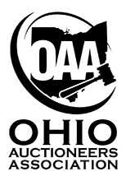
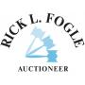
Owner: Karen Brutchey
Rick L. Fogle
740-225-2541
www.rickfogleauctioneer.com

