Real Estate Auction

Auction for the Estate of Debra Dickerson

Monday May 7th, 2018 @ 6:00pm

2173 North 21ST Street, Nitro, WV
Directions: From Route 25 & 21st Street intersection in Nitro, turn onto 21st Street.
Travel thru stop sign to left on North 21st Street. #2173 on left. Watch for signs.

*** OPEN HOUSE SUNDAY 2-4PM ***

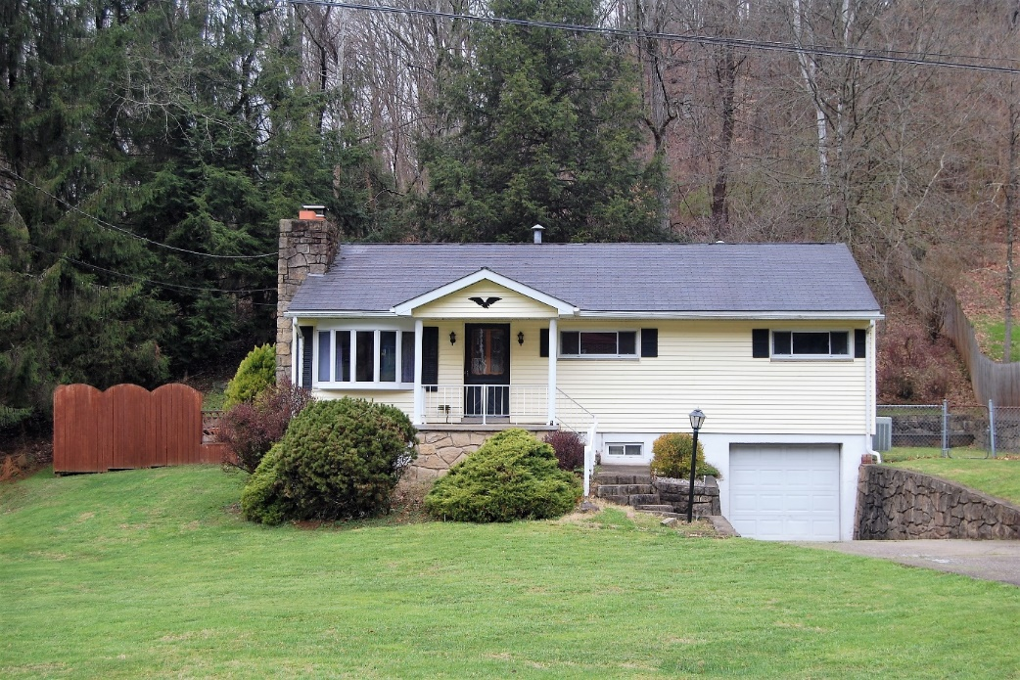

Auctioneer: Stacy L. Cooper #1517 Auctioneer/Agent: Roger Mullins #1703

www.MOUNTAINEERAUCTIONS.com

or www.auctionzip.com ID #4152 or #4158 for terms & photos

BEDROOMS: 3

BATHS: 1

SQ. FEET: Approx. 1,020 sq ft. main level
Approx. 1,020 sq ft. basement level

COUNTY: Kanawha
TYPE: 1 story
YEAR BUILT: Approx. 1960
CONSTRUCTION: Vinyl siding
ROOF: Asphalt shingle
HEAT: Gas forced air
WATER: City
WALLS: Sheetrock
WINDOWS: Updated vinyl double pane
FLOORS: Carpet (over hardwood), Vinyl
A/C: Central
SEWER: City
LOT: 56/100A AREA R LTS 73-74
21ST ST 73N – Nitro District -
Kanawha County WV

ADDITIONAL: All season sun room, private patio w/hot tub, 2 stone fireplaces, updated central heat & air, 1/2acre lot with large front yard

