Real Estate Auction
Auction for the Estate of Mary Thumm
Monday April 9th, 2018 @ 5:00pm
984 Elliott Street, St. Albans, WV
Directions: From MacCorkle Ave. & Walnut St. intersection in St. Albans, take Walnut Street to left on Kanawha Terrace to right on Poplar Street. At top of hill turn right on Elliott Street. #984 on left. Watch for signs.
*** OPEN HOUSE SUNDAY 2-4PM ***
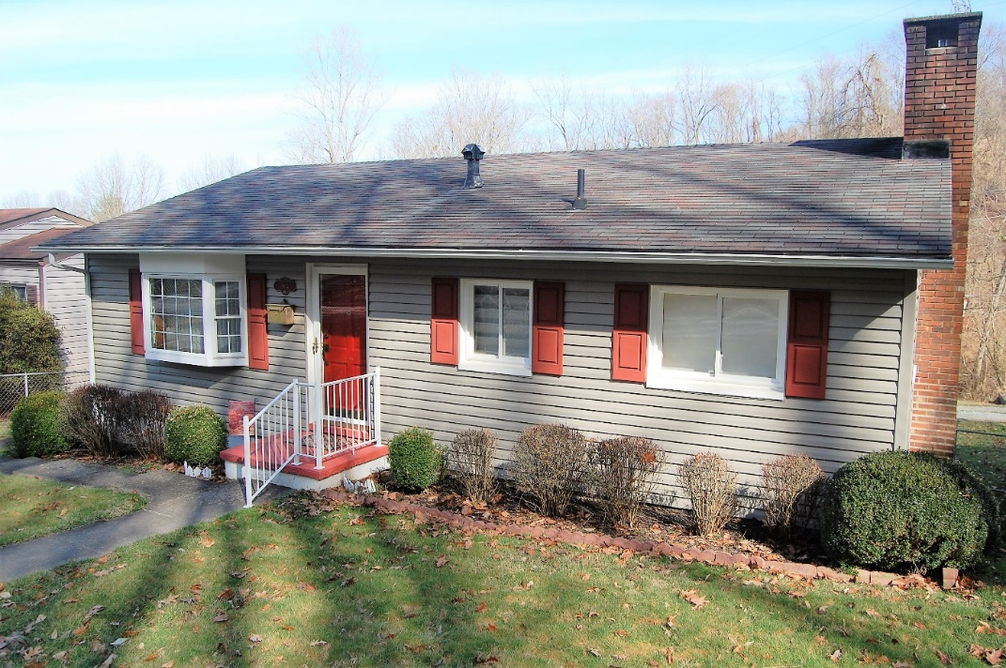

Auctioneer: Stacy L. Cooper #1517 Auctioneer/Agent: Roger Mullins #1703

www.MOUNTAINEERAUCTIONS.com

or www.auctionzip.com ID #4152 or #4158 for terms & photos

BEDROOMS: 3

BATHS: 1

SQ. FEET: Approx. 900 sq ft. main level
Approx. 650 sq ft. basement level

COUNTY: Kanawha
TYPE: 1 story
YEAR BUILT: Approx. 1950
CONSTRUCTION: Vinyl siding
ROOF: Asphalt shingle
HEAT: Gas forced air
WATER: City
WALLS: Sheetrock/Plaster
WINDOWS: Vinyl double pane
FLOORS: Carpet, Vinyl
A/C: Central
SEWER: City
LOT: PT LT 6 SEC 3 ELDOT AND 52’x120’ ELLIOTT ST 984 – St. Albans District-Kanawha County WV

ADDITIONAL: Updated central heat & air, windows, siding, roof, screened patio

