Real Estate Auction

Auction for the Estate of Norma Moss

Monday January 29th, 2018 @ 5:00pm

149 Pine Street, Charleston, WV

Directions: From I77/I64 Greenbrier Street Exit #99 turn onto Greenbrier Street/Rt. 114 North 4miles to left on Beech Street 100yards to right on Pine Street to #149 on left. Watch for signs.

*** OPEN HOUSE SUNDAY 2-4PM ***

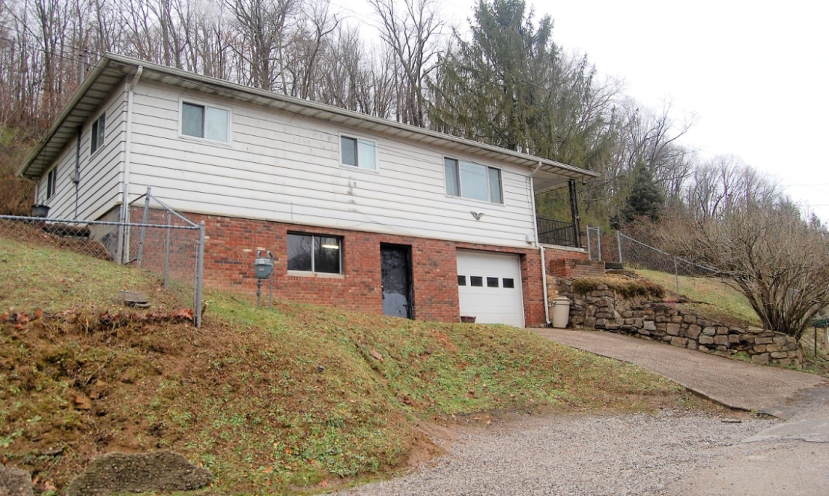

Auctioneer: Stacy L. Cooper #1517 Auctioneer/Agent: Roger Mullins #1703

www.MOUNTAINEERAUCTIONS.com

or www.auctionzip.com ID #4152 or #4158 for terms & photos

BEDROOMS: 3

BATHS: 1

SQ. FEET: Approx. 1,040 sq ft. main level
Approx. 1,040 sq ft. unfinished basement level

COUNTY: Kanawha
TYPE: 1 story
YEAR BUILT: Approx. 1964
CONSTRUCTION: Brick/Aluminum siding
ROOF: Dimensional shingle
HEAT: Gas forced air
WATER: City
WALLS: Sheetrock
WINDOWS: Vinyl double pane
FLOORS: Hardwood, Vinyl
A/C: Central
SEWER: Septic
LOT: LTS 98-99-100 PT LT 101
MEADOW BROOK HILLS – 1.35acres
Elk District-Kanawha County WV

ADDITIONAL: Updated central heat & air – 1owner - integrated 1car basement garage

