Real Estate Auction

Auction for the Estate of Bernard Burcham

Monday, November 9th, 2020 @ 5:00pm

2301 Jefferson Ave., Point Pleasant, WV 25550
Directions: From WV Route 62 Jackson Ave./Ohio River Road to 23rd street intersection turn onto
23rd street toward Ohio River 1 block to Jefferson Avenue. #2301 on right. Watch for signs.

*** OPEN HOUSE SUNDAY October 18, 25, Nov. 1 & 8 2-4PM ***

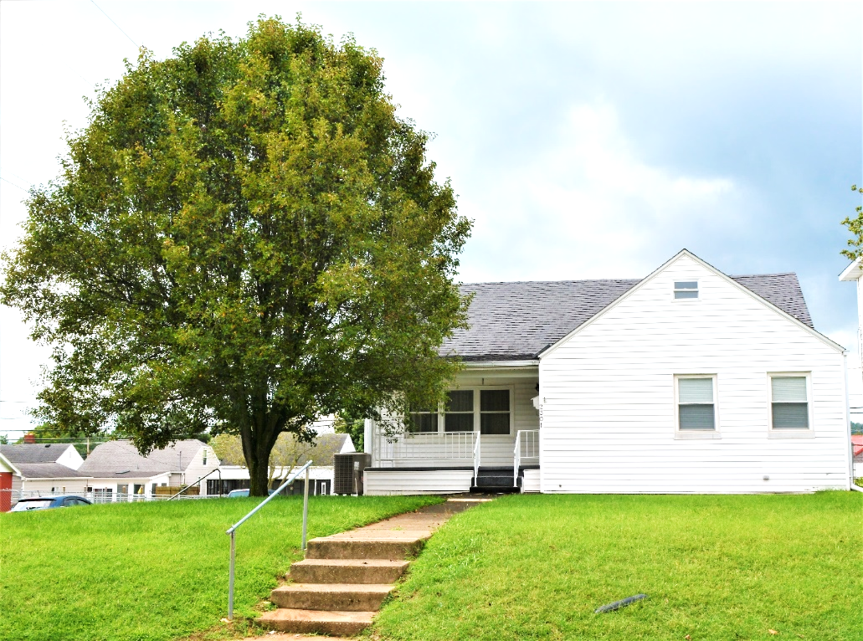

Auctioneer: Stacy L. Cooper #1517 Auctioneer/Agent: Roger Mullins #1703

www.MOUNTAINEERAUCTIONS.com

or www.auctionzip.com ID #4152 or #4158 for terms & photos

BEDROOMS: 3

BATHS: 3

SQ. FEET: Approx. 1,850sq. ft. finished

COUNTY: Mason
TYPE: 1 story
YEAR BUILT: 1945
CONSTRUCTION: Block & Frame
ROOF: Shingle
HEAT: Forced air gas heat
WATER: City
WALLS: Plaster & Sheetrock
WINDOWS: Wood & Replacement vinyl
FLOORS: Carpet, Oak Hardwood & vinyl
A/C: Central
SEWER: Public
LOT: BLK 3 LOT 25: Jefferson Ave - District 13 Point Pleasant – Mason County WV

ADDITIONAL: Full unfinished basement – 2car attached garage/workshop - Established neighborhood & convenient corner lot location

