Selling At Public Auction

For the Estate of Jack Powell

Saturday, November 7th, 2020 @ 10:00am

5708 E Dupont Ave., Glasgow, WV 25086
Directions: From Charleston – I-79South to US Route 60 East Midland Trail 15miles to
5708 E Dupont Ave. Glasgow on right. Property faces Rt. 60 in Glasgow. Watch for signs.

*** CALL TODAY TO SCHEDULE SHOWING***

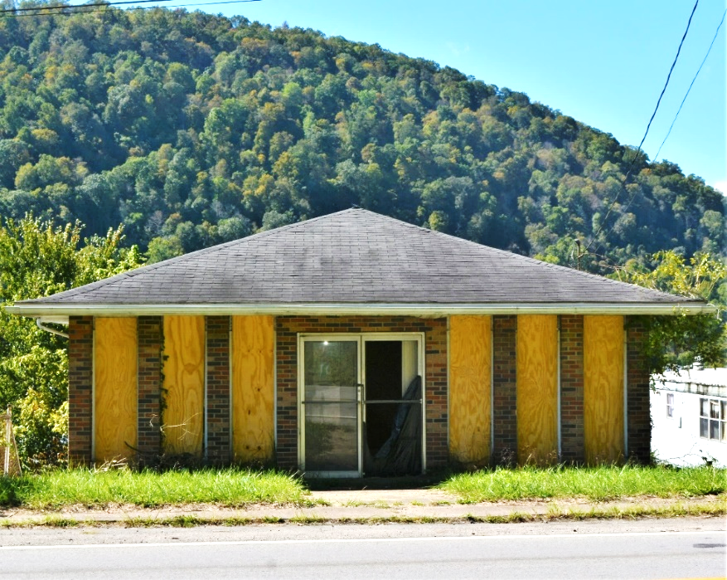

Auctioneer: Stacy L. Cooper #1517 Auctioneer/Agent: Roger Mullins #1703

www.MOUNTAINEERAUCTIONS.com

or www.auctionzip.com ID #4152 or #4158 for terms & photos

OFFICES: 3 + LOBBY AREA

BATHS: 2

SQ. FEET: Approx. 2,000sq. ft. Office area + ground level work area (not included)

COUNTY: Kanawha
TYPE: 1 story w/lower level
YEAR BUILT: 1915 & more recent
CONSTRUCTION: Block & Frame
ROOF: Shingle
HEAT: Forced air gas heat
WATER: City
WALLS: Plaster & Sheetrock
WINDOWS: Aluminum
FLOORS: Carpet & vinyl
A/C: Central
SEWER: Public
LOT: LOT 3 BK B: District 06 Glasgow – Kanawha County WV

ADDITIONAL: Commercial class property -Basement work/storage area – Route 60 road frontage – Street level rear access from alley – Building needs work & updates but has income potential

