Real Estate Auction

Auction for the Estate of Elizabeth Ann Westfall

Monday, November 2nd, 2020 @ 5:00pm

66 Brushy Fork Road, Bridgeport, WV 26330
Directions: From I-79 Anmoore Exit 117 onto WV 58 toward Anmoore. Turn left onto Philippi Pike/Brushy Fork Road 1/2mile to #66 on right. Watch for signs.

*** OPEN HOUSE SUNDAY October 11, 18, 25 & Nov. 1 2-4PM ***
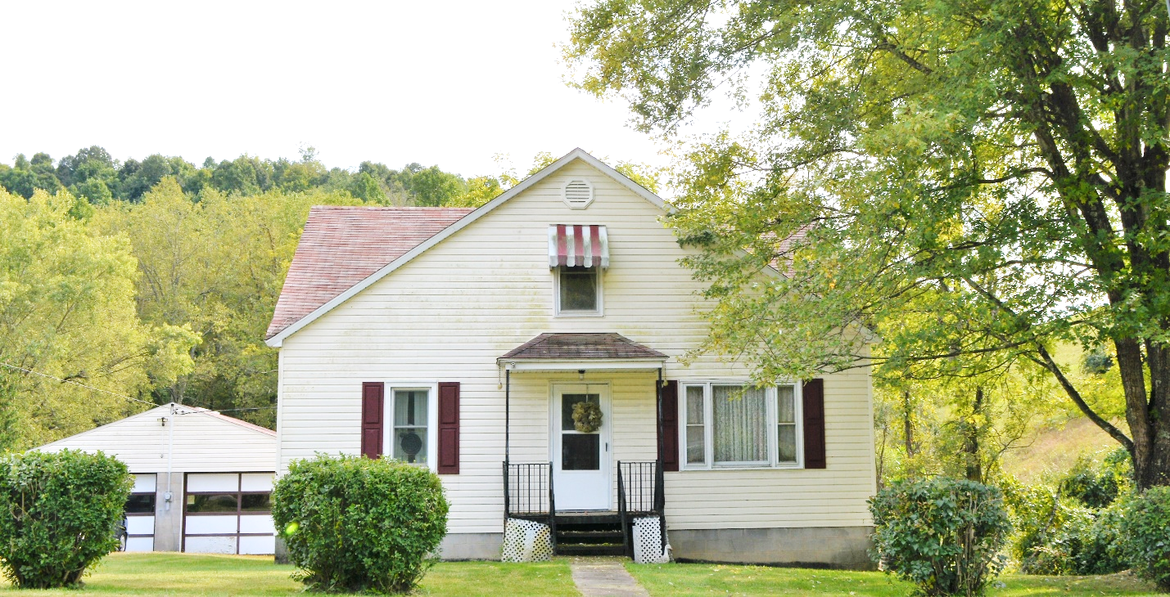

Auctioneer: Stacy L. Cooper #1517 Auctioneer/Agent: Roger Mullins #1703

www.MOUNTAINEERAUCTIONS.com

or www.auctionzip.com ID #4152 or #4158 for terms & photos

BEDROOMS: 3

BATHS: 1

SQ. FEET: Approx. 1,300sq. ft.

COUNTY: Harrison
TYPE: 1 ½ story
YEAR BUILT: 1958
CONSTRUCTION: Block & Frame
ROOF: Shingle
HEAT: Forced air gas heat
WATER: City
WALLS: Plaster & Sheetrock
WINDOWS: Wood & Replacement vinyl
FLOORS: Carpet, Oak Hardwood & vinyl
A/C: Central
SEWER: Public
LOT: 1 tract (LOTS 106 PT 105) ROBIN HOOD ADDITION – District 15 Simpson-Outside - Harrison County WV

ADDITIONAL: Full unfinished basement – 2car detached garage/workshop - Established neighborhood & very convenient location

