Real Estate Auction

Auction for the Estate of Linda Mullins

Monday, August 31st, 2020 @ 6:00pm

816 Churchill Drive, Charleston, WV 25314
Directions: From I-64 Oakwood Drive Exit 58A take Corridor G/Rt.119 South ¼ mile to right on Cantley Drive to right on Wilkie Drive to left on Churchill Drive. #816 on right. Watch for signs.
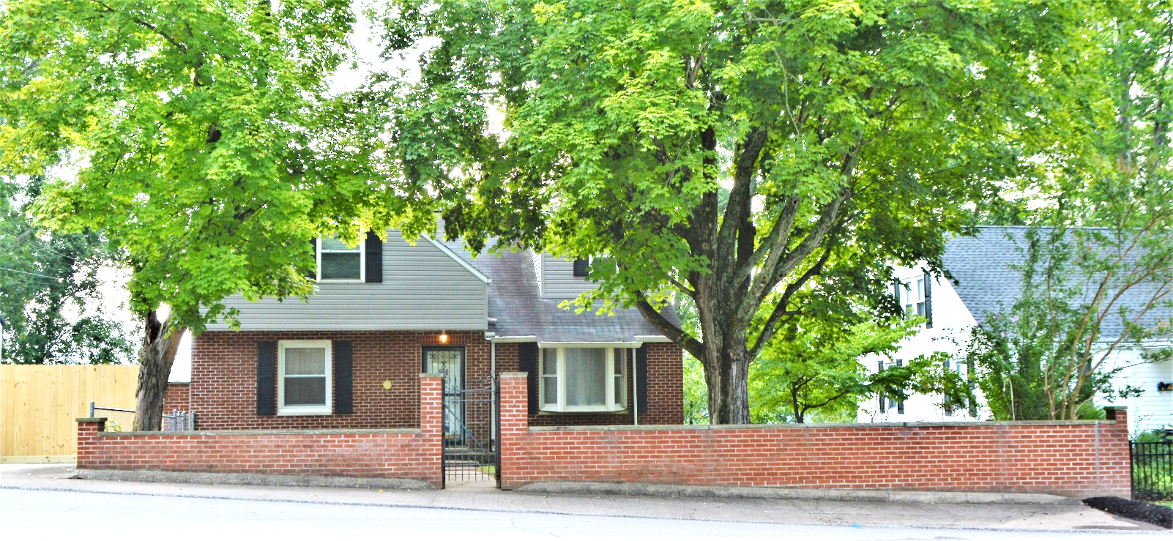

Auctioneer: Stacy L. Cooper #1517 Auctioneer/Agent: Roger Mullins #1703

www.MOUNTAINEERAUCTIONS.com

or www.auctionzip.com ID #4152 or #4158 for terms & photos

BEDROOMS: 3

BATHS: 2 ½

SQ. FEET: Approx. 2,400 sq. ft.

COUNTY: Kanawha
TYPE: 1 ½ story
YEAR BUILT: 1949
CONSTRUCTION: Masonry & Frame
ROOF: Shingle
HEAT: Forced air gas heat & wall air unit
WATER: City
WALLS: Plaster & Sheetrock
WINDOWS: Replacement vinyl & wood
FLOORS: Carpet, Oak Hardwood & tile
A/C: Wall/widow units
SEWER: Public
LOT: LT 90 SEC 3 FOREST HILLS ADN CHURCHILL DR 816 – Charleston SA District - Kanawha County WV

ADDITIONAL: Full partially finished basement – Established neighborhood & convenient location

