Real Estate Auction

Auction for the Estate of George Keller

Monday, June 22nd, 2020 @ 6:00pm

1207 Ellen Drive, So. Charleston, WV 25309
Directions: From I-64 Montrose Drive Exit 56 take Montrose Drive uphill 1.3miles to right on Henry Road in James Park to right on Ellen Drive. #1207 on right. Watch for signs.

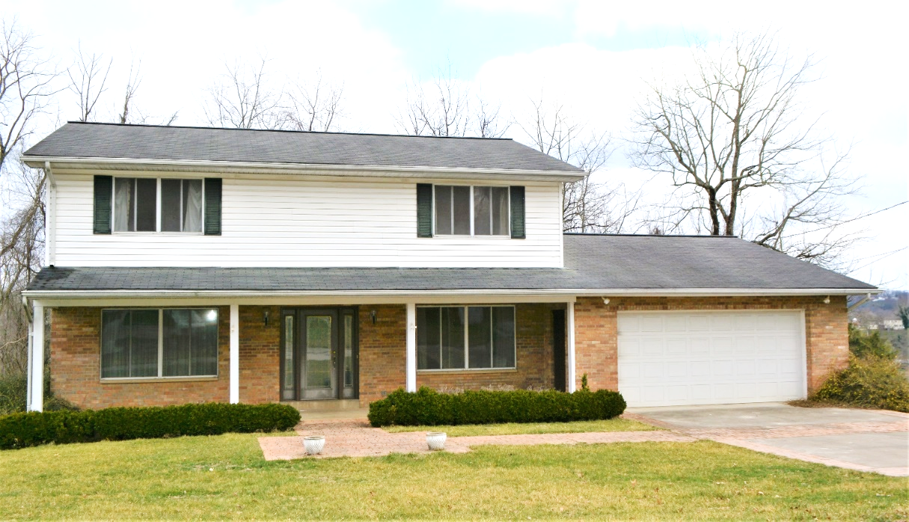

Auctioneer: Stacy L. Cooper #1517 Auctioneer/Agent: Roger Mullins #1703

www.MOUNTAINEERAUCTIONS.com

or www.auctionzip.com ID #4152 or #4158 for terms & photos

BEDROOMS: 5

BATHS: 3 ½

SQ. FEET: Approx. 3,450 sq. ft.

COUNTY: Kanawha
TYPE: 2story
YEAR BUILT: 1969
CONSTRUCTION: Masonry & Frame
ROOF: Shingle
HEAT: Dual gas forced air w/heat pumps
WATER: City
WALLS: Sheetrock
WINDOWS: Mixed new & original double pane
FLOORS: Carpet, Oak Hardwood & tile
A/C: Dual central units
SEWER: Public
LOT: LT 27 JAMES PARK ADN; ELLEN DR 1207 - South Charleston Corp District - Kanawha County WV

ADDITIONAL: 2 car garage – Full unfinished basement – 2 fireplaces - Established neighborhood & convenient location – Over ½ acre lot – Updated open kitchen & sunroom

