Real Estate Auction

Court Ordered Conservatorship Auction

Monday, April 1, 2024 @ 4:00pm

1077 Greenland Circle, South Charleston, WV 25309

SHOWN BY APPOINTMENT–CALL TODAY FOR YOUR OWN PRIVATE SHOWING

Directions: MacCorkle Ave. turn onto Rock Lake Drive to right on Lincoln Drive to right on Chestnut Ave to left on Pershing Ave. to right on Holleyberry Lane to right on Greenland Circile. #1077 on left. 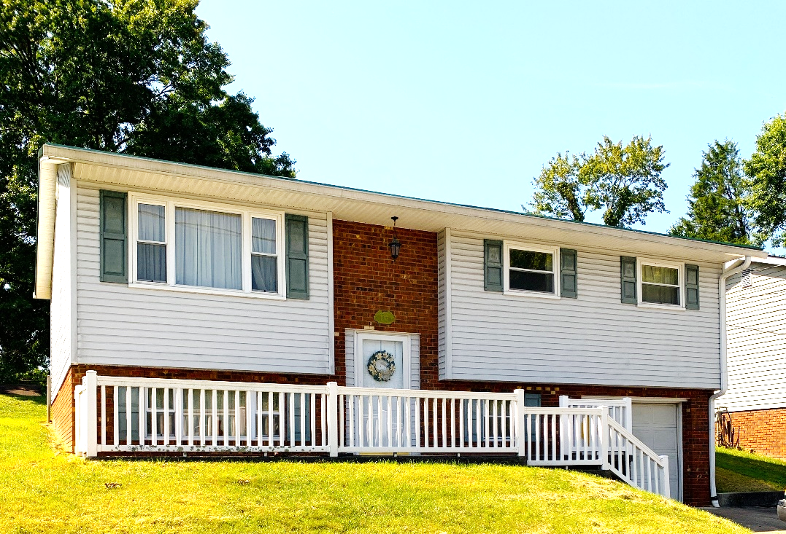

Auctioneer: Stacy L. Cooper #1517 Auctioneer/Agent: Roger Mullins #1703

www.MOUNTAINEERAUCTIONS.com

BEDROOMS: 3

BATHS: 1 full upstairs 1/2 bath in basement

SQ. FEET: Approx. 1,590 total

COUNTY: Kanawha
TYPE: Split-level/Bi-level
YEAR BUILT: 1973
CONSTRUCTION: Frame
ROOF: Metal
HEAT: Electric warm air
WATER: City
WALLS: Sheetrock
WINDOWS: Metal frame
FLOORS: Carpet & vinyl
A/C: Central
SEWER: Public
LOT: LOT 504 SEC 5 ARMOR VIEW ADN, Spring Hill District, Kanawha County, WV

ADDITIONAL: Desirable Armor View location – Fenced back yard area – Oversized 1car lower level garage with additional workshop/storage area - House needs some updates

