Real Estate Auction

Court Ordered Conservatorship Auction

Monday, February 12, 2024 @ 4:00pm

1727 Pennsylvania Ave, Charleston, WV 25302

SHOWN BY APPOINTMENT–CALL TODAY FOR YOUR OWN PRIVATE SHOWING

Directions: From I-77 Westmoreland Exit take Westmoreland Road toward river to Left on Pennsylvania Ave. #1727 on left. Signs posted.

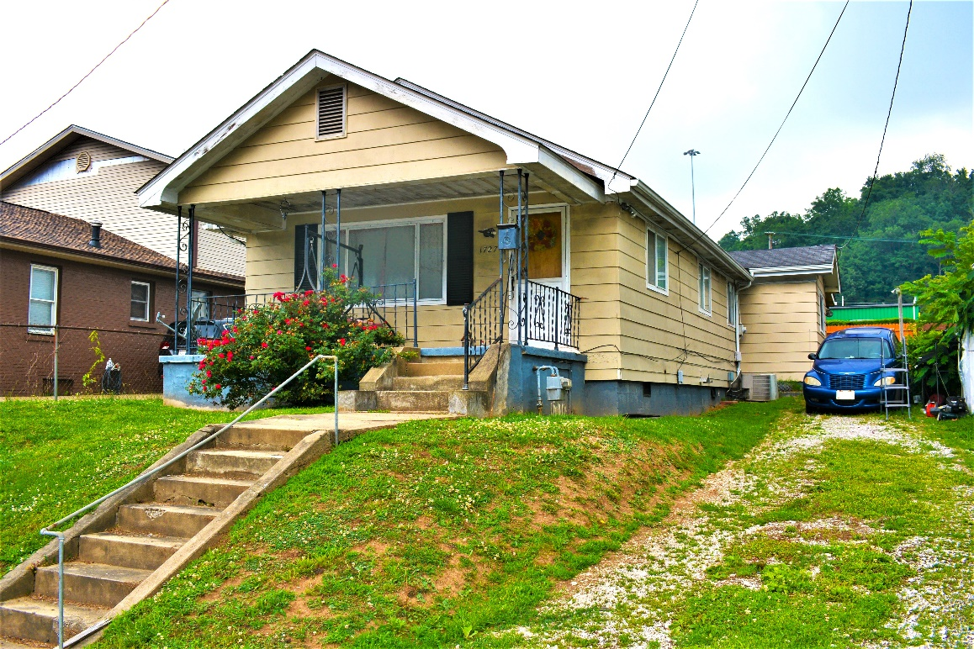

Auctioneer: Stacy L. Cooper #1517 Auctioneer/Agent: Roger Mullins #1703

www.MOUNTAINEERAUCTIONS.com

BEDROOMS: 2

BATHS: 1

SQ. FEET: Approx. 675 total

COUNTY: Kanawha
TYPE: Rambler
YEAR BUILT: 1925
CONSTRUCTION: Frame
ROOF: Shingle
HEAT: Gas warm air
WATER: City
WALLS: Sheetrock
WINDOWS: Metal frame
FLOORS: Oak & laminate
A/C: Central
SEWER: Public
LOT: LOT 3 RESUB OF K-L BK 10 GLEN ELK PENNA AVE 1727, Charleston West Corp. District, Kanawha County, WV

ADDITIONAL: On & off-street parking – Small back yard – Strong candidate for family residence or income property - House needs repair but has updated bathroom

