Real Estate Auction

Court Ordered Guardianship Auction

Monday, September 9th, 2019 @ 6:00pm

24 9th Avenue, South Charleston, WV 25309

Directions: I64 Montrose Exit #56 to left on MacCorkle Ave. West 1.0mile to stoplight at G Street.

Turn right onto 9th Avenue - Property located on right. Signs posted.

*** PROPERTY VIEWING SUNDAY 2-4PM ***

*** August 18, 25, September 1 & 8 ***

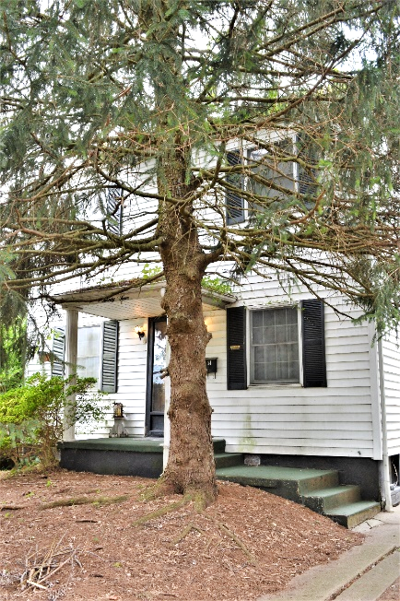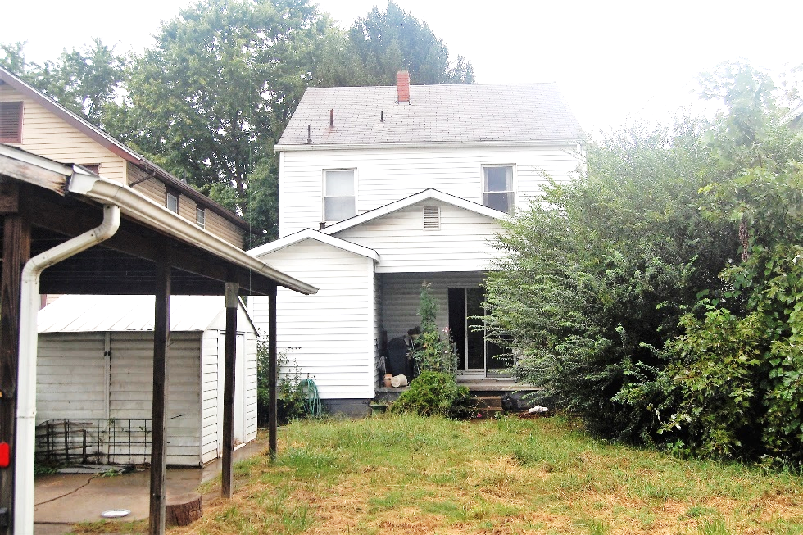

Auctioneer: Stacy L. Cooper #1517 Auctioneer/Agent: Roger Mullins #1703

www.MOUNTAINEERAUCTIONS.com

or www.auctionzip.com ID #4152 or #4158 for terms & photos

BEDROOMS: 3

BATHS: 1 ½

SQ. FEET: Approx. 1,425 sq. ft.

COUNTY: Kanawha
TYPE: Colonial 2story
YEAR BUILT: Approx. 1920
CONSTRUCTION: Wood
ROOF: Shingle
HEAT: Gas forced air
WATER: City
WALLS: Plaster
WINDOWS: Original wood w/storm
FLOORS: Oak hardwoods under carpet
A/C: Central
SEWER: Public
LOT: LT 11 RILEY ADN 9TH AVE 24 South Charleston District-Kanawha County WV

ADDITIONAL: Vinyl siding – Fenced back yard with carport – Utility storage building – Partial basement – Full attic storage area

