Real Estate Auction

For the estate of Marie Estep

Monday, August 26th, 2019 @ 6:00pm

606 Fort Hill Drive, Charleston, WV 25314

Directions: I-64 Oakwood Exit 58A to right on Corridor G/Rt.119 South. Right on Cantley Drive then immediate right onto Fort Hill Drive 1/2mile turn left on Fort Hill Drive to left on Hayes Avenue to right on Fort Hill Drive. Property located on left. Signs posted.

*** PROPERTY VIEWING SUNDAY 2-4PM ***

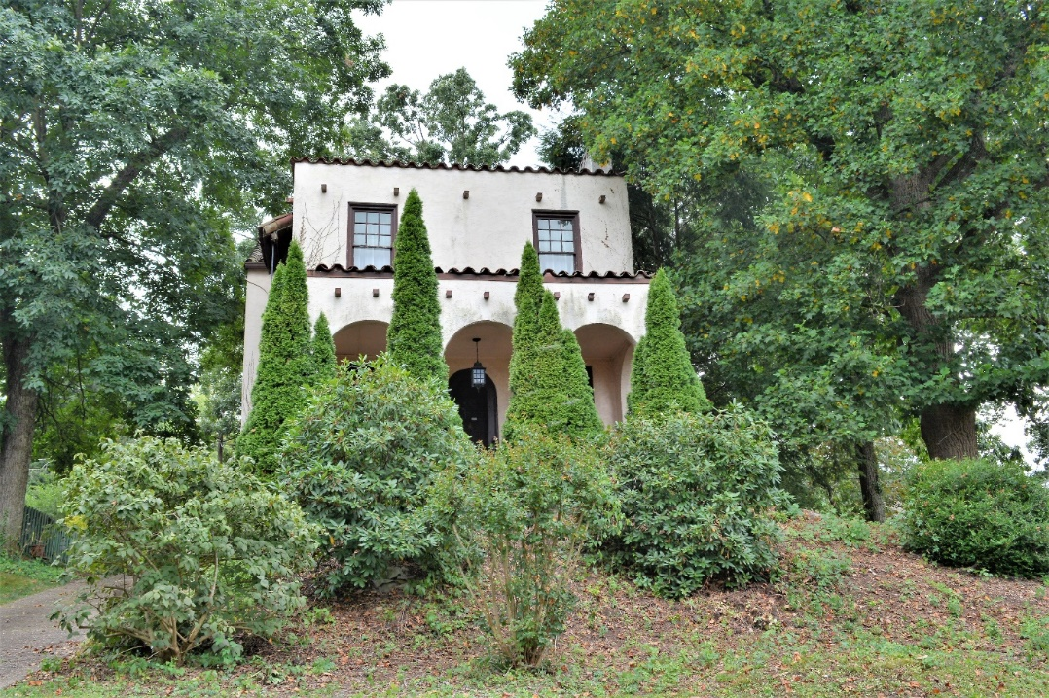

Auctioneer: Stacy L. Cooper #1517 Auctioneer/Agent: Roger Mullins #1703

www.MOUNTAINEERAUCTIONS.com

or www.auctionzip.com ID #4152 or #4158 for terms & photos

BEDROOMS: 3

BATHS: 2 ½

SQ. FEET: Approx. 2,206 sq. ft.

COUNTY: Kanawha
TYPE: Spanish Colonial 2story
YEAR BUILT: Approx. 1931
CONSTRUCTION: Stucco
ROOF: Terra cotta tile & rubber
HEAT: Gas forced air
WATER: City
WALLS: Plaster
WINDOWS: Original wood
FLOORS: Oak hardwoods - ceramic tile
A/C: Central
SEWER: Public
LOT: PT LT 82 & LTS 83 & 84: Fort Hill ADN Chas SA District-Kanawha County WV

ADDITIONAL: Architect designed residence - Large oversize corner lot Mature landscaping - Detached garage/workshop – Finished basement

