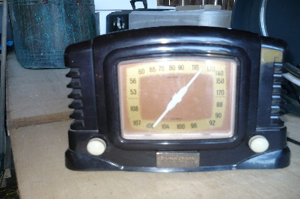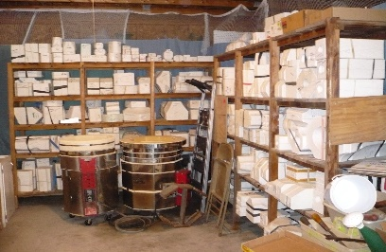

Antique Tools, Crafts, Ceramics Business
Piche Rd. Barn Auction Brimley, MI
Sat. Aug. 29, 10:00 a.m
Tools: Welder and Supplies, sand blaster, paint shaker, router table, routers, skill saw, drawer slides, router bits, freud cabinet maker bits, saw blades, 8ft folding tables, filing cabinet, 2ftx6ft scaffold and platform
Antiques: brass porthole frame with glass, brass 3-blade prop, R.R lantern (red lens/wick), (2) danforth anchors, old wood skis, large ornate well pump, coffe mugs and sucers from ore carrier, photo albums boats, naval wood pully, old vaval bell,adz’s, scths, sickles, barn beam augers, wood braces, wood planes, wood bits, rivetors, old car jacks, buck saws, metal buck saws, buck saw blades, rass tip horse hames, axes, saw sets, hand saws, hand tools, traps, ice tongs, wood pulleys, picks, grub hoes, hand air pumps, X-lug wrenches, Stainless kitchen meat grinders, White wooden kitchen table, school table,sewing machines and tables, peanut machines, 1pt to qt storage jars blue and clear, glass insulators, bait cast reels, lures and old tackle boxes, record player and radio 33 1/3, old books, x-mass stands, x-mass décor, floor lamps, chairs, rocking chait, antlers,/hornets nest/ birds nest, washer ringers, wooden kegs
MIsc: Light up Open Sign, display racks, colored glass and ceramics, reels and poles, star fish, sea shells, Nautical charts, nautical dishes, hockey sticks, wood including: oak, ash, curly maple, birds eye maple, redwood, 8x8 storage building, John Deere #1Rare Sickle Bar Mower inter changeable teeth, Gun Books, 2 bottom plow
Ceramics: (5) racks of ceramic molds with racks included, Lehman slip o matic pouring table 30 in x 8ft, 35 gal tub, hoses and nozzle, (2) large kilns, absentee bids welcomed

Duncanauctions.org for pics and information

