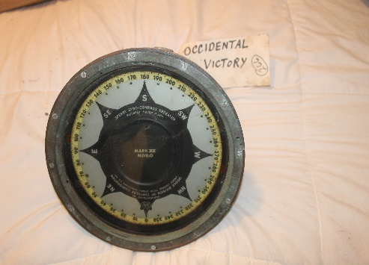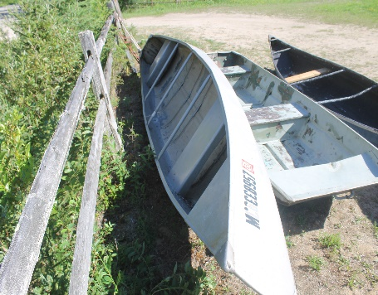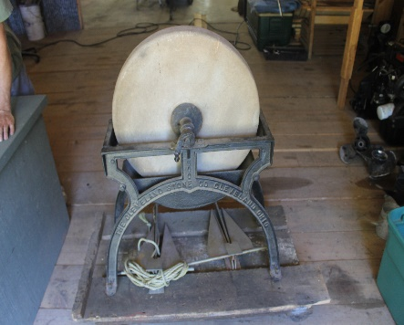
Auction Thursday Aug. 27
5:00 p.m 248 Blindline Rd
Cedarville
Tools/ Equipment:metal shop cabinet with advertising, compressor, wrenches, screw drivers, bench top band saw, pipe clamps, out door shop light, power washer, gas cans, Truck tool box, shovels, snow mobile parts, galvanizes pails, electric motor, 10 ft wooden step ladder, bench top drill press, commercial Metal shop cabinet with drawer, vintage lawnboy mower with original manual, shovels, splitting mauls, sledge hammers,
Furniture: dining cain chairs, end table, single bed, lamps, cot, Anderson Windows, Entry doors, card table and chairs,
Sporting/ Collectibles: fish decoys, duck decoys, fishing lures, tackle boxes, draw knives, old sharpening stone and stand, vintage snow mobile helments, vintage racing suits, wooden ship pulleys, Walt Disney movie posters, Singer Sewing machine, cast iron décor, american flag, enamel bowl, old lisence plates, (2) aluminum canoes, flat bottom boat, old pop bottles, oil cans, vintage coolers, pitcher pump, shoe shine box, wash board, (2) down riggers, Evinrude Detachable Row Boat motor early 1900’s, Johnson Model A-25 outboard early, 6 hp Johnson Outboard, Brass Boat spotlight, wooden planes, ammo boxes with ammo, snow mobile parts, Old wooden tobbogan, wooden sleds, boat bow light, Zenith Oceanic radio 50’s, Brass ACME fire extinguisher, pocket knives, earlt griswold frying pan, stainless steel kerosene lamps, gray marine gauge,
Household: pictures, leather office chair, pine closet doors, metal mirror bathroom cabinet,
More Added until sale date. Duncanauctions.org for pictures and terms.

