Kujala Family Farm Auction
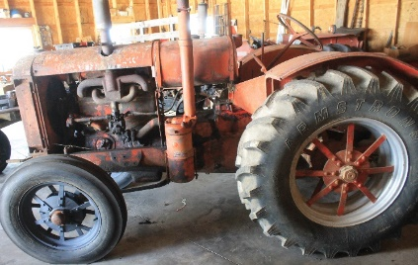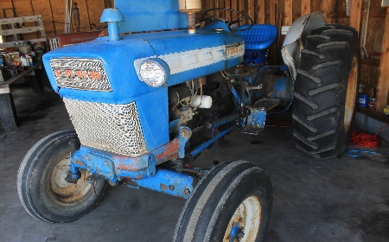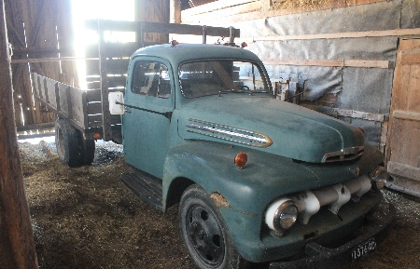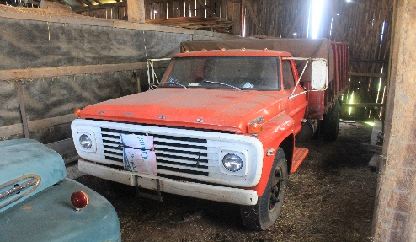
18278 Centerline Rd. Rudyard, Mi
Fri. June 26, 3:00 p.m
duncanauctions.org/ auctionzip.com (for Pics)
Tractors: International 574, McCormick/Deering early, Ford 4000,
Trucks: 1950’s Ford Flatbed dual wheel, Ford 700 flatbed dual wheel
Farm Equipment:2 heavy duty hay wagons, Elevator Hay Rake, Seed Drill, Brush Hog, New Holland Hay Rake, Single and Double Plow, Heston Haybine, Whell Harrows, Field Sprayer, Hay Elevator, Antique hay rake, (2) Moline hay balers,
Tools and Equipment:Lawn tractor, power washer, chain saws, axes, splitting mauls, sledge hammers,chains, tap and die set, battery charger, power cords, jumper cables, grease guns, wrenches and sockets, torch set, motor oil, gas cans, generator, anvil, cutting torches and tanks, wheel barrow, bench grinder, compressor, floor jack, gasoline tanks, chain falls, John Deere parts, Rail road jack, metal chop cabinets, hardware bins, spare tractor tires, Antiques: Antique wooden sled, (2) singer sewing machines ,Sheep Shearer, advertising Seed bags, copper boiler, Whiskey Crock, wooden water barrel, stack of roughed sawed lumber, snow shoes, Cook Stove, drill press, Cedar Saws, Hand well pump, Milt Cans, Sharpening Stone, Horse drawn hay rake, Anco Anderson Wiper Blade Service Center Cabinet with content, Early antique snowmobile

.
.

