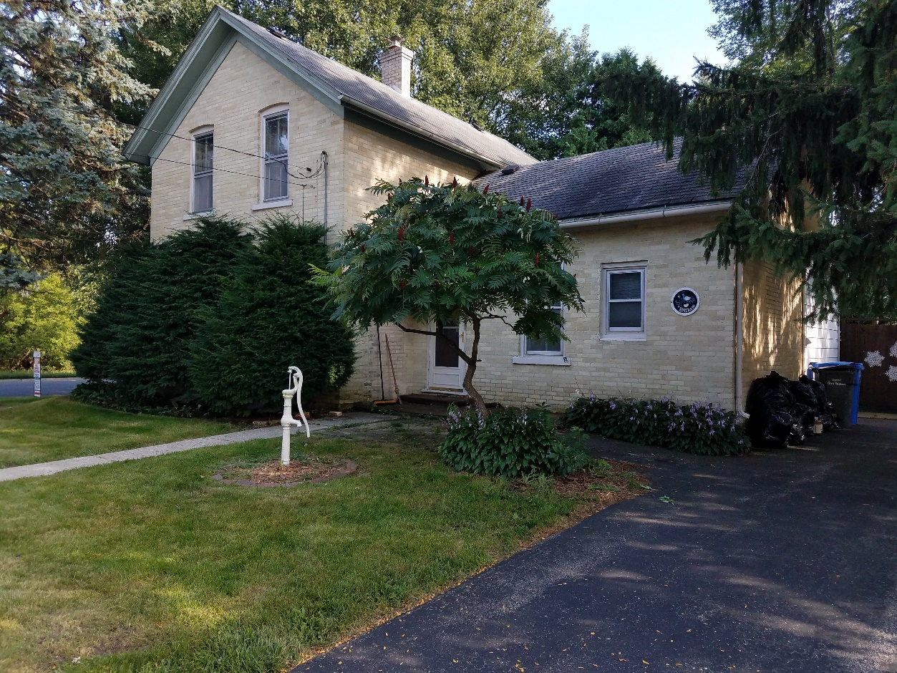

FOR SALE AT ONLINE BIDDING

CREAM CITY 3 BEDROOM BRICK HOME

**1001 MEADOW STREET**

**WATERTOWN, WI 53098**

* Cream City Brick Home on .26 Acres
* 3 Bedroom / 1 Bath
* Detached Garage and Private Patio Area
* Special Term & Conditions Apply
* Call for a Showing Appointment TODAY

(920) 261-6820 or visit www.JonesAuctionService.com

**BIDDING IS NOW OPEN & CLOSES MONDAY, SEPTEMBER 24, 2018 at 3:00pm**

**CONTACT STAN JONES AT (920) 261-6820 www.JonesAuctionService.com**