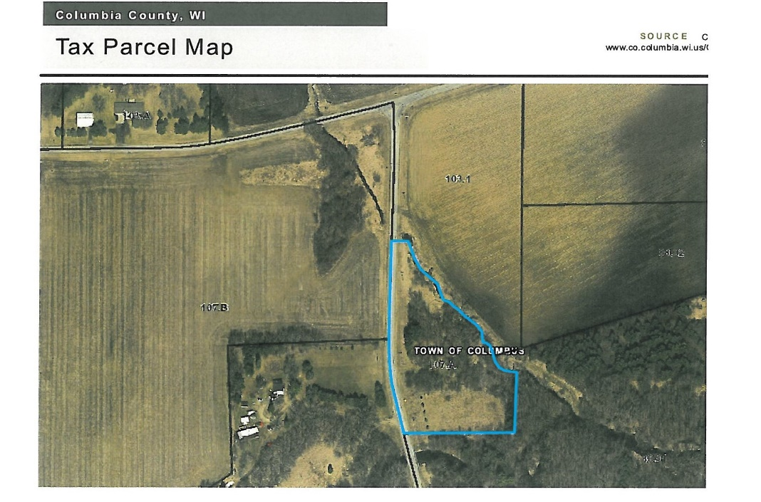

**3 Acre LOT FOR SALE BY ONLINE BIDDING UNTIL JUNE 30th**

*** Vacant Land Only Sale *** Artesian Well *** Driveway **** Partially Wooded ***

Rare chance to own your private site for camping and to get-away from the city! Only 30 minutes to Madison!

**Once starting bid of $10,000 is met,**

**auction will be ABSOLUTE and will sell to highest pre-qualified bidder.**

**ACCEPTING BIDS NOW UNTIL TUESDAY, JUNE 30th and CLOSES PROMPTLY AT 2pm (CT)**

**Visit:** [**www.JonesAuctionService.Hibid.com**](http://www.JonesAuctionService.Hibid.com) **Phone (920) 261-6820**

$10,000 Starting Bid. Once met, auction becomes ABSOLUTE and will sell to highest prequalified bidder.

See Website for Details – Auction Terms & Conditions Apply. 10% Buyer’s Fee – Successful High Bid Plus 10% Buyer’s Fee Equals Total Purchase Price. Sale price is high bid, Buyers Fee is an expense to the buyer. $5,000 Earnest Money, closing 30-45 days.

Property Sells AS IS, WHERE IS, NO CONTIGENCIES OR EXCEPTIONS.

**Stan Jones, CAI, WRA #993**

**Special Terms & Conditions Apply**

**Call or Visit the Website for More Details**

**Phone: (920) 261-6820**

**Visit:** [**JonesAuctionService.Hibid.com**](http://www.JonesAuctionService.Hibid.com)

3 ACRES N2364 Wendt Rd., Rio WI 53925

TOWN OF COLUMBUS, COLUMBIA COUNTY

**REAL ESTATE AUCTION!**

**N2364 Wendt Rd., Town of Columbus** 3+/- ACRES LOT FOR SALE

**by ONLINE BIDDING until Tues, June 30th, 2020 @2p (CT)**

**Visit: JonesAuctionService.Hibid.com or Call (920) 261-6820**

**Visit:** [**www.JonesAuctionService.com**](http://www.JonesAuctionService.com)

Visit: JonesAuction