Watch and Clock Catalog
Selling Friday Feb. 14, 9:00 AM, Ring 2 - Lot #7701 to 8000

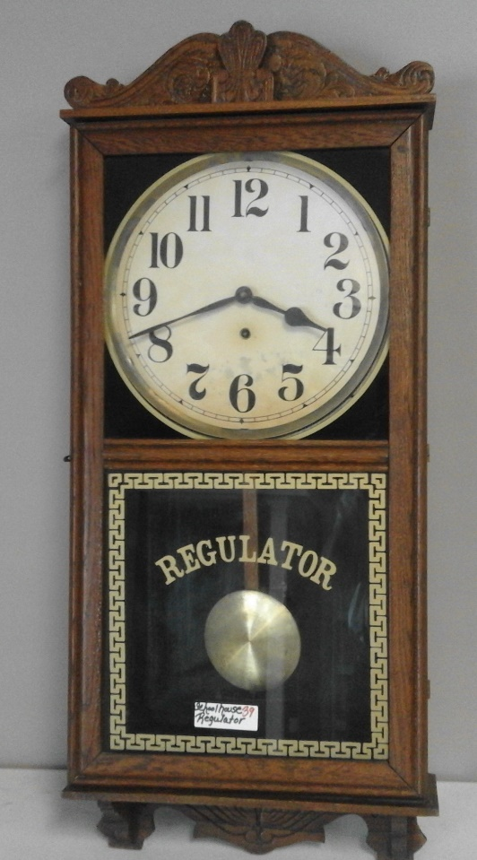

Lot # 7714

Lot #7725
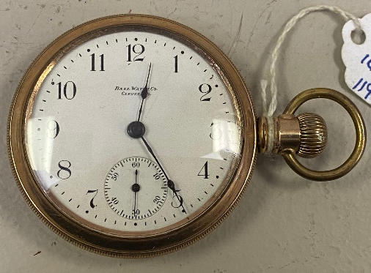

Lot #7724 Lot #7770 Lot #7726

Lot #7701. Elgin; 7 Jewel, 16S. White dial with Arabic numbers, Smooth Nickel case, Nice service watch sn 22905226 (1919)
Lot #7702. Am. Waltham; 17 jewel, 18S. White porcelain double-sunk dial with Roman numbers, numbered every 5 minutes. Beautiful 10 K gold filled case with filigreed back. Sn 12938671 (1904)
Lot #7703. Hampden; 17 jewel, 16 size adjusted, LS. White Arabic dial numbered every 5 minutes. Hinged gold filled case with design on back. Very nice. sn 1045020 (1898)
Lot #7704. Am. Waltham, Riverside A; 21 jewel, 14S, adj. 5 pos. Arabic number dial. 10K rolled gold case. Nice dress watch. Sn 20104789 (1915)
Lot #7705. Elgin, Model 7, Grade 265; 17 jewel, adjusted, 18 size. White porcelain Arabic dial, numbered every 5 minutes. 20-year gold filled case, embossed with floral bird design. Beautiful. Sn 11540811 (1905)
Lot #7706. Hamilton 974; 17 jewel, 16S, LS, adjusted. White Arabic double sunk dial, numbere every 5 minutes, a few hairline cracks. Gold filled case with bird & flowers embossed on back. Sn 362784 (1905)
Lot #7707. Elgin; 7 jewel, 18 size, key wind & set. White Roman numeral dial, has fine hairline crack. Heavy hinged silveroid case with thick glass. Sn 2907803 (1888)
Lot #7708. Elgin, BW Raymond; 21 jewel, 16S, LS, 5 pos. White porcelain Arabic dial. 12k gold filled case marked Elgin RR on front of pendant. Very slight brassing. Smooth back with dentil edge. Nice. Sn 29367852 (1926)
Lot #7709. Illinois; 15 jewel, 18S, LS. White dial with Arabic numbers and numbered minutes. Heavy Nickel case with striped back & edge design. Great service watch. Sn 1702887 (1904)
Lot #7710. Hamilton 924; 17 jewel, 18S, LS. White Arabic dial numbered every 5 minutes, repaired between 7 & 8. Smooth nickel case with thick glass and swing out movement. Great service watch. Sn 490333 (1906)
Lot #7711. South Bend, Grade 291; 17J, 16S, adj. 3 pos, LS. White double sunk Arabic dial, numbered every 5 minutes, tiny chip and hairline between 7 & 8. Hinged 25 yr gold filled case w/RH initials on back. Sn384671 (1903)
Lot #7712. Am. Waltham; 15 jewel, 16S, Unusual gold flashed movement. 25 year gold filled case with some brassing. White porcelain Arabic dial. Sn 22537998 (1919)
Lot #7713. Elgin; 7 jewel, 12S, White porcelain dial, Arabic numbers, numbered every 5 minutes. 20 year gold filled case with initials monogrammed on back. Sn 16850951 (1912)
Lot #7714. Am. Waltham, Vanguard; 23 jewel, 16S, 8 positions, lever set. White porcelain double sunk dial with Arabic numbers. 25 year gold filled case with filigreed back. Very nice. Sn 14072596 (1904)
Lot #7715. Elgin, BW Raymond; 21J, 16S, Grade. 571, 9 adj. lever set. White porcelain dail, marked BW Raymond with Arabic numbers. 10k gold filled case with initials on back. Very nice. Sn 54368497 (1954)
Lot #7716. Am. Waltham; 15 jewel, 3S, Ladies pendant or wrist watch. Hinged back gold filled case, gold Arabic dial. Cute. Sn 22904107 (1920)
Lot #7717. Hampton, Wm. Mckinley; 17 jewel, 16S, adj. White Arabic double sunk dial, numbered every 5 minutes. Smooth gold filled case. Sn 2718159 (1910)
Lot #7718. Illinois; 19 jewel, 16S, dbl. roller adj. 3 positions, LS. White double sunk Arabic dial with numbered minutes. 20 year smooth gold filled case. Very nice. Sn 3946527 (1937)
Lot #7719. Am. Waltham, Riverside; 21J, 16S, adj. lever set. White porcelain dial w/Arabic numbers, numbered every 5 minutes. Smooth nickel case. Sn 29484911 (1937)
Lot #7720. Ancre De Precision; 15 J Swiss watch, Spiral Breguet, 20 lignes. White dial w/Arabic numbers, side winder, hinged silver case w/filigreed back. Paper label on back from antique shop in Munich Germany.
Lot #7721. Hamilton 974; 17 jewel, 16S, LS, adjusted. White double sunk Arabic dial with numbered minutes, fine hairline crack. Filigreed 20 year gold filled case. Nice. Sn 332839 (1904)
Lot #7722. Elgin, BW Raymond; 19 jewel, 16S, LS, 5 position. White double sunk Arabic dial. Smooth 20 year gold filled case. Nice. Sn 22793380 (1919)
Lot #7723. Elgin; 15 J, 3/0S. White Arabic dial numbered every 5 minutes. Lift out movement. Hinged pendant case of 14 Karat .585 fine gold. GRM initials on back. Cute dress watch. Sn 16779238 (1911)
Lot #7724. Elgin, Father Time; 21J, 16S, LS, 5 pos. White double sunk porcelain Arabic dial. 20 year gold filled case with nice design and M monogram on back. Very nice. Sn 21367809 (1918)
Lot #7725. Hamilton 992B; 21J, 16S, 6 pos. LS. White Arabic dial. 10k rolled gold case with nice edge design. Earl C. Burch, Denison TX inscribed inside back cover. Very nice. Sn C166601 (1944)
Lot #7726. Ball Watch Co, Elgin Commercial Standard Model 327 C; 16J, lever set, 18S, White Arabic dial. Gold filled side winder case with design on back. Nice. Pat. 1896 sn11956023 (1905)
Lot #7727. Hamilton 992; 21J, 16S, 5 pos. LS, double roller. White Arabic, double sunk dial with numbered minutes, very tiny chip at no. 8. Gold filled case with brassing around rim of back cover. Sn 870005 (1911)
Lot #7728. Elgin, 12S. White Arabic double sunk dial. Hinged back 14 kt. Gold filled case with filigreed edges and CIM initials on back. Nice dress watch. Sn 2150415 (1918)
Lot #7729. Watch Fob, Lima Shovel; MOVE THE EARTH WITH A LIMA, Baldwin Lima Hamilton Corporation. Slightly over 1 ½” diameter.
Lot #7730. 5 watch straps. Sell choice.
Lot #7731. Elgin B.W. Raymond; 19 jewel, 16S, LS, 5 position. White Arabic dial. 10k gold filled case with brassing. Sn 17539408 (1915)
Clocks
Lot #7732. 31 day wall clock.
Lot #7733. New Haven; mantel clock, 8 day.
Lot #7734. New Haven; San Mateo mantel clock.
Lot #7735. Waterbury; mantel clock.
Lot #7736. Westclox; big ben alarm clock.
Lot #7737. Westclox; big ben alarm clock.
Lot #7738. Westclox; big ben alarm clock.
Lot #7739. Westclox; alarm clock.
Lot #7740. Westclox; big ben alarm clock.
Lot #7741. Kundo; wind, anniversary.
Lot #7742. Mantel clock
Lot #7743. 31 day regular wall clock.
Lot #7744. Plymouth; mantel clock.
Lot #7745. New Haven; mantel clock w/alarm.
Lot #7746. Ingraham; mantel clock.
Lot #7747. Montgomery Ward; 31 day wall clock.
Lot #7748. Ingraham; mantel clock.
Lot #7749. New Haven; 8 day Dandy Line w/alarm.
Lot #7750. Regulator; 31 day clock
Lot #7751. New Haven; mantel clock
Lot #7752. Waterbury; mantel clock.
Lot #7753. Seth Thomas; mantel clock.
Lot #7754. Centurion; 35 day clock.
Lot #7755. Waterbury; mantel clock.
Lot #7756. 31 day wall clock.
Lot #7757. Seth Thomas; mantel clock.
Lot #7758. Ornate wall clock.
Lot #7759. 31 day wall clock.
Lot #7760. Ingraham; mantel clock w/alarm.
Lot #7761. Regulator; solid oak wall clock.
Lot #7762. Ornate wall clock
Lot #7763. New Haven; mantel clock.
Lot #7764. Steeple clock.
Lot #7765. Regulator; schoolhouse clock.
Lot #7766. Waterbury; fancy mantel clock
Lot #7767. Regulator; 31 day clock.
Lot #7768. Waterbury; mantel clock w/alarm.
Lot #7769. Early schoolhouse clock.
Lot #7770. Regulator; early schoolhouse clock.
Lot #7771. Banjo; wall clock.
Lot #7772. New; mantel clock. NIB
Lot #7773. Fancy mantel clock.
Lot #7774. Ingraham; wall clock.
Lot #7775. Regulator; 31 day oak clock.
Lot #7776. Waterbury; mantel clock.
Lot #7777.
Lot #7778.
Lot #7779.
Lot #7780.
Lot #7781.
Lot #7782.
Lot #7783.
Lot #7784.
Lot #7785.
Lot #7786.
Lot #7787.
Lot #7788.
Lot #7789.
Lot #7790.

More Watches
Lot #7791. Elgin; 17 Jewels
Lot #7792. Illinois; 17 Jewels
Lot #7793. Elgin; USA 15 Jewels
Lot #7794. Swiss; Time
Lot #7795. Elgin; USA 17 Jewels, Gold filled
Lot #7796. Elgin; USA 17 Jewels, Gold filled
Lot #7797. Burlington; 21 Jewels
Lot #7798. Elgin; 17 Jewels
Lot #7799. Avalon Swiss; 7 Jewels
Lot #7800. Elgin; 15 Jewel
Lot #7801. Elgin; USA 15 Jewels
Lot #7802. Elgin; USA 15 Jewels
Lot #7803. Elgin; USA 17 Jewels
Lot #7804. Elgin; USA 17 Jewels
Lot #7805. Waltham; 15 Jewels
Lot #7806. Bulova Swiss; 17 Jewels
Lot #7807. Elgin USA; unknown number of Jewels
Lot #7808. Elgin USA; unknown number of Jewels
Lot #7809. Gruen Veristhin Switzerland; precision, 17
Jewels
Lot #7810. Waltham
Lot #7811. Elgin USA; unknown number of Jewels
Lot #7812. Miller; 17 Jewels
Lot #7813. Walthan; unknown number of Jewels
Lot #7814. Elgin; unknown number of Jewels, 10k
gold filled
Lot #7815. Illinois; 21 Jewels
Lot #7816. Illinois; 21 Jewels, 10k gold filled
Lot #7817. Elgin; 546 USA 15 Jewels Star case
Lot #7818. Hamilton 699 Swiss; 17J, 10k gold filled
Lot #7819. Elgin; watch USA Ferguson dial 17 Jewels
Lot #7820. Elgin; 7 Jewels, 10k rolled gold plate
Lot #7821. Walthan; 15 Jewels
Lot #7822. Elgin USA; 15 Jewels
Lot #7823. Illinois; 21 Jewels Star case, 14k gold filled
Lot #7824. Bulls Eye USA;
Lot #7825. Elgin USA; 17 Jewels
Lot #7826. Elgin; 777 19 Jewels
Lot #7827. Elgin USA; 15 Jewels
Lot #7828. Ingersoll;
Lot #7829. Elgin; lever set, unknown number of
Jewels
Lot #7830. Elgin; 15 Jewels
Lot #7831. Elgin USA; 15 Jewels
Lot #7832. Colibri Swiss; made 17 jewels
Lot #7833. Elgin USA; 15 Jewels, 14k gold filled
Lot #7834. Elgin USA; unknown number of Jewels
Lot #7835. Elgin USA;
Lot #7836. Sheraton Swiss made; unknown number
of Jewels
Lot #7837. Elgin; 17 Jewels
Lot #7838. Hamilton; 1896 salesman's sample
w/jewels
Lot #7839. Elgin; lever set, unknown number of
Jewels
Lot #7840. Hamilton; 21 Jewels, lever set
Lot #7841. Hamilton; 940, 21 Jewels, lever set
Lot #7842. Hamilton; 21 Jewels, lever set
Lot #7843. Elgin; lever set, unknown number of
Jewels
Lot #7844. A. Watham; lever set, unknown number of
Jewel
Lot #7845. Elgin; lever set, 21 Jewels
Lot #7846. Seth Thomas; lever set
Lot #7847. Watch, push button set
Lot #7848. D.A. Shepherd; lever set
Lot #7849. Waltham; 15 Jewels, salesman's sample
Lot #7850. Engine Special; 23 Jewel
Lot #7851. Peerless Watch Co.; lever set
Lot #7852. The Dueber; lever set, unknown number
of Jewels
Lot #7853. Hamilton; lever set, 17 Jewels
Lot #7854. Ludwig Simon Berlin;
Lot #7855. Watham; 15 Jewels
Lot #7856. American Watham Watch Co.;
Lot #7857. Elgin Watch Co.;
Lot #7858. Elgin; unknown number of Jewels
Lot #7859. Elgin; 15 Jewels
Lot #7860. Elgin; 15 Jewels
Lot #7861. Elgin; lever set, Not. L. Watch Co.
Lot #7862. Elgin; Not. L. W. Co. unknown number of
Jewels
Lot #7863. Ingersoll Reliance; 7 Jewels
Lot #7864. American Watham Watch Co.; unknown
number of Jewels
Lot #7865. Watham; 15 Jewels
Lot #7866. Elgin USA; 15 Jewels
Lot #7867. Elgin USA; unknown number of Jewels
Lot #7868. Elgin USA; 7 Jewels
Lot #7869. Watham Watch Co.; unknown number of
Jewels
Lot #7870. Elgin USA; 15 Jewels
Lot #7871. Waltham; 7 Jewels
Lot #7872. Elgin USA; unknown number of Jewels
Lot #7873. Tavannes Watch Co.; 15 Jewels
Lot #7874. Rc. Eisenbach; unknown number of
Jewels
Lot #7875. Olympic Swiss made; 17 RE
Lot #7876. Elgin; 15 Jewels
Lot #7877. Elgin; 15 Jewels
Lot #7878. Ingran;
Lot #7879. Hamilton USA; 17 Jewels
Lot #7880. Elgin; unknown number of Jewels
Lot #7881. Watham;
Lot #7882. Gold Dust
Lot #7883. Elgin;
Lot #7884. Watham;
Lot #7885. Watham; 17 Jewels
Lot #7886. Elgin; 15 Jewels
Lot #7887. Elgin;
Lot #7888. Standard USA; 15 Jewels
Lot #7889. No name, no key
Lot #7890. Hamilton; 17 Jewels
Lot #7891. Elgin; 15 Jewels
Lot #7892. Elgin; 17 Jewels
Lot #7893. Seth Thomas;
Lot #7894. Hampden Watch Co.; lever set
Lot #7895. Watch, button set
Lot #7896. Elgin; 17 Jewels
Lot #7897. Elgin; 15 Jewel
Lot #7898. Elgin; 17 Jewels
Lot #7899. Ben Rus Watch Co.; 17 Jewels
Lot #7900. Elgin USA; 15 Jewels
Lot #7901. Elgin USA;
Lot #7902. Vallon;
Lot #7903. Watham;
Lot #7904. Columbia USA;
Lot #7905. Elgin;
Lot #7906. Elgin;17 Jewels
Lot #7907. Elgin; 15 Jewel
Lot #7908. Elgin; USA
Lot #7909. Elgin; 15 Jewels
Lot #7910. Elgin;
Lot #7911. Watham; 15 Jewels
Lot #7912. M-K-T; unknown number of Jewels
Lot #7913. 12 knives and chains
Lot #7914. 3 bags w/chains
Lot #7915.
Lot #7916.
Lot #7917.
Lot #7918.
Lot #7919.
Lot #7920.
Lot #7921. Elgin; 7 jewel, Keystone 20 year gold filled swing out case, J boss. Sn 9164005 (1900)
Lot #7922. Hampden, Canton Oh; 17 jewel, adj. D roll. Dueber 20 year.
Lot #7923. Tiffany & Co. New York; 6 size, LS. warranted 20 year. B-B Royal. Sn 59463
Lot #7924. Waltham Mass. AWW Co.; 15 jewel, Fahy’s gold filled. Sn 15397.809 (1906)
Lot #7925. Seth Thomas, Thomaston Conn. Stem set, silveroid. Sn 2548009 (1909)
Lot #7926. Wilber Watch Co. Buffulo NY; Marine W. Co. 15J, 14k gold filled.
Lot #7927. AWC USA; silveroid. Sn 3165321
Lot #7928. Elgin; 7 jewel, 12S, sn 26839250 (1923)
Lot #7929. Waltham, Riverside; 21 jewel, 10k rolled gold. Nice! Sn 29483618 (1937)
Lot #7930. Elgin; silveroid. Sn 12301203
Lot #7931. Gruen Verithin; 17 jewel, gold filled. Sn 501016
Lot #7932. Colibri; 17 jewel, Swiss
Lot #7933. Springfield Watch Co. Il; 19 jewel gold filled. Sn 3946823
Lot #7934. Springfield Watch Co. Il; 17 jewel, Dueber 20 year. Sn 4587345
Lot #7935. Waltham, Appleton Tracy & Co; key wind, key set. Sn 98754
Lot #7936. Shing Co. TJ China Wall; 2 jewel
Lot #7937. Elgin; lever set. Sn 1965436
Lot #7938. Elgin; 8 day clock.
Lot #7939. Alarm clock, Made in Germany
Lot #7940.

