AllPropertyAuctions,Inc

815 S. Center Casper, WY

www.allpropertyauctions.net

Location: Auction online only. Pick up downtown Casper.
Preview days: October 25 or 28, 2016 from 10am-noon at 315 N. Wolcott Casper, WY

Items include: large True double door freezer, hot dog cart, hot boxes, stove, pizza oven, steam tables, Old Hickory restaurant chairs, bar stools, fryer, china, glass ware, popcorn machine, snack warmers, proofers, racks, prep tables, sundae prep station with sink, flat ware, bathroom stalls, room screens, maple prep table and much more!!!
See it all and bid online at
www.allpropertyauctions.net.
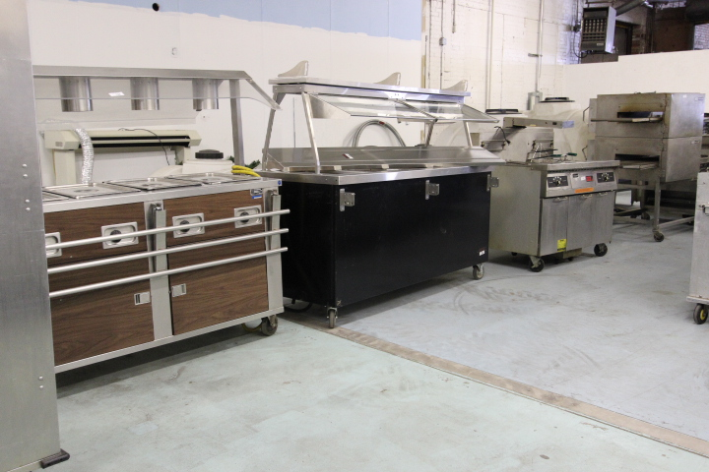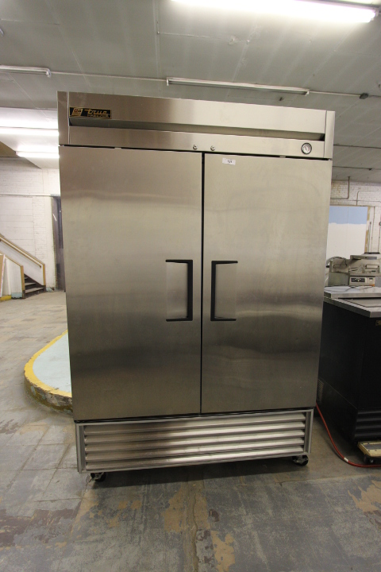
This auction is being conducted by All Property Auctions. Please contact Larry Forsberg at 307-262-2148 or Jennifer Forsberg at 307- 262-7491 with questions.

