VERY LARGE PUBLIC AUCTION
SATURDAY, OCTOBER 20TH ,2018
RUNNING TWO RINGS- STARTING AT 9:00
Lunch by: Relish the Dog 9:00 A.M. Comfort Station Available
LOCATION: Boone Co. Fairgrounds, 8847 IL. Rt. 76, 1 Mi. North of Belvidere. Located in the goat barn near south end. Plenty of Parking! Dress Accordingly!
SALE STARTING WITH PRECISION TOY TRACTORS AT 9:00 SHARP!
ANTIQUES, COLLECTIBLES, TOYS, HOUSEHOLD, YARD, TOOLS, EQUIPT.& Misc.
SPECIALTY ITEM: 1988 Pro Craft Bass Boat w/88hp Johnson & Trailer - To Be Sold at 11:00 SHARP!
ANTIQUES & COLLECTIBLES: Presicion Toy Tractors- J.D, Farmall, Case, Oliver, Allis-Chalmers, & more, Collections of Delivery Trucks- Budweiser, Coca Cola, Lennox, Campbell’s & Mooseheart Trucks; Boone Co. Fair Toys; (Almost all toys still with original boxes) ; Time Life Civil War Book Series; Toledo Scale; Metal spoke tire (Corduroy Rubber Co); Bedroom set; 1983 95th Anniversary Loyal Order of the Moose Decanter; Hamm’s lighted beer sign; milking machines; Primitive tools; 1918 History of the 33rd Infantry Division maps; Allis Chalmers fridge (works); baseball bats; Lots of old LP’s & records; Buck saws; Model sail ship; wood planes; wood clamps; 1973 Honda 500 Four motorcycle w/manuals; metal trunk & Much, much more!
HOUSEHOLD & MISC: Lots & lots of misc. Holiday Décor! Modern D.R. set w/6 chairs, leaf & cabinet; off white sofa & loveseat; chairs; coffee & end tables; book shelves; books; chest of drawers; TV center-low boy; Chair lift; Crystal; nic nacs; white entertainment unit; wood dinette set; recliners; love seat; stereo set & Lots, Lots more!
YARD & TOOLS: Yard cart; Craftsman 3 hp air compressor; Craftsman 6.5hp self propelled mower; Craftsman 10” band saw; B & D belt sander; blow torch; shop vacs; bench vise; misc. power tools; McCulloch chain saw; 1 ½ ton floor jack; wood carpenter’s tool box/chest; Yardman 15hp, 42” cut hydro; Yardman MTD 20hp 46” cut garden tractor; 20 & 24’ alum. ext. ladders; 16hp MTD hydro riding mower; Ryobi small tiller; Craftsman upright tool chest; Ingersoll Rand 5 hp air compressor; chipper/shredder; Roto-Hoe cut & shred; 3.5 McLane weed trimmer; Hann Eclipse riding mower; battery chargers; chain saws; bench grinder; saws; tire changer; torch & cart; Kerosene & Reddy Heaters; engine stand; Toboggan; bowling balls & so much more!!
EQUIPTMENT: IH Planter w/plates (model 56); Woods 48” 3 pt mower; Woods 60” 3 blade belly mower; Woods 36” Bush hog type mower; tree planter for seedlings, 3 pt mount; draw bar & cultivator for Farmall; one bottom plow for Farmall C; IH rear tractor tire chains; Troy-Bilt walk behind weed eater, 5 hp w/24” cut; JD Rototiller model 216; Wi V-4 air cooled engine w/power take off; Radiator for 2003 Jeep Wrangler; IH rear wheel tractor weights; snow blade for MTD; Cement mixer; Very old Cushman gas golf cart ; Melroe Skid steer; Power Washer 1500 PSI; Citadel heater; tillers; axle; & more.
SPECIALTY ITEM: 1988 Pro Craft Bass Boat w/88 hp Johnson motor & Pro Craft trailer. Has trolling motor, depth finder, rod locker, two live wells. Excellent condition. Everything works as should. Water ready!
TERMS: Cash or checks w/proper I.D. Visa, Mastercard & Discover accepted. 9% Buyer’s Premium w/4 % Discount for cash or check. No property to be removed until settled for. All items sold “AS IS”. Number system will be used. Must have driver’s license or valid ID for registration Lee Auction Service is NOT responsible for accidents or items after purchase. Announcements day of sale prevail over written material.

Owners: C. Gilman,T. Fidder,, J. Rudie, D. Sitter, T. Macomber, K. Kowal, M. Donahue, A, Hathaway, S. Long, M. Otxoa, M. Dekker, T. Walliing, L. De Grand, B. Berning, J. Huffman, Lori Turner Estate & R. Myers Estate

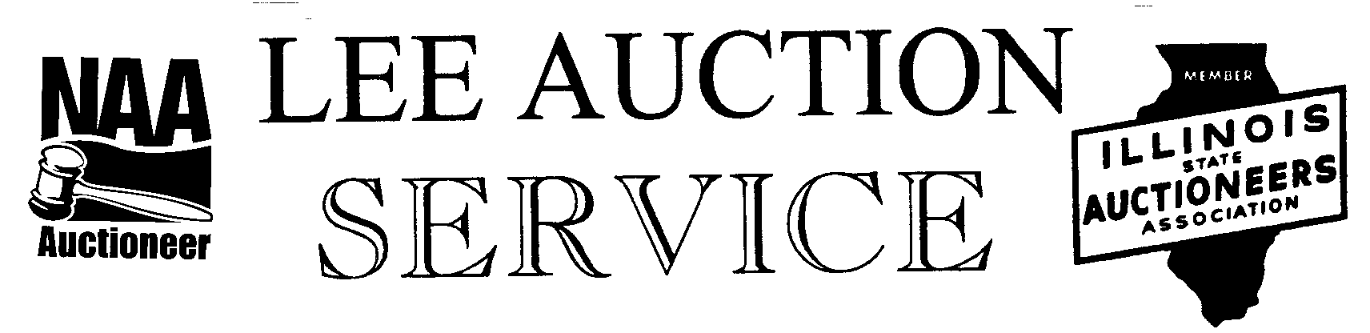
Belvidere, IL 61008
815-988-0249 cell
AUCTIONEER: LYLE LEE IL. State License #440.000200/ WI # 2863-52 & Troy Rudy
CLERKS & CASHIERS: LEE AUCTION SERVICE
Visit our web site at www.leeauctionservice.com/See Go To Auction or Auction Zip for pictures

