PA’s 1st Friends of the NRA
February 3rd 2024
STRATIGOS BANQUET CENTRE
131 Colonial Manor Road
North Huntingdon, PA. 15642
Doors Open at 5:00PM

Celebrate a legacy of shooting sports traditions.
Join other champions of the Second Amendment for dinner, games, auctions and fun
with a chance to win exclusive NRA guns, gear, décor and collectibles!

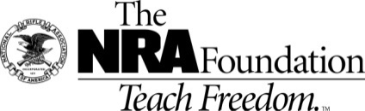
NRA Guns & Prizes |  | Special BANQUET Raffles
2024 GUN OF THE YEAR SET | NRA EXCLUSIVES | FLAG GAME  Live & Silent Auction
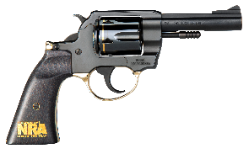  Henry big boy Revolver  .357MAG/.38SPL  Henry Big Boy Side Gate  .357MAG/.38SPL  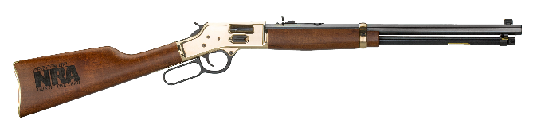 | 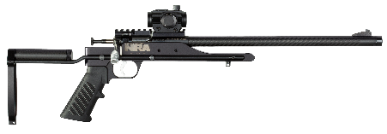  AND MORE!  View all items at  friendsofnra.org/merchandise | Starting Bid $100  ONLY 13 FLAGS  1 in 13 Chance for DIAMONDBACK DB10 6.5 CREEDMOOR NRA EDITION  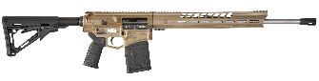

The NRA Foundation is a 501(c)3 charity of the National Rifle Association. Net proceeds benefit shooting sports programs in our communities. NRA membership is not required to participate. All firearm laws apply. Winners are responsible for any taxes / transfer fees.

Pre-Event Specials  Buy Early & Save Money |  | more  Special BANQUET Raffles
$180 Sportsmen’s Raffle Pack  Includes 1 Upper Teir Ticket | Locked & Loaded Game Card | Live Auction  BUMP UP GAME
$200 in Tickets per Sportsmen’s Raffle Pack  Includes 1 Upper Teir Ticket $50  PRE-EVENT ONLY  $180  NIGHT OF THE EVENT  $200 | 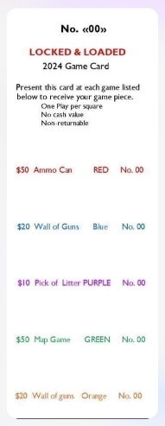  $150 in Event Day Game Tickets on each  Lock & Loaded Punch Card.  PRE-EVENT ONLY $100  WILL NOT BE AVAILALE AT BANQUET. | $100 per BUMP  LESS THAN 50 LIVE AUCTION BUMPS  TO BE SOLD  CARBON  CHASSIS RIFLE  308 WIN Cal.  MSRP $1,899

Just Some of the Facts:
- All 2024 Friends of NRA Standard Package Firearms are Limited Editions of 750 or less in production.

- Underwriting some or all of the Banquet Items & Expenses to advance our cause is a 100% Tax Deduction.

- Buy Early & Get More. The more Patriot Raffle Packs sold ahead of time, the more guns we’ll have at the event!

But Wait! There’s More! |  | EVEN more  Special BANQUET Raffles
AMMO CAN GAME!  NEW FOR 2024! | Custom NRA Gun Rack Made in the USA by Meissenburg Enterprises | Silent Auction  YELLOW LINE GAME
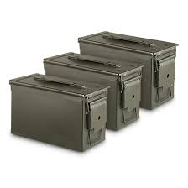  Ammo Can Prize  WEATHERBY VANGUARD COMPACT HUNTER .308 WIN WITH NRA LOGO  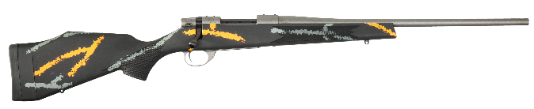 | 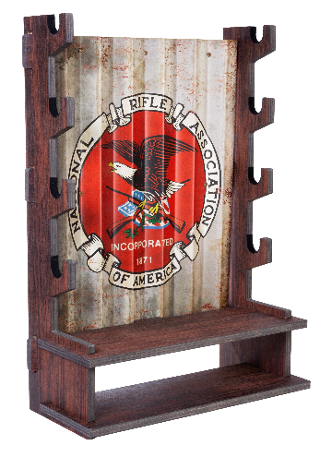  MAKE SURE TO PLAY THE BRAND NEW “STATE GAME” | Sign on the Yellow Line in the Silent Auction to get a chance in the Yellow Line Raffle.  Yellow Line Raffle Prize  SIG SAUER P322 WITH ROMEO ZERO ELITE .22LR WITH NRA SEAL  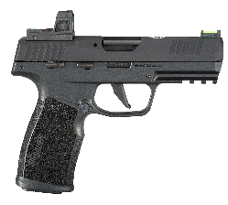

Win This AR 15 Decanter Set at the Event! Exclusive NRA Browning Knife Set
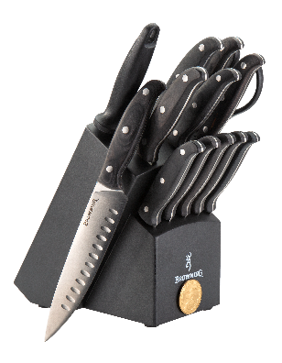
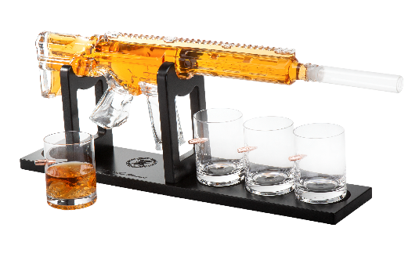

STRATIGOS BANQUET CENTRE, 131 Colonial Manor Road, North Huntingdon, PA. 15642
Doors Open at 5:00 PM
Purchase your TICKETS BELOW
Order Dinner tickets online:
www.friendsofnra.org

ALL SPORTSMEN”S RAFFLE PACKS
MUST Be Ordered on This Form

All tickets held at door
Cancelled check or CC charge is your receipt/confirmation
Questions?

Dale Emerick
1262 Morris Street
North Huntingdon, PA. 15642

Dale_emerick@att.net

(412) 580-1642

EARLY BIRD DATE
Or mail order by 1/27/2024

Clip address below & tape to envelope for easy addressing!

Dale Emerick
1262 Morris Street
North Huntingdon Pa, 15642
QTY |  |  | $ 100.00 Individual Event Ticket: 1 Dinner (Open Seating) |  |  |  |  | $
 |  |  | $ 380.00 Couples Package: 2 Dinner + $200 Sportsmen’s Raffle Pack Voucher
 |  |  | $ 1000.00 Liberty Table10 Dinners + 1 Chance for a Pick from Wall of Guns |  |  |  |  | $
 |  |  | $ 1500.00 Club Table: 10 Dinners + 1 Pick from Wall of Guns or  $600 Sportsmen’s Raffle Pack Voucher |  |  |  |  | $
 |  |  | $ 2600.00 Corporate Table: 10 Dinners + $600 Sportsmen’s Raffle Pack Voucher +  Pick from the Wall of Guns |  |  |  |  | $
 |  |  | $ 3200.00 Corporate-Plus Table: 10 Dinners + Pick from Wall of Guns +  $1200 Sportsmen’s Raffle Pack Voucher |  |  |  |  | $
 |  |  | $ 5200.00 All American Table: 10 Dinners + A Gun from Special List +  $2400 Sportsmen’s Raffle Pack Voucher |  |  |  |  | $
 |  |  | $ 100 Locked & Loaded Game Card ($130 in Game Tickets on Each Card)  Special: Only Available If Bought Before Banquet |  |  |  |  | $
 |  |  | $ 180 Sportsmen’s Raffle Pack Voucher PRE-EVENT ($200 Night of EVENT)  (Each Sportsmen’s Pack Contains 1 Upper Teir Ticket) |  |  |  |  | $
 |  |  | EVENT UNDERWRITER - Underwrite Some or All of the Banquet Items and Expenses  100 % Tax Deductible |  |  |  |  | $
 | [ ] $100 [ ] $500 [ ] $2,500 [ ] $3,500 [ ] $5,000
 | [ ] $300 [ ] $1,000 [ ] $3,000 [ ] $4,000 [ ] Other Amt
 |  |  | Advertise your Business or General Ad at the Event |  |  |  |  | $
[ ] $50 Business Card [ ] $100 Quarter Page [ ] $150 Half Page
[ ] $200 Full Page

 |  |  | TAX-DEDUCTIBLE SPONSORSHIP (Dinner tickets are not included) |  |  |  |  | $
NATIONAL SPONSOR PROGRAM
Legacy Sponsor [ ] $400, Freedom Sponsor [ ] $1,500, Pioneer Sponsor [ ]$2,500,
Patriot Sponsor [ ] $5,000

 | Choose One :
Please enclose check to PA’s1st FONRA or complete credit card info below |  |  |  |  |  |  |  | $
AmEx/Disc/MC/Visa charged upon receipt. All sales are final. |  |  |  |  |  |  |  |  | TOTAL
Card # |  |  |  |  | Expiration
Signature |  |  |  |  | Sec Code
Name |  |  |  |  | Company
Address |  |  |  |  | Phone
City/St/Zip |  |  |  |  | Email

