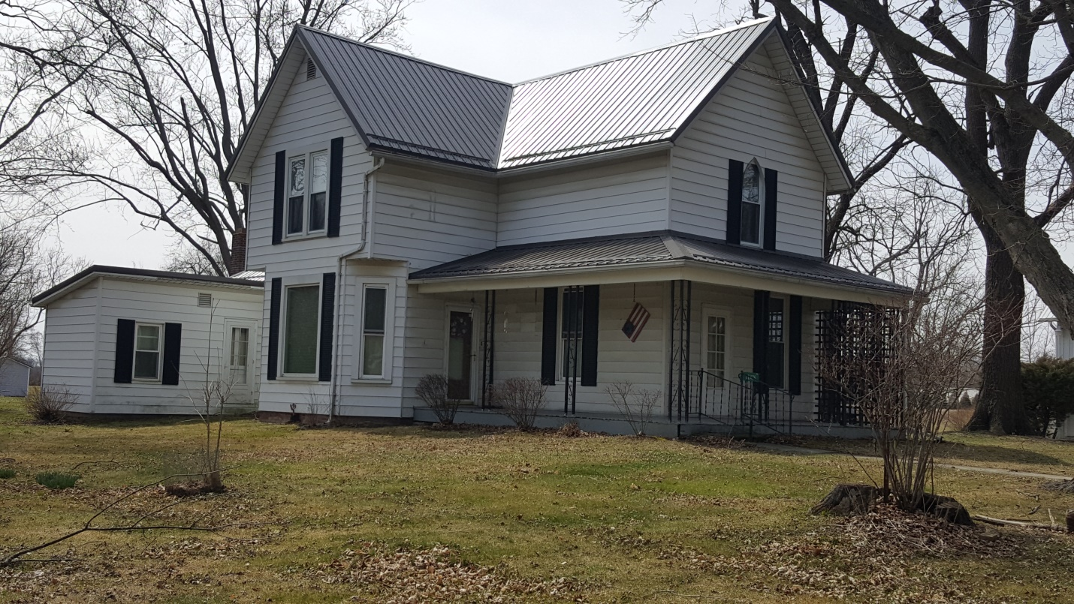
Location: 22476 2nd Street (Brunersburg) Defiance, Ohio
Welcome to Tinora School District. If you need plenty of room to grow, you’ll want to see this well maintained country 2 story home which offers many updates, Metal Roof 2017, Water Heater, Replacement Windows, Furnace, Electical and more. 4 bedrooms, 1 bath, Kitchen, LR , DR, Parlor & Office. This 2 acre lot also comes with a 32x66 barn. Close to St. Rt. 24 access.
Note: A complete listing of personal property in upcoming advertising, or go to auctionzip.com #7737

Owner:
Robert E. Hanker Trust, Rita A. Cordes Trustee
Marc Warncke Attorney
FOR TERMS, CONDITIONS, or PRIVATE SHOWING Contact: Dan Limber 419-576-2717

Conducted By:
DAN LIMBER CAI AUCTIONEER / REALTOR
&
SIEFKER REAL ESTATE & AUCTION CO. LTD *
OTTAWA, OH
AARON SIEFKER, Broker/Auctioneer

Licensed by the Department of Agriculture <> View Online @ www.dlimberauctions.com

