HUGE SURPLUS AUCTION
Saturday, April 28th 10:00 AM
Location: 28394 Ayersville Pleasant Bend Rd. Defiance, OH 43512
3-4 Semi Loads of Surplus Returns
Lawn & Garden, Tools, Small Appliances
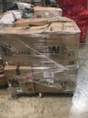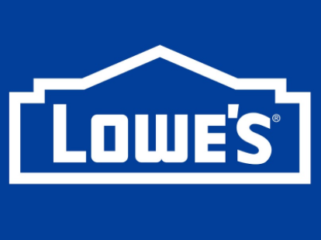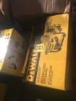
No guarantees of what will be there, but typically loads include: DeWalt, Husky, Ridgid, Milwaukee, WEN, Honda, as well as other brands.
Items may include: mowers, generators, chainsaws, trimmers, pressure washers, blowers, hose reels, lawn vacs, tillers, edgers, thatchers, other outdoor equipment, tool sets, sawzalls, circular saws, tile saws, air tools, grinders, impact wrenches, air compressors, tool chests, tool boxes, hand tools, floor jacks, storage shelves, gas and electric heaters.
Attention Wholesalers: There is a lot of volume here and opportunity to buy lots of merchandise.
Terms: Cash, or Visa MC Discover Credit/Debit Card, There will be a 10% Buyers Premium applied to all purchases. We will not be accepting checks.
Note: Mostly new surplus, scratch and dents or returned items from Target, Amazon, Home Depot and others. This is a partial list. We are bringing items in by the semi load so there are bound to be some unadvertised specials and some things on the list that don’t show up. Everything is on a one way ticket and sold AS-IS under your own inspection. There will be something for everyone. We will be selling in 2 rings out of the gate so bring a couple friends. It should be a great day, a lot of volume and good volume so bring the box truck and bring a friend or two! Pictures will be added to web when available a few weeks before the auction. Info at: dlimberauctions.com and www.auctionzip.com
Auctioneers: Dan, Cole & Kendra Limber
Conducted By:
Dan Limber CAI Auctioneer LLC

