READY TO RETIRE!
HOUSE FOR SALE THROUGH AUCTION
Sold with owner confirmation
August 18, 2018 @ 12 noon
All personal property will be auctioned starting at 10am the same day. For a full preview of these items go to AuctionZip.com and use our auctioneer id #18017.

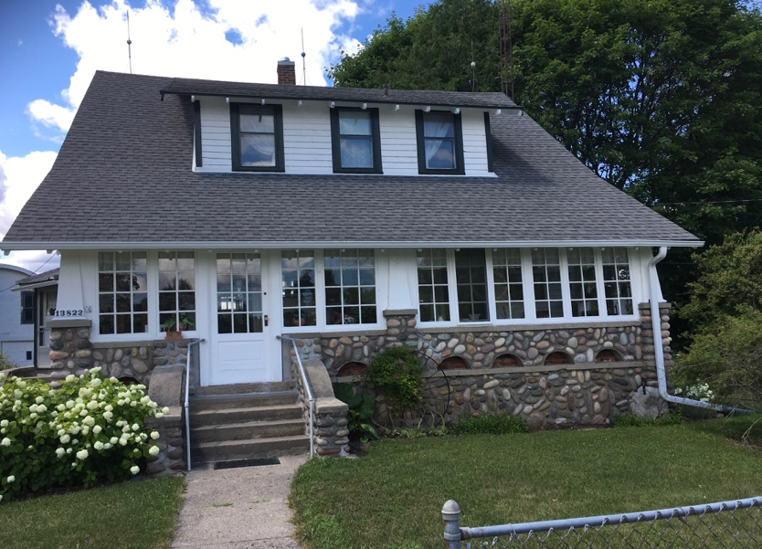

13822 HUBBARD LAKE RD.
HUBBARD LAKE, MI. 49747

Nicely landscaped Historic Early 20th Century Craftsman’s Style 4-bedroom, 2 baths, full basement home. With features such as 8 ft. bay window in dining room, hardwood floors, oak open staircase to 2nd floor, quarter sawn oak trim. This beautiful home has a newer roof, central air, natural gas furnace and hot water heater. Carriage house style garage and additional out building. All on .6 acre.

Term for house auction:
5% Non-refundable deposit day of sale. To close within 30 days of auction sale. Sold as is, where is with NO GUARANTEES. Taxes to be treated as being paid in advance.

To set up an appointment to view this beautiful home, contact Kevin Burr from Burr Auctions @ 989-464-5880

