Joe Joyner
Email: auctionsbyjoe@cox.net
Website: www.progressiveauctionsva.com

2150 Armada Dr.
Chesapeake, VA. 23321
Phone: 757-478-9630

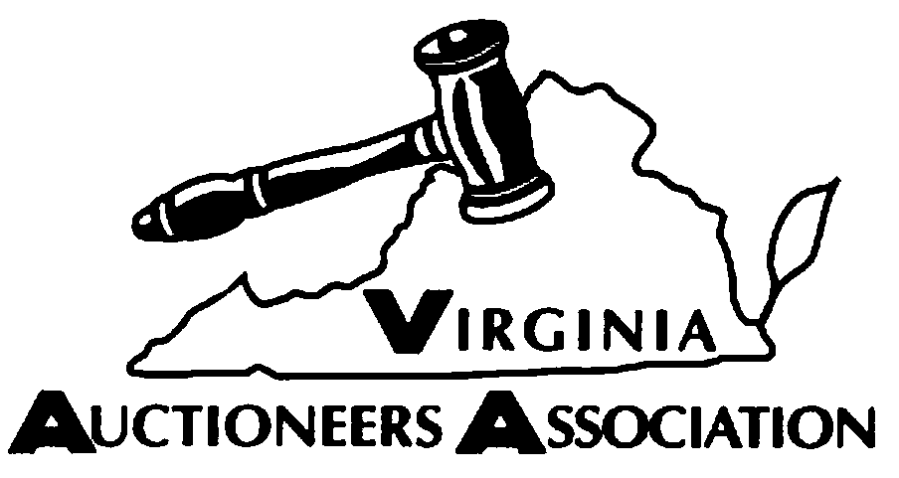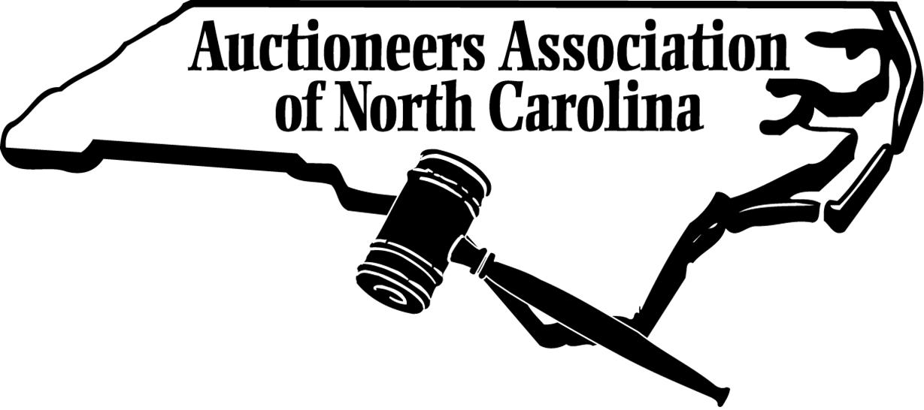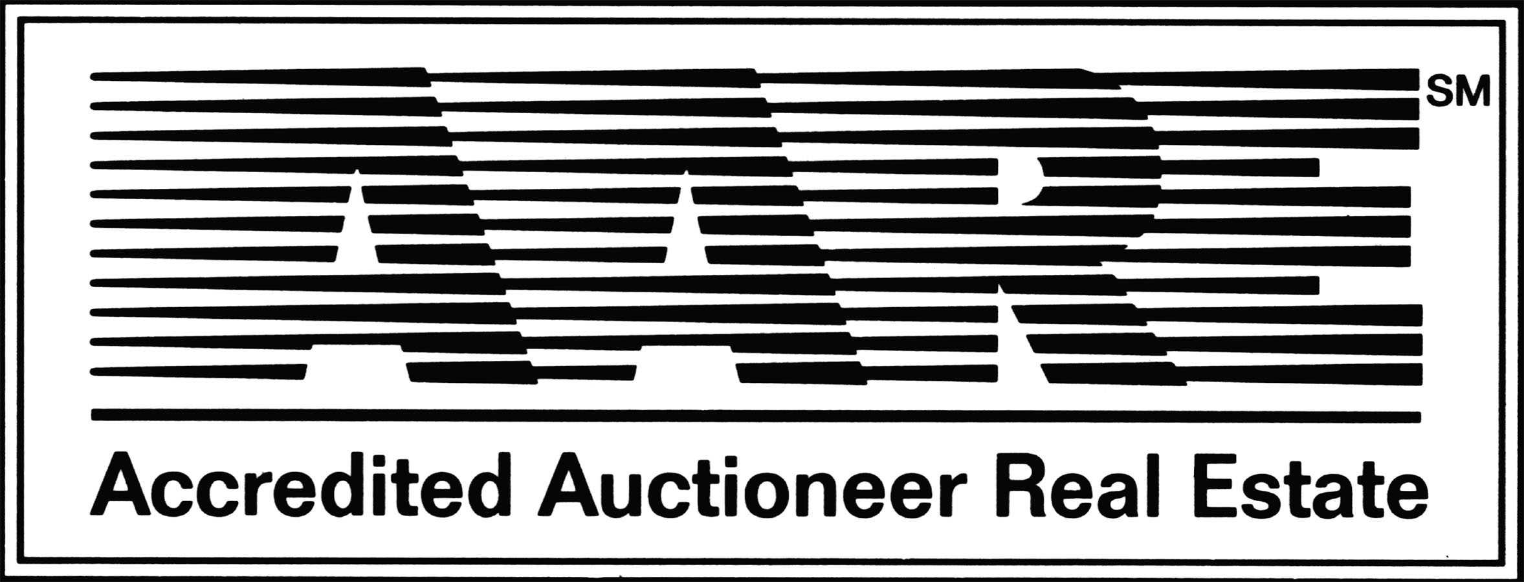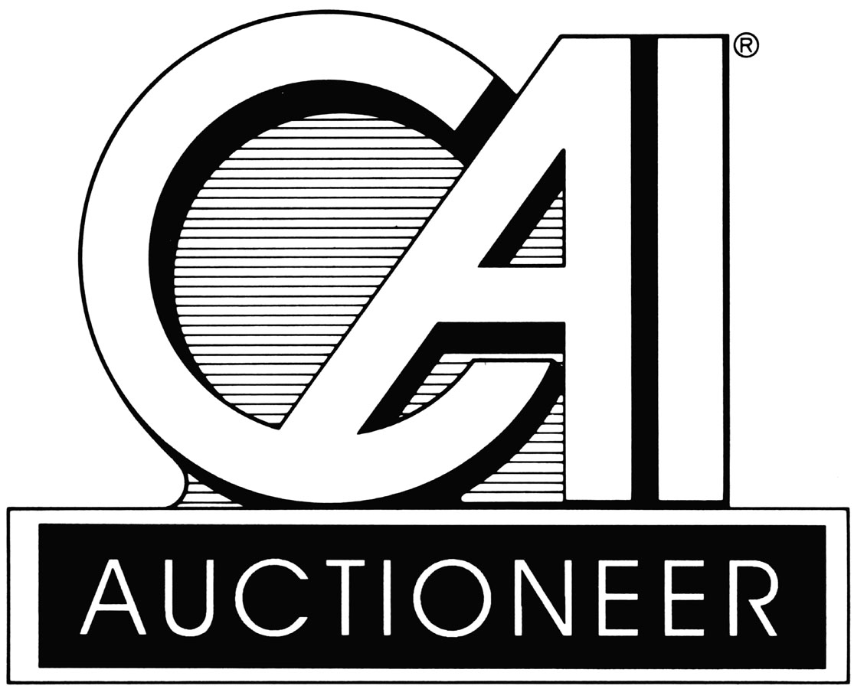Pre Bid Instructions

- By signing the pre bid form you are entering into a legal binding contract provided your bid be accepted.
- The Sellers can either accept, counter, and or reject your bid offer.
- If the Seller accepts your bid or there is a negotiation process that is finally accepted, you as the Buyer will be required to complete a legal binding
contract and submit a 10% deposit by wire transfer to an account set up
by Progressive Auction and Real Estate Co. LLC. The funds will remain
in the escrow account until such time, the property closes. Once the property
closes the auction co. will transfer the funds into their account as payment
of the Buyer Premium as referenced in the terms and conditions as well as
in the contract.
- The buyer is required to close within thirty ( 30 ) days from the date of the contract.
- The property is being sold in a AS IS, WHERE IS, and HOW IS
condition.
- If you have any questions feel free to contact the auction company prior
to submitting a bid.
- Once the contract has been signed by all parties a copy will be sent back to
you for your records.
- Make sure you provide the name of the closing company, name of the person
handling the closing, their phone number, and their email address.
There is a space provided on page two of the contract for this information.
- The auction co. will send a copy of the contract to the closing company with
instructions.

