THE RENAISSANCE AUCTION GROUP
COMMERCIAL REAL ESTATE AUCTION

FRIDAY JULY 27TH LIVE ONSITE @ 6PM
640 & 658 S. 7TH ST., READING, PA 19602

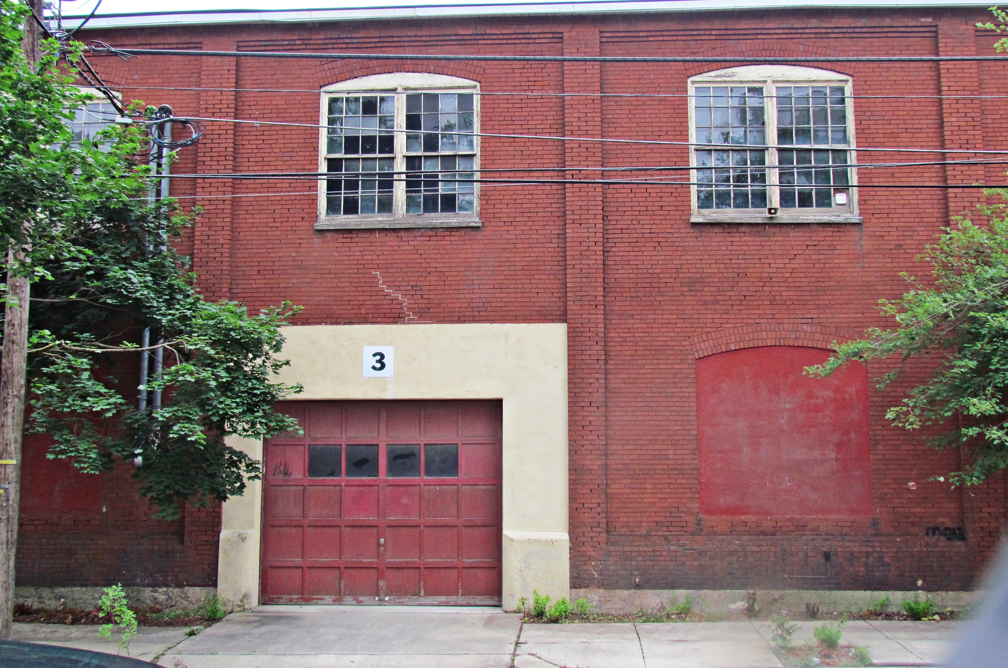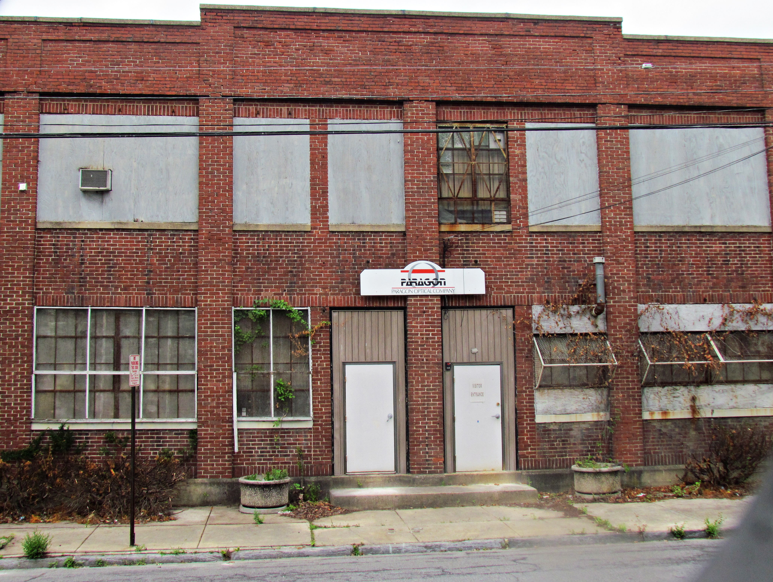
640 S. 7th St 658 S. 7th St
BID LIVE AT THE AUCTION OR ONLINE @ www.auctionhowze.com
PROPERTY INSPECTION: SATURDAY JULY 21ST 10 AM - NOON
PROPERTY INSPECTION: SUNDAY, JULY 22ND 1PM-3PM
640 S. 7th St.: Brick, Open Floor Plan Both Floors, Commercial / Industrial
658 S. 7th St.: Brick, Open Floor Plan Downstairs, Offices Upstairs, Commercial / Industrial

ALL MEASUREMENTS APPROXIMATE
- 640 S. 7th St
First Floor
Open - 70’ x 22’ ” 1540 Sq Ft
Open - 70’ x 16’ 1120 Sq Ft
Two Bathrooms
Second Floor
Open - 70’ x 40’ 2800 Sq Ft
Office -14’ x 14’ 196 Sq Ft

658 S. 7th St
First Floor
Open – 48’ x 36’ 1728 Sq Ft
Open – 48’ x 15” 720 Sq Ft
Office – 18’ x 12’ 221 Sq Ft
Bathroom
Second Floor
Office – 23’ x 15’ 345 Sq Ft
Office – 19’ x 15’ 285 Sq Ft
Office – 12’ x 24 288 Sq Ft’
Office – 20’ x 10’ 200 Sq Ft
Office – 12’ x 10’ 120 Sq Ft

Office – 12’ x10’ 120 Sq Ft
Office – 12’ x 10’ 120 Sq Ft

Break Room -- 11’ x 11’ 121 Sq Ft
Break Room – 12’ x 15 180 Sq Ft
Bathroom

www.auctionhowze.com 610-370-2879 bill@auctionhowze.com

II. PLUMBING
A. Municipal Water, Sewer,
B. Two Bathrooms Per Property, Multiple Utility Sinks Per Property

III. ELECTRICAL
A. Commercial Grade Both Buildings

IV. HEATING / COOLING
- 640. S. 7th St.: Natural Gas Forced Hot Air Heat
- 658 S. 7th St.: Natural Gas Forced Hot Air Heat; AC
V. ROOF
A. Asphalt, Rolled Rubber

VI. TAX INFORMATION
- 640 S. 7th St.: Annual Est. $1982.00 (County Tax: $351; Municipal Tax: $810; School Tax $821)
- 658. S. 7th St.: Annual Est.$1476.00 (County Tax: $261; Municipal Tax: $603; School Tax: $611)
- Assessed Value - $157,500; Residence $102,500; Land $55,000

VII. LOT INFORMATION
A. 640 S. 7th St: 4792 Sq. Ft. (.11A); Paved Sidewalk, Level, Industrial
B. 658. S. 7th St: 5227 Sq. Ft. (.12A); Paved Sidewalk, Level, Industrial

VIII. NOTES
A. 640 S. 7th has three large open space work areas
B. 640 S. 7th has two bathrooms on first floor
C. 640 S. 7th has one office area upstairs
D. 640 S. 7th has garage door drive in entrance
E. 640 S. 7th St has industrial / light manufacturing electrical service
F. 658 S. 7th St has one large and two medium open work areas
G. 658 S. 7th St has two bathrooms, one on each floor
H. 658 S. 7th St has one office on first floor, nine offices / break rooms on second floor
I Ample on street parking consistently available for both buildings
J

IX. TERMS OF AUCTION
$3,000 Down Per Property Day Of Auction In Certified Funds. 10% Buyer's Premium. Forty-Five Days to
Close.

HOW TO PARTICIPATE IN THE REAL ESTATE AUCTION

1) Inspect The Property By Attending An Open House Or Schedule A Property Inspection By Appointment

2) Obtain A Property Information Pack & The Terms & Conditions Of Sale In Person Or By
Downloading The Documents From Our Website: www.auctionhowze.com

3) Bring Cash Or A Cashier's Check To The Auction In The Amount Of $3,000.00. Have The Cashier's
Check Made Out To You. If You Are The Successful High Bidder, You Will Endorse The Check
And Make It Payable To The Escrow Agent.

4) Bid Your Price. You Could Be The New Owner Of These Investment Properties At A Price You Determine

5) If You Have Any Questions Or Need Further Assistance Please Refer to The Contact Information Below

CONTACT INFORMATION:
E-Mail - bill@auctionhowze.com
Phone - 610-370-2879

We Make A Difference You Can Take To The Bank

